INTRODUCTION

The Travel India Management System is a C based application. The main purpose of “Travel India management system” is to provide a convenient way for a customer to book hotels, train and bus for tour purposes. The objective of this project is to develop a system that automates the processes and activities of a travel agency. In this project, We will make an easier task of searching places and for booking train, hotels or bus. . In the present system a customer has to approach various agencies to find details of places and to book tickets. This often requires a lot of time and effort. We provide approach skills to critically examine how a tourist visits and its ability to operate in an appropriate way when dealing with the consequences of tourism, locally, regionally, and nationally including visitor security and ecological influences. It is tedious for a customer to plan a particular journey and have it executed properly. The project ‘Travel India Management System’ is developed to replace the currently existing system, which helps in keeping records of the customer details as well as provide customer a convenient way to book holidays.

PURPOSE

This specification document describes the capabilities that will be provided by the software application Travel India Management System. It also states the various constraints by which the system will abide. The intended audience for this document is the customer or agents who use to book hotel, bus tickets or train tickets.

SCOPE

The application will manage the information about various customers or agents who use to book bus tickets, train tickets or hotels. The customer can modify their records. The application will greatly, simplify and speed up the result preparation and management process.

OBJECTIVES

This application is developed to provide best travelling services to the customers and travel agents. I have developed Travel India Management System to provide a search platform where a tourist can find their places according to their choices. This system also helps to promote responsible and interesting tourism so that people can enjoy their holidays at their favorable places. This system also helps to develop tourism with different cultures so that they enrich the tourism experience and build pride. We develop this system to create and promote forms of tourism that provide healthy interaction opportunities for tourists and locals and increase better understanding of different cultures, customs, lifestyles, traditional knowledge and believes. This system also provides a better way to connect with various events.
This system also helps the user to find the relevant hotel as per there choice as well as affordability. The system also provides special discounts on all the bookings. The main objective is to make the application used by the user during there routine life for booking bus tickets, train tickets as well as hotels for their personal as well as professional life.

DESCRIPTION

In this project, we have made different modules which make my project more compactable and user friendly to use. The modules are as following: -

- Main LOGIN

The options to the customer are given bellow:
- Add The Customer User
In this function, we are adding the details like Customer ID, Name , Phone Number, E-mail, Preferred Travel Means and City.
- Modify The Details Of Student
In this function, we are modifying the record of the user by Customer Id of customer.

- Hotel Booking

The options to the customer are given bellow: -
- Book Hotel
In this function, we are booking the hotel with help of the customer id already generated at the time of user registration.
- Display Booking
In this function, we are displaying booking of the hotel with help of the customer id already generated at the time of user registration.
- Cancelling Booking
In this function, we are cancelling booking of the hotel with help of the customer id already generated at the time of user registration.

- Bus Booking

The options to the customer are given bellow: -

- View Bus List
In this function, we are displaying the list of the busses available.
- Book Bus Ticket
In this function, we are booking the bus ticket with help of the customer id and name of the ticket holder.
- Cancelling Booking
In this function, we are cancelling booking of the hotel with help of the customer id already generated at the time of user registration.
- Boarding Status
In this function, we are showing the status of the bus according to the booked tickets with the help of bus number.

- Train Booking

The options to the customer are given bellow: -
- Book Train Ticket
In this function, we are booking the train ticket with help of the customer id and name of the ticket holder.
- View Available Trains
In this function, we are showing the trains available along with the cost of ticket and time.
- Cancelling Booking
In this function, we are cancelling booking of the hotel with help of the customer id already generated at the time of user registration.

Operating Environment – Hardware and Software
Hardware Requirements :
- Processor: Pentium 4 or more for optimum performance
- RAM: Recommended 256MB
- Hard Disk: Minimum 20GB

Software Requirements :
- Operating System - Certified Distribution of WINDOWS
- Visual Basic 2005 Express Edition
- Database(Backend) - MS Access 2003

CODING

#include <conio.h>
#include <stdio.h>
#include <string.h>
char ch[10][130] = { "Delhi Express", "Mumbai Express", "Banglore Express", "Pune Express", "Hyderabad Express",
"Jaipur Express" };
char name[32][100] = { '\0' };
char number[32][2] = { '\0' };
int num1[32] = { 0 };
int trno;

/********************************Structure for New User Registration*****************************************/
struct New_User {
char Name[50];
char Phone_No[10];
char DOB[10];
char Gender[1];
char Email[50];
char City[20];
char Preffred_Travel_Means[20];
char Status[1];
char Customer_id[10];
int Secondary_id;
char Hotel_Name[50];
char Total_Price[10];
} u;

/*****************************Structure for User Details required in Hotel Booking*********************************/
struct hotel {
char name[50];
int type;
long int price;
char Customer_Id[10];
int nop;
} h;

/*****************************Structure for User Details required in Hotel Booking*********************************/
struct passdetails {
char name[50];
int train_num;
int num_of_seats;
char Customer_Id[10];
} pd;

/*******************************************GLOBAL VARIABLES**********************************************************/
// ALl the globle variables and the composite data types will be declared here

/*******************************************FUNCTION
* PROTOTYPE**********************************************************/
// function prototypes to be used
void reservation(void); // main train reservation function
void viewdetails(void); // view details of all the trains
void cancel(void);
int printticket(char Customer_Id[], char name[], int, int, float); // print ticket
void specifictrain(int); // print data related to specific train
float charge(int, int); // charge automatically w.r.t number of seats and train
int Bus_Booking(); // main bus reservation function
int bus(); // for selecting bus operations
int name_number(int booking, char numstr[100]); // for user details
int read_number(int trno); // for putting the numeric value in the array
void read_name(int trno); // for putting the numeric value in the array
int status();
int status_1(int trno);
int cancel_Bus_Ticket(); // for cancelling bus tickets
int Hotel_Booking(); // for selecting hotel operations
int Select_Operation(); // for selecting operations
int Book_Hotel(); // for booking hotel
void New_User_Registration(); // for getting user details
/******************************************FUNCTION
* DECLARATION**********************************************************/

/*****************************Functions for booking train tickets***********************************/

int Train_Booking()

{
int menu_choice, choice_return;
system("cls");
printf("\t\t=================================================\n");
printf("\t\t| |\n");
printf("\t\t| ------------------------------ |\n");
printf("\t\t| TRAIN TICKET RERSERVATION |\n");
printf("\t\t| ------------------------------ |\n");
printf("\t\t| |\n");
printf("\t\t| |\n");
printf("\t\t| |\n");
printf("\t\t| BROUGHT TO YOU BY |\n");
printf("\t\t| | Travel India Management System | |\n");
printf("\t\t| |\n");
printf("\t\t=================================================\n\n\n");

printf(" \n Press any key to continue:");

getch();
system("cls");

// int menu_choice, choice_return;
start:
system("cls");
printf("\n=================================\n");
printf(" TRAIN RESERVATION SYSTEM");
printf("\n=================================");
printf("\n1>> Reserve A Ticket");
printf("\n------------------------");
printf("\n2>> View All Available Trains");
printf("\n------------------------");
printf("\n3>> Cancel Reservation");
printf("\n------------------------");
printf("\n4>> Previous Menu");
printf("\n------------------------");
printf("\n\n-->");
scanf("%d", &menu_choice);
switch(menu_choice) {
case 1:
reservation(); // Fucntion still not added
break;
case 2:
viewdetails();
printf("\n\nPress any key to go to Main Menu..");
getch();
break;
case 3:
cancel();
break;
case 4:
Select_Operation();
default:
printf("\nInvalid choice");
}
goto start;
}

/*****************************Functions for New User Registration***********************************/
void New_User_Registration()
{

FILE* fp;
char another = 'Y', Customer_id[10];
char customer[30];
int choice, l, i, flag;
struct New_User u;

printf("\n\n\t\t====================================\n");
printf("\t\t\t - ADD RECORDS -");
printf("\n\t\t====================================\n");
printf("\n\n\tENTER customer id(To Check whether record exists or not): ");
fflush(stdin);
gets(customer);

fp = fopen("customer", "ab+");

if(fp == NULL) {

fp = fopen("fcustomer", "wb+");
if(fp == NULL) {

printf("\nSYSTEM ERROR...");
printf("\nPRESS ANY KEY TO EXIT");
getch();
return;
}
}

while(another == 'Y' || another == 'y')

{
choice = 0;
fflush(stdin);

printf("\tENTER Customer id(To check whether it matches or not): ");
scanf("%s", Customer_id);

rewind(fp);

while(fread(&u, sizeof(u), 1, fp) == 1) {
if(strcmp(u.Customer_id, Customer_id) == 0) {

printf("\n\tTHE RECORD ALREADY EXISTS.\n");
choice = 1;
}
}

if(choice == 0) {
printf("Enter User name \n");

abc:
fflush(stdin);
gets(u.Name);
l = strlen(u.Name);
for(i = 0; i < l; i++) {
if(u.Name[i] >= 'a' && u.Name[i] <= 'z' || u.Name[i] >= 'A' && u.Name[i] <= 'Z') {
flag = 0;
} else {
printf("Enter Valid Name Only!!!(Enter alphabets only(a-z or A-Z))");
flag = 1;
break;
}
}
if(flag == 1) {
printf("Enter the name again!!");
goto abc;
}
printf("Enter User Phone Number \n");

xyz:
fflush(stdin);
gets(u.Phone_No);
l = strlen(u.Phone_No);
for(i = 0; i < l; i++) {
if(u.Phone_No[i] < 8 && u.Phone_No[i] > 10) {
goto pq;
}
if(u.Phone_No[i] >= '0' && u.Phone_No[i] <= '9') {
flag = 0;
} else {
pq:
printf("Enter Valid Phone NUmber Only!!!\n");
flag = 1;
break;
}
}
if(flag == 1) {
printf("Enter the Phone No. again!!");
goto xyz;
}
printf("Enter User Date of Birth (dd0mm0year\n");

pqr:
fflush(stdin);
gets(u.DOB);
l = strlen(u.DOB);
for(i = 0; i < l; i++) {
if(u.DOB[i] < 8 && u.DOB[i] > 10) {
goto ab;
}
if(u.DOB[i] >= '0' && u.DOB[i] <= '9') {
flag = 0;
} else {
ab:
printf("Enter Valid Date of Birth Only!!!\n");
flag = 1;
break;
}
}
if(flag == 1) {
printf("Enter the Date of Birth again!!");
goto pqr;
}
printf("Enter User Gender (M for Male or F for Female of O for Other)\n");

gets(u.Gender);

printf("Enter User Email \n");
scanf("%s", u.Email);
printf("Enter User City \n");
bcd:
fflush(stdin);
gets(u.City);
l = strlen(u.City);
for(i = 0; i < l; i++) {
if(u.Name[i] >= 'a' && u.Name[i] <= 'z' || u.Name[i] >= 'A' && u.Name[i] <= 'Z') {
flag = 0;
} else {
printf("Enter Valid City Only!!!(Enter alphabets only(a-z or A-Z))");
flag = 1;
break;
}
}
if(flag == 1) {
printf("Enter the City again!!");
goto bcd;
}

printf("Enter User Preffred mean for travelling\n");

efg:
fflush(stdin);
gets(u.Preffred_Travel_Means);
l = strlen(u.Preffred_Travel_Means);
for(i = 0; i < l; i++) {
if(u.Name[i] >= 'a' && u.Name[i] <= 'z' || u.Name[i] >= 'A' && u.Name[i] <= 'Z') {
flag = 0;
} else {
printf("Enter Valid Preffred Travel Means Only!!!(Enter alphabets only(a-z or A-Z))");
flag = 1;
break;
}
}
if(flag == 1) {
printf("Enter the Preffred Travel Means again!!");
goto efg;
}
printf("Enter User Customer ID \n");
scanf("%s", &u.Customer_id);
printf("\t%s\t %s\t %s\t %s\t %s\t %s\t %s\t %s\t %s\t %s", u.Customer_id, u.Name, u.Phone_No, u.DOB,
u.Gender, u.Email, u.City, u.Preffred_Travel_Means, u.Status);
printf("\nYOUR RECORD IS ADDED...\n");
Select_Operation();
}

printf("\n\tADD ANOTHER RECORD...(Y/N) \t");
fflush(stdin);
another = getch();
}

fclose(fp);
printf("\n\n\tPRESS ANY KEY TO EXIT...");
getch();
}

/*****************************Functions for modifying user details***********************************/
void Modify_User_Details()
{

FILE* fp;
struct New_User u;
char Customer_id[10], choice, customer[14];
int num, count = 0;

printf("\n\n\t\t====================================\n");
printf("\t\t\t- MODIFY RECORDS -");
printf("\n\t\t====================================\n\n");

do {

printf("\n\tENTER THE User NAME TO BE EDITED:");
fflush(stdin);
gets(customer);

printf("\n\tENTER ID:");
gets(Customer_id);
fp = fopen("customer", "rb+");

while(fread(&u, sizeof(u), 1, fp) == 1) {

if(strcmp(u.Customer_id, Customer_id) == 0) {

printf("\nYOUR OLD RECORD WAS AS:");
printf("\n NAME: %s", u.Name);
printf("\n Phone Number: %s", u.Phone_No);
printf("\n Date of Birth: %s", u.DOB);
printf("\n Gender: %s", u.Gender);
printf("\n Email: %s", u.Email);
printf("\n City: %s", u.City);
printf("\n Preffered Travel Means: %s", u.Preffred_Travel_Means);

printf("\n\n\t\tWHAT WOULD YOU LIKE TO EDIT..");

printf("\n1.NAME.");
printf("\n2.Phone Number.");
printf("\n3.Date of Birth.");
printf("\n4.Gender.");
printf("\n5.Email.");
printf("\n6.City.");
printf("\n7.Preffered Means of Travel.");
printf("\n8.Status");
printf("\n9.WHOLE RECORD.");
printf("\n10.GO BACK TO MAIN MENU.");

do {

printf("\n\tENTER YOUR CHOICE:");
fflush(stdin);
scanf("%d", &num);
fflush(stdin);

switch(num) {

case 1:
printf("\nENTER THE NEW DATA:");
printf("\nNAME:");
gets(u.Name);
break;

case 2:
printf("\nENTER THE NEW DATA:");
printf("\nPhone Number:");
gets(u.Phone_No);
break;

case 3:
printf("\nENTER THE NEW DATA:");
printf("\n Date of Birth:");
gets(u.DOB);
break;

case 4:
printf("\nENTER THE NEW DATA:");
printf("\nGender:");
gets(u.Gender);
break;

case 5:
printf("ENTER THE NEW DATA:");
printf("\nEmail:");
gets(u.Email);
break;

case 6:
printf("ENTER THE NEW DATA:");
printf("\n City:");
gets(u.City);
break;

case 7:
printf("ENTER THE NEW DATA:");
printf("\n Preffred Travel Means:");
gets(u.Preffred_Travel_Means);
break;

case 8:
printf("ENTER THE NEW DATA:");
printf("\nStatus:");
gets(u.Status);
break;

case 14:
printf("ENTER THE NEW DATA:");
printf("\t NAME:");
gets(u.Name);
printf("\tPhone Number:");
gets(u.Phone_No);
printf("\tDate of Birth:");
gets(u.DOB);
printf("\tGender:");
gets(u.Gender);
printf("\tEmail:");
gets(u.Email);
printf("\tCity:");
gets(u.City);
printf("\tPreffred Travel Means:");
gets(u.Preffred_Travel_Means);
printf("\tStatus:");
gets(u.Status);

break;

case 15:
printf("\nPRESS ANY KEY TO GO BACK...\n");
getch();
break;

default:
printf("\nYOU TYPED SOMETHING ELSE...TRY AGAIN\n");
break;
}

} while(num < 1 || num > 20);

fwrite(&u, sizeof(u), 1, fp);

fread(&u, sizeof(u), 1, fp);

choice = 5;

break;
}
}

if(choice == 5)

{

printf("\n\t\tEDITING COMPLETED...\n");
printf("--------------------\n");
printf("THE NEW RECORD IS:\n");
printf("--------------------\n");
printf("\nNAME IS: %s", u.Name);
printf("\nPhone Number IS: %s", u.Phone_No);
printf("\nDate of Birth IS: %s", u.DOB);
printf("\nGender IS: %s", u.Gender);
printf("\nEmail IS: %s", u.Email);
printf("\nPreffred Travel Mean IS: %s", u.Preffred_Travel_Means);

fclose(fp);

printf("\n\n\tWOULD YOU LIKE TO EDIT ANOTHER RECORD.(Y/N)");
scanf("%c", &choice);
count++;

} else {

printf("\nTHE RECORD DOES NOT EXIST::\n");
printf("\nWOULD YOU LIKE TO TRY AGAIN...(Y/N)");
scanf("%c", &choice);
}
} while(choice == 'Y' || choice == 'y');

fclose(fp);
printf("\tPRESS ENTER TO EXIT EDITING MENU.");
getch();
}

/*****************************Functions for displaying train details***********************************/

void viewdetails(void)
{
system("cls");
printf("-----------------------------------------------------------------------------");
printf("\nTr.No\tName\t\t\tDestinations\t\tCharges\t\tTime\n");
printf("-----------------------------------------------------------------------------");
printf("\n1001\tShatabdi Express \tNew Delhi to Hyderabad\tRs.1500\t\t9am");
printf("\n1002\tRajdhani Express \tNew Delhi To Mumbai \tRs.2000\t\t12pm");
printf("\n1003\tRajdhani Express \tNew Delhi To Surat \tRs.1600\t\t8am");
printf("\n1004\tShatabdi Express \tNew Delhi To Chennai \tRs.1800\t\t11am");
printf("\n1005\tGareeb Rath \tNew Delhi To Banglore \tRs.2200\t\t7am");
printf("\n1006\tRajdhani Express \tMumbai To New Delhi \tRs.2000\t\t9.30am");
printf("\n1007\tMumbai Express \tSurat To Mumbai \tRs.1000\t\t1pm");
printf("\n1008\tBanglore Express \tMumbai To Banglore \tRs.1200\t\t4pm");
printf("\n1009\tShatabdi Express \tHyderabad To New Delhi\tRs.1500\t\t3.35pm");
printf("\n1010\tJaipur Express \tNew Delhi To Jaipur \tRs.1400\t\t4.15pm");
}

/*********************************************RESERVATION()*************************************************/

void reservation(void)
{
char confirm;
int i;
float charges;

struct passdetails pd;
FILE* fp;
fp = fopen("seats_reserved.txt", "a");
system("cls");
printf("\nEnter your Customer id:>");
gets(pd.Customer_Id);
printf("\nEnter Your Name:> ");
fflush(stdin);
gets(pd.name);
// error here have to take input of the name
printf("\nEnter Number of seats:> ");
scanf("%d", &pd.num_of_seats);
printf("\n\n>>Press Enter To View Available Trains<< ");
getch();
system("cls");
viewdetails();

printf("\n\nEnter train number:> ");
start1:
scanf("%d", &pd.train_num);
if(pd.train_num >= 1001 && pd.train_num <= 1010) {
charges = charge(pd.train_num, pd.num_of_seats);
printticket(pd.Customer_Id, pd.name, pd.num_of_seats, pd.train_num, charges);
} else {
printf("\nInvalid train Number! Enter again--> ");
goto start1;
}

printf("\n\nConfirm Ticket (y/n):>");
start:
scanf(" %c", &confirm);
if(confirm == 'y') {
fprintf(fp, "%d\t\t%s\t\t%d\t\t%d\t\t%.2f\n", &pd.Customer_Id, pd.name, pd.num_of_seats, pd.train_num, charges);
printf("==================");
printf("\n Reservation Done\n");
printf("==================");
printf("\nPress any key to go back to Main menu");
} else {
if(confirm == 'n') {
printf("\nReservation Not Done!\nPress any key to go back to Main menu!");
} else {
printf("\nInvalid choice entered! Enter again-----> ");
goto start;
}
}
fclose(fp);
getch();
}

/*********************************************CHARGE()*************************************************/

float charge(int train_num, int num_of_seats)
{
if(train_num == 1001) {
return (1500.0 * num_of_seats);
}
if(train_num == 1002) {
return (2000.0 * num_of_seats);
}
if(train_num == 1003) {
return (1600.0 * num_of_seats);
}
if(train_num == 1004) {
return (1800.0 * num_of_seats);
}
if(train_num == 1005) {
return (2200.0 * num_of_seats);
}
if(train_num == 1006) {
return (2000.0 * num_of_seats);
}
if(train_num == 1007) {
return (1000.0 * num_of_seats);
}
if(train_num == 1008) {
return (1200.0 * num_of_seats);
}
if(train_num == 1009) {
return (1500.0 * num_of_seats);
}
if(train_num == 1010) {
return (1400.0 * num_of_seats);
}
return (0);
}

/*********************************************PRINTTICKET()*************************************************/

int printticket(char Customer_Id[], char name[], int num_of_seats, int train_num, float charges)
{
system("cls");
printf("-------------------\n");
printf("\tTICKET\n");
printf("-------------------\n\n");
printf("\nCustomer ID:\t%s", Customer_Id);
printf("Name:\t\t\t%s", name);
printf("\nNumber Of Seats:\t%d", num_of_seats);
printf("\nTrain Number:\t\t%d", train_num);
specifictrain(train_num);
printf("\nCharges:\t\t%.2f", charges);
return (0);
}

/*********************************************SPECIFICTRAIN()*************************************************/

void specifictrain(int train_num)
{

if(train_num == 1001) {
printf("\nTrain:\t\t\tShatabdi Express");
printf("\nDestination:\t\tNew Delhi to Hyderabad");
printf("\nDeparture:\t\t9am ");
}
if(train_num == 1002) {
printf("\nTrain:\t\t\tRajdhani Express");
printf("\nDestination:\t\tNew Delhi to Mumbai");
printf("\nDeparture:\t\t12pm");
}
if(train_num == 1003) {
printf("\nTrain:\t\t\tRajdhani Express");
printf("\nDestination:\t\tNew Delhi to Surat");
printf("\nDeparture:\t\t8am");
}
if(train_num == 1004) {
printf("\nTrain:\t\t\tRajdhani Express");
printf("\nDestination:\t\tNew Delhi to Chennai");
printf("\nDeparture:\t\t11am ");
}
if(train_num == 1005) {
printf("\nTrain:\t\t\tGareeb Rath");
printf("\nDestination:\t\tNew Delhi to Banglore");
printf("\nDeparture:\t\t7am");
}
if(train_num == 1006) {
printf("\ntrain:\t\t\tRajdhani Express");
printf("\nDestination:\t\tMumbai to New Delh");
printf("\nDeparture:\t\t9.30am ");
}
if(train_num == 1007) {
printf("\ntrain:\t\t\tMumbai Express");
printf("\nDestination:\t\tSurat to Mumbai");
printf("\nDeparture:\t\t1pm ");
}
if(train_num == 1008) {
printf("\ntrain:\t\t\tBanglore Express");
printf("\n Destination:\t\tMumbai to Banglore");
printf("\nDeparture:\t\t4pm ");
}
if(train_num == 1009) {
printf("\ntrain:\t\t\tShatabdi Express");
printf("\nDestination:\t\tHyderabad to New Delhi");
printf("\nDeparture:\t\t3.35pm ");
}
if(train_num == 1010) {
printf("\ntrain:\t\t\tJaipur Express");
printf("\nDestination:\t\tNew DElhi to Jaipur");
printf("\nDeparture:\t\t1.15 ");
}
}

/*****************************Functions for cancelling train tickets***********************************/
void cancel(void)
{
FILE *t1, *f1, *ft, *fp;
int e = 0, recsize;
int trainnum, id[10];
char name[50], another;
struct passdetails pd;
t1 = fopen("seats_reserved.txt", "w");
if((f1 = fopen("seats_reserved.txt", "r")) == NULL)
;
{
printf("\nEnter Customer id to Cancel Ticket: ");
scanf("%d", &id);
printf("\nEnter Customer Name");
scanf("%d", &name);
ft = fopen("Temp.dat", "wb"); /// create a intermediate file for temporary storage
rewind(fp); /// move record to starting of file
while(!feof(fp)) { /// read all records from file
if(strcmp(pd.Customer_Id, id) != 0) { /// if the entered record match
if(strcmp(pd.name, name) != 0) {
fwrite(&e, recsize, 1, ft); /// move all records except the one that is to be deleted to temp file
printf("Ticket Cancelled\n");
}
} else {
printf("Wrong Details\n");
}
} // end of while
fclose(fp);
fclose(ft);
remove("seats_reserved.txt"); /// remove the orginal file
rename("Temp.txt", "seats_reserved.txt"); /// rename the temp file to original file name
fp = fopen("seats_reserved.txt", "rb+");
printf("Cancel another ticket(y/n)");
fflush(stdin);
scanf("\n%c", &another);
system("cls");
}
getch();
}

/*****************************Functions for bus boking***********************************/
int Bus_Booking()
{

int num, i;
do {
system("cls");
printf("\n\n\n");
printf("====================================== WELCOME TO BUS RESERVATION SYSTEM "
"======================================\n\n\n");
printf("\t\t\t\t\t[1]=> View Bus List\n");
printf("\n");
printf("\t\t\t\t\t[2]=> Book Tickets\n");
printf("\n");
printf("\t\t\t\t\t[3]=> Cancle Booking\n");
printf("\n");
printf("\t\t\t\t\t[4]=> Bus Status Board\n");
printf("\n");
printf("\t\t\t\t\t[5]=> Exit\n\n");
printf("======================================================================================================="
"========\n\n");
printf("\t\t\tEnter Your Choice:: ");
scanf("%d", &num);
switch(num) {
case 1:
bus(); // for list of bus
break;
case 2:
booking(); // for booking the tickets
break;
case 3:
cancle();
break;
case 4:
status();
break;
}
getch();
} while(num != 5);
system("CLS");
printf("\t---------------------------------------------------------------------------------------------------------"
"-\n");
printf("\t\t\t\t\tThank You For Using This System\t\t\t\t\t\t\n");
printf("\t---------------------------------------------------------------------------------------------------------"
"-\n");
printf("\t\t\t Brought To You By Travel India Management");
getch();
return 0;
}

/*****************************Functions for displaying available busses***********************************/
void bus()
{
system("cls");
printf("\n\n\n");
printf("=========================================== BUS RESERVATION SYSTEM "
"============================================\n\n\n");
printf("\t\t\t\t\t[1] => %s\n", ch[0]);
printf("\n");
printf("\t\t\t\t\t[2] => %s\n", ch[1]);
printf("\n");
printf("\t\t\t\t\t[3] => %s\n", ch[2]);
printf("\n");
printf("\t\t\t\t\t[4] => %s\n", ch[3]);
printf("\n");
printf("\t\t\t\t\t[5] => %s\n", ch[4]);
}

/*****************************Functions for booking bus tickets***********************************/
void booking()
{

int i = 0;
char numstr[100];
system("cls");
printf("=========================================== BUS RESERVATION SYSTEM "
"============================================\n\n\n"); // for entering train number
bus(); // for seeing train least
printf("Enter the Bus number:--->");
scanf("%d", &trno);
system("cls");
printf("=========================================== BUS RESERVATION SYSTEM "
"============================================\n\n\n"); // for selecting coach
printf("Your Bus Number is %d ********** %s", trno, ch[trno - 1]);
status_1(trno);
FILE *f1, *fopen(); // for reading the seats from the user.
char str1[80] = "32", str2[4], str3[4];
int seat1, seat2, booking = 0;
if(trno == 1) {
f1 = fopen("tr1.txt", "r+");
fgets(str1, 80, f1);
fclose(f1);
} else if(trno == 2) {
f1 = fopen("tr2.txt", "r+");
fgets(str1, 80, f1);
fclose(f1);
} else if(trno == 3) {
f1 = fopen("tr3.txt", "r+");
fgets(str1, 80, f1);
fclose(f1);
} else if(trno == 4) {
f1 = fopen("tr4.txt", "r+");
fgets(str1, 80, f1);
fclose(f1);
} else if(trno == 5) {
f1 = fopen("tr5.txt", "r+");
fgets(str1, 80, f1);
fclose(f1);
}
seat1 = atoi(str1); // covert the string into number
if(seat1 <= 0) {
printf("There is no blank seat in this bus ");
} else {
printf("\n\n\n\t\t\t\tAvailable Seats:------>%d\n", seat1);
printf("\n\t\t\t\tNumber of Tickets:----->");
scanf("%d", &booking);
printf("\n");

seat1 = seat1 - booking;
itoa(trno, numstr, 10);
name_number(booking, numstr);
printf("\n\t\t\t\tThe Total booking amount is %d", 200 * booking);
itoa(seat1, str1, 10);
// for reading the seats from the user.
if(trno == 1) {
f1 = fopen("tr1.txt", "w");
fputs(str1, f1);
fclose(f1);
} else if(trno == 2) {
f1 = fopen("tr2.txt", "w");
fputs(str1, f1);
fclose(f1);
} else if(trno == 3) {
f1 = fopen("tr3.txt", "w");
fputs(str1, f1);
fclose(f1);
} else if(trno == 4) {
f1 = fopen("tr4.txt", "w");
fputs(str1, f1);
fclose(f1);
} else if(trno == 5) {
f1 = fopen("tr5.txt", "w");
fputs(str1, f1);
fclose(f1);
}
}
}

/*****************************Functions for storing names ***********************************/
void name_number(int booking, char numstr[100])
{
char tempstr[100], tempstr1[12] = "status", tempstr2[12] = "number";
int number;
FILE *a, *b;
int i = 0;
strcat(numstr, ".txt");
strcat(tempstr1, numstr);
strcat(tempstr2, numstr);
a = fopen(tempstr1, "a"); // for open the file to write the name in the file
b = fopen(tempstr2, "a"); // for open the file for writing the number in the file
for(i = 0; i < booking; i++) // for entering the person name and seat number in the file
{
printf(
"============================Enter the details for ticket no %d============================\n\n\n", i + 1);
printf("\t\t\t\tEnter the seat number:--->");
scanf("%d", &number);
printf("\t\t\t\tEnter the name of person:--->");
scanf("%s", name[number - 1]);
printf("\n====================================================================================================="
"=\n\n");
printf("\n");
itoa(number, tempstr, 10);
fprintf(a, "%s ", name[number - 1]);
fprintf(b, "%s ", tempstr);
}
fclose(a);
fclose(b);
}

/*****************************Functions for putting the numerical value in the array***********************************/
int read_number(int trno)
{
char tempstr[100], tempstr2[12] = "number";
FILE *a, *b;
char numstr[100];
int i = 0, j = 0, k;
itoa(trno, numstr, 10);
strcat(numstr, ".txt");
strcat(tempstr2, numstr);
a = fopen(tempstr2, "a+"); // for open the file to write the name in the file
while(!feof(a)) {
number[i][j] = fgetc(a);

if(number[i][j] == ' ') {
j = 0;
i++;
} else {
j++;
}
}
k = i;
for(i = 0; i < k; i++) {
num1[i] = atoi(number[i]);
}
fclose(a);
return k;
}

/*****************************Functions for putting the numeric value in the array***********************************/
void read_name(int trno)
{
char tempstr1[12] = "status";
FILE* b;
char numstr[100];
int i = 0, j = 0, k = 0;
itoa(trno, numstr, 10);
strcat(numstr, ".txt");
strcat(tempstr1, numstr);
b = fopen(tempstr1, "a+"); // for open the file to write the name in the file
while(!feof(b)) {
name[i][j] = fgetc(b);

if(name[i][j] == ' ') {
j = 0;
i++;
} else {
j++;
}
}
name[i][j] = '\0';
k = i;
fclose(b);
}

/*****************************Functions for status of the buss***********************************/
void status()
{
system("cls");
printf("=========================================== BUS RESERVATION SYSTEM "
"============================================\n\n\n");
int i, trno, index = 0, j;
printf("Enter the number of bus:---->");
scanf("%d", &trno);
j = read_number(trno);
read_name(trno);
printf("___________________________________________________________________________________________________________"
"_________\n");
printf(" Bus.no-->%d---->%s "
" \n",
trno, ch[trno - 1]);
printf("___________________________________________________________________________________________________________"
"_________\n");
char tempname[33][10] = { "Empty ", "Empty ", "Empty ", "Empty ", "Empty ", "Empty ", "Empty ", "Empty ", "Empty ",
"Empty ", "Empty ", "Empty ", "Empty ", "Empty ", "Empty ", "Empty ", "Empty ", "Empty ", "Empty ", "Empty ",
"Empty ", "Empty ", "Empty ", "Empty ", "Empty ", "Empty ", "Empty ", "Empty ", "Empty ", "Empty ", "Empty ",
"Empty ", "Empty " };
for(i = 0; i < j; i++) {
strcpy(tempname[num1[i]], name[i]);
}
for(i = 0; i < 8; i++) {
printf("\t\t\t\t");
for(j = 0; j < 4; j++) {
printf("%d.%s\t", index + 1, tempname[index + 1]);
index++;
}
printf("\n");
}
}

/**************************Functions for showing status of the seats of the buss********************************/
void status_1(int trno)
{
printf("Your Bus Number is %d ********** %s", trno, ch[trno - 1]);
system("cls");
printf("=========================================== BUS RESERVATION SYSTEM "
"============================================\n\n\n");
int i, index = 0, j;
j = read_number(trno);
read_name(trno);
char tempname[33][10] = { "Empty ", "Empty ", "Empty ", "Empty ", "Empty ", "Empty ", "Empty ", "Empty ", "Empty ",
"Empty ", "Empty ", "Empty ", "Empty ", "Empty ", "Empty ", "Empty ", "Empty ", "Empty ", "Empty ", "Empty ",
"Empty ", "Empty ", "Empty ", "Empty ", "Empty ", "Empty ", "Empty ", "Empty ", "Empty ", "Empty ", "Empty ",
"Empty ", "Empty " };
for(i = 0; i < j; i++) {
strcpy(tempname[num1[i]], name[i]);
}
for(i = 0; i < 8; i++) {
printf("\t\t\t\t");
for(j = 0; j < 4; j++) {
printf("%d.%s\t", index + 1, tempname[index + 1]);
index++;
}
printf("\n");
}
}

/*****************************Functions for cancelling bus tickets***********************************/
void cancle()
{
int seat_no, i, j;
char numstr[100], tempstr2[15] = "number", tempstr1[15] = "status";
printf("Enter the bus number:---->");
scanf("%d", &trno);
itoa(trno, numstr, 10);
strcat(numstr, ".txt");
strcat(tempstr1, numstr);
strcat(tempstr2, numstr);
read_number(trno);
read_name(trno);
status_1(trno);
printf("Enter the seat number:--->");
scanf("%d", &seat_no);
FILE *a, *b;
a = fopen(tempstr1, "w+");
b = fopen(tempstr2, "w+");
for(i = 0; i < 32; i++) {
if(num1[i] == seat_no) {
for(j = 0; j < 32; j++) {
if(num1[j] != seat_no && num1[j] != 0) {
fprintf(b, "%d ", num1[j]);
fprintf(a, "%s", name[j]);
} else if(num1[j] == seat_no && num1[j] != 0) {
strcpy(name[j], "Empty ");
}
}
}
}
fclose(a);
fclose(b);
printf("\n\n");
printf("======================================================================================================\n");
printf("\t\t\t\tYour 200 rupees has been Returned\t\t\t\n");
printf("======================================================================================================\n");
}

void login()
{
int a = 0, i = 0;
char uname[10], c = ' ';
char pword[10], code[10];
char user[10] = "user";
char pass[10] = "pass";
do {
system("cls");

printf("\n ========================= LOGIN FORM ========================= ");
printf(" \n ENTER USERNAME:-");
scanf("%s", &uname);
printf(" \n ENTER PASSWORD:-");
while(i < 10) {
pword[i] = getch();
c = pword[i];
if(c == 13)
break;
else
printf("*");
i++;
}
pword[i] = '\0';
// char code=pword;
i = 0;
// scanf("%s",&pword);
if(strcmp(uname, "deepit") == 0 && strcmp(pword, "abcd") == 0) {
printf(" \n\n\n WELCOME TO OUR SYSTEM !!!! LOGIN IS SUCCESSFUL");
printf("\n\n\n\t\t\t\tPress any key to continue...");
getch(); // holds the screen
user();
} else {
printf("\n SORRY !!!! LOGIN IS UNSUCESSFUL");
a++;

getch(); // holds the screen
}
} while(a <= 2);
if(a > 2) {
printf("\nSorry you have entered the wrong username and password for four times!!!");

getch();
}
system("cls");
}

/*****************************Functions for hotel Booking***********************************/
int Hotel_Booking()
{
int Menu_Choice;
system("cls");
printf("\t\t=================================================\n");
printf("\t\t| |\n");
printf("\t\t| ----------------------------- |\n");
printf("\t\t| Hotel RERSERVATION |\n");
printf("\t\t| ----------------------------- |\n");
printf("\t\t| |\n");
printf("\t\t| |\n");
printf("\t\t| |\n");
printf("\t\t| BROUGHT TO YOU BY |\n");
printf("\t\t| | Travel India Management System | |\n");
printf("\t\t| |\n");
printf("\t\t=================================================\n\n\n");

printf(" \n Press any key to continue:");

printf("\n=================================\n");
printf(" Hotel Booking");
printf("\n=================================");
printf("\n1>> Book Hotel");
printf("\n------------------------");
printf("\n2>> Display Hotel Booking");
printf("\n------------------------");
printf("\n3>> Cancelation Booking");
printf("\n------------------------");
printf("\n4>> Previous Menu");
printf("\n------------------------");
printf("\n\n-->");
printf("select the option \n ");
scanf("%d", &Menu_Choice);
switch(Menu_Choice) {
case 1:
hotel();
break;

case 2:
display_hotel_Booking();
break;

// case 3:
// Modify_User_Details();
// break;

case 4:
Select_Operation();
break;
default:
printf("Invalid Choice");
}

return (0);
}

/*****************************Functions for selecting operations***********************************/
int Select_Operation()
{
int Menu_Choice;
system("cls");

printf("select the option \n ");

printf("\n=================================\n");
printf(" RESERVATION SYSTEM");
printf("\n=================================");
printf("\n1>> Hotel Booking");
printf("\n------------------------");
printf("\n2>> Train Booking");
printf("\n------------------------");
printf("\n3>> Bus Booking");
printf("\n------------------------");
printf("\n4>> Modify User Details");
printf("\n------------------------");
printf("\n>>Exit");
printf("\n------------------------");
printf("\n\n-->");
scanf("%d", &Menu_Choice);
switch(Menu_Choice) {
case 1:
Hotel_Booking();
break;
case 2:
Train_Booking();
break;
case 3:
Bus_Booking();
break;
case 4:
Modify_User_Details();
break;
case 5:
system("CLS");
printf("\t---------------------------------------------------------------------------------------------"
"----"
"----"
"----"
"-\n");
printf("\t\t\t\t\tThank You For Using This System\t\t\t\t\t\t\n");
printf("\t---------------------------------------------------------------------------------------------"
"----"
"----"
"----"
"-\n");
printf("\t\t\t Brought To You By Travel India Management System");
getch();
exit(0);
}
return (0);
}

/*****************************Main Calling***********************************/
int main()
{

clrscr();
system("cls");
printf("\t\t=================================================\n");
printf("\t\t| |\n");
printf("\t\t| ------------------------------ |\n");
printf("\t\t| TRAVEL RERSERVATION |\n");
printf("\t\t| ------------------------------ |\n");
printf("\t\t| |\n");
printf("\t\t| |\n");
printf("\t\t| |\n");
printf("\t\t| BROUGHT TO YOU BY |\n");
printf("\t\t| | Travel India Management System | |\n");
printf("\t\t| |\n");
printf("\t\t=================================================\n\n\n");

printf(" \n Press any key to continue:");

getch();
system("cls");

login();
return 0;
}

int Hotel()
{

FILE *f1, *a;
char customer[30];
int f;
struct New_User u;
struct hotel h;
a = fopen(customer, "r");
printf("Enter Customer ID");
scanf("%s", h.Customer_Id);
while(fread(&u, sizeof(u), 1, f1) == 1) {
if(u.Customer_id == h.Customer_Id) {
Book_Hotel();
} else {
f = 1;
}
}
if(f == 1) {
printf("Customer ID\n");
fclose(f1);
}
}

/*****************************Functions for displaying hotel booking***********************************/
int display_hotel_Booking()
{
FILE *f1, *f2;
int x;

char customer[30], hotel[30];
struct New_User u;
struct hotel h;
system("cls");
fopen(customer, "r");
fopen(hotel, "r");
printf("Enter Customer ID");
scanf("%d", &x);
while(fread(&u, sizeof(u), 1, f1))
;
{
if(x == u.Customer_id)
;
printf("\t%S\t%s\t%st%S\t%s\t%st%S\t%s", &u.Customer_id, u.Name, u.Phone_No, u.DOB, u.Gender, u.Email, u.City,
u.Preffred_Travel_Means);
}
fclose(f1);
while(fread(&h, sizeof(h), 1, f2))
;
{
if(x == h.Customer_Id)
;
printf("\t%s\t%s\t%d\t%d\t%ld", &h.Customer_Id, h.name, h.type, h.nop, h.price);
}
fclose(f2);
return (0);
}

/*****************************Functions for booking hotel***********************************/
int Book_Hotel()
{
FILE* f2;
char hotel[20];

int customerid;
int user;
int Menu_Choice;
int Type_Hotel;
int No_Customers;
long int Total_Price;
char Select_Hotel;
char Cnf_Booking;
system("cls");
printf("select the city \n ");
// scanf("%d",&Menu_Choice);
printf("\n=================================\n");
printf(" Names 0f the Cities");
printf("\n=================================");
printf("\n1>>Mumbai");
printf("\n=================================");
printf("\n2>> Banglore");
printf("\n=================================");
printf("\n3>> Chennai ");
printf("\n=================================");
printf("\n4>> Kolkata ");
printf("\n=================================");
printf("\n5>> Hyderabad ");
printf("\n=================================");
printf("\n6>> Pune");
printf("\n=================================");
printf("\n7>> Ahmedabad");
printf("\n=================================");
printf("\n8>> New Delhi ");
printf("\n=================================");
printf("\n9>> Jaipur ");
printf("\n=================================");
printf("\n10>> Surat ");
printf("\n=================================");
printf("\n11>> Exit");
printf("\n------------------------");
printf("\n\n-->");
scanf("%d", &Menu_Choice);
switch(Menu_Choice) {
case 1:
printf("\n Mumbai");
{
printf("\n1>> 5 Star Hotel");
printf("\n2>> 3 Star Hotel");
printf("Select the type of Hotel \n");
scanf("%d", &Type_Hotel);
if(Type_Hotel == 1) {
printf("S No.| Hotel Name | Price | No. of Persons ");
printf("\na>>| The Leela Mumbai | @Rs. 5,000 | 2 person ");
printf("\nb>>| The Lalit Mumbai | @Rs. 10,230 | 2 person ");
printf("\nc>>| JW Marriott Mumbai Juhu | @Rs. 12,450 | 2 person ");
printf("\nd>>| Four Seasons Hotel Mumbai | @Rs. 13,400 | 2 person ");
printf("\n Select the Hotel");
scanf("%s", &Select_Hotel);
printf("Enter the total number of customers");
scanf("%d", &No_Customers);
if(No_Customers / 2 == 0) {
No_Customers = No_Customers / 2;
} else {
No_Customers++;
No_Customers = No_Customers / 2;
}
switch(Select_Hotel) {
case 'a': {

strcpy(h.name, "THE LEELA MUMBAI");
Total_Price = (5000 * (No_Customers));

printf("\n Cost of the hotel is %ld", Total_Price);
printf("\n Do you want to confirm the booking");
printf("Y for yes \n");
printf("N for no \n");
scanf("%s", &Cnf_Booking);
switch(Cnf_Booking) {
case 'Y': {
h.type = Type_Hotel;
h.nop = No_Customers;
h.price = Total_Price;
fwrite(&h, sizeof(h), 1, f2);
printf("Booking Confirmed");

} break;
case 'N':
printf("\n Booking not Confirmend");
Select_Operation();
break;
}

} break;
case 'b': {
strcpy(h.name, "The Lalit Mumbai");
Total_Price = (10230 * (No_Customers));

printf("\n Cost of the hotel is %ld", Total_Price);
printf("\n Do you want to confirm the booking");
printf("Y for yes \n");
printf("N for no \n");
scanf("%s", &Cnf_Booking);
switch(Cnf_Booking) {
case 'Y': {
h.type = Type_Hotel;
h.nop = No_Customers;

h.price = Total_Price;
fwrite(&h, sizeof(h), 1, f2);
printf("Booking Confirmed");

} break;
case 'N':
printf("\n Booking not Confirmend");
Select_Operation();
break;
}

} break;
case 'c': {
strcpy(h.name, "JW Marriott Mumbai Juhu");
Total_Price = (12450 * (No_Customers));

printf("\n Cost of the hotel is %ld", Total_Price);
printf("\n Do you want to confirm the booking");
printf("Y for yes \n");
printf("N for no \n");
scanf("%s", &Cnf_Booking);
switch(Cnf_Booking) {
case 'Y': {
h.type = Type_Hotel;
h.nop = No_Customers;

h.price = Total_Price;
fwrite(&h, sizeof(h), 1, f2);
printf("Booking Confirmed");

} break;
case 'N':
printf("\n Booking not Confirmend");
Select_Operation();
break;
}

} break;
case 'd': {
strcpy(h.name, "Four Seasons Hotel Mumbai");
Total_Price = (13400 * (No_Customers));

printf("\n Cost of the hotel is %ld", Total_Price);
printf("\n Do you want to confirm the booking");
printf("Y for yes \n");
printf("N for no \n");
scanf("%s", &Cnf_Booking);
switch(Cnf_Booking) {
case 'Y': {
h.type = Type_Hotel;
h.nop = No_Customers;

h.price = Total_Price;
fwrite(&h, sizeof(h), 1, f2);
printf("Booking Confirmed");

} break;
case 'N':
printf("\n Booking not Confirmend");
Select_Operation();
break;
}

} break;
}
}
}

if(Type_Hotel == 2) {
printf("S No.| Hotel Name | Price | No. of Persons ");
printf("\na>>| Treebo Trend Ocean Suites | @Rs. 2,500 | 2 person ");
printf("\nb>>| Hotel Parle International | @Rs. 5,230 | 2 person ");
printf("\nc>>|FabHotel Sahar Garden Marol| @Rs. 4,450 | 2 person ");
printf("\nd>>| Hotel The Ambassador | @Rs. 9,000 | 2 person ");
printf("\n Select the Hotel");
scanf("%s", &Select_Hotel);
printf("\n Enter your Customer ID");
printf("Enter the total number of customers");
scanf("%d", &No_Customers);
if(No_Customers / 2 == 0) {
No_Customers = No_Customers / 2;
} else {
No_Customers++;
No_Customers = No_Customers / 2;
}
switch(Select_Hotel) {
case 'a': {

strcpy(h.name, "Treebo Trend Ocean Suites");
Total_Price = (2500 * (No_Customers));

printf("\n Cost of the hotel is %ld", Total_Price);
printf("\n Do you want to confirm the booking");
printf("Y for yes \n");
printf("N for no \n");
scanf("%s", &Cnf_Booking);
switch(Cnf_Booking) {
case 'Y': {
h.type = Type_Hotel;
h.nop = No_Customers;

h.price = Total_Price;
fwrite(&h, sizeof(h), 1, f2);
printf("Booking Confirmed");

} break;
case 'N':
printf("\n Booking not Confirmend");
Select_Operation();
break;
}

} break;
case 'b': {
strcpy(h.name, "Hotel Parle International");
Total_Price = (5230 * (No_Customers));

printf("\n Cost of the hotel is %ld", Total_Price);
printf("\n Do you want to confirm the booking");
printf("Y for yes \n");
printf("N for no \n");
scanf("%s", &Cnf_Booking);
switch(Cnf_Booking) {
case 'Y': {
h.type = Type_Hotel;
h.nop = No_Customers;

h.price = Total_Price;
fwrite(&h, sizeof(h), 1, f2);
printf("Booking Confirmed");

} break;
case 'N':
printf("\n Booking not Confirmend");
Select_Operation();
break;
}

} break;
case 'c': {
strcpy(h.name, "FabHotel Sahar Garden Marol");
Total_Price = (4450 * (No_Customers));

printf("\n Cost of the hotel is %ld", Total_Price);
printf("\n Do you want to confirm the booking");
printf("Y for yes \n");
printf("N for no \n");
scanf("%s", &Cnf_Booking);
switch(Cnf_Booking) {
case 'Y': {
h.type = Type_Hotel;
h.nop = No_Customers;

h.price = Total_Price;
fwrite(&h, sizeof(h), 1, f2);
printf("Booking Confirmed");

} break;
case 'N':
printf("\n Booking not Confirmend");
Select_Operation();
break;
}

} break;
case 'd': {
strcpy(h.name, "Hotel The Ambassador ");
Total_Price = (9000 * (No_Customers));

printf("\n Cost of the hotel is %ld", Total_Price);
printf("\n Do you want to confirm the booking");
printf("Y for yes \n");
printf("N for no \n");
scanf("%s", &Cnf_Booking);
switch(Cnf_Booking) {
case 'Y': {
h.type = Type_Hotel;
h.nop = No_Customers;

h.price = Total_Price;
fwrite(&h, sizeof(h), 1, f2);
printf("Booking Confirmed");

} break;
case 'N':
printf("\n Booking not Confirmend");
Select_Operation();
break;
}

} break;
}
}

case 2: {
printf("\n Banglore");

printf("\n1>> 5 Star Hotel");
printf("\n2>> 3 Star Hotel");
printf("Select the type of Hotel \n");
scanf("%d", &Type_Hotel);
if(Type_Hotel == 1) {
printf("S No.| Hotel Name | Price | No. of Persons ");
printf("\na>>| The Leela Mumbai | @Rs. 11,000 | 2 person ");
printf("\nb>>| The Ritz-Cariton | @Rs. 14,500 | 2 person ");
printf("\nc>>| Shangri_La Hotel | @Rs. 10,450 | 2 person ");
printf("\nd>>| ITC Gardenia | @Rs. 11,200 | 2 person ");
printf("\n Select the Hotel");
scanf("%s", &Select_Hotel);
printf("\n Enter your Customer ID");
printf("Enter the total number of customers");
scanf("%d", &No_Customers);

if(No_Customers / 2 == 0) {
No_Customers = No_Customers / 2;
} else {
No_Customers++;
No_Customers = No_Customers / 2;
}
switch(Select_Hotel) {
case 'a': {
strcpy(h.name, "The Leela Mumbai ");
Total_Price = (11000 * (No_Customers));

printf("\n Cost of the hotel is %ld", Total_Price);
printf("\n Do you want to confirm the booking");
printf("Y for yes \n");
printf("N for no \n");
scanf("%s", &Cnf_Booking);
switch(Cnf_Booking) {
case 'Y': {
h.type = Type_Hotel;
h.nop = No_Customers;

h.price = Total_Price;
fwrite(&h, sizeof(h), 1, f2);
printf("Booking Confirmed");

} break;
case 'N':
printf("\n Booking not Confirmend");
Select_Operation();
break;
}
} break;
case 'b': {
strcpy(h.name, "The Ritz-Cariton");
Total_Price = (14500 * (No_Customers));

printf("\n Cost of the hotel is %ld", Total_Price);
printf("\n Do you want to confirm the booking");
printf("Y for yes \n");
printf("N for no \n");
scanf("%s", &Cnf_Booking);
switch(Cnf_Booking) {
case 'Y': {
h.type = Type_Hotel;
h.nop = No_Customers;

h.price = Total_Price;
fwrite(&h, sizeof(h), 1, f2);
printf("Booking Confirmed");

} break;
case 'N':
printf("\n Booking not Confirmend");
Select_Operation();
break;
}
} break;
case 'c': {
strcpy(h.name, "Shangri_La Hotel ");
Total_Price = (10500 * (No_Customers));

printf("\n Cost of the hotel is %ld", Total_Price);
printf("\n Do you want to confirm the booking");
printf("Y for yes \n");
printf("N for no \n");
scanf("%s", &Cnf_Booking);
switch(Cnf_Booking) {
case 'Y': {
h.type = Type_Hotel;
h.nop = No_Customers;

h.price = Total_Price;
fwrite(&h, sizeof(h), 1, f2);
printf("Booking Confirmed");

} break;
case 'N':
printf("\n Booking not Confirmend");
Select_Operation();
break;
}

} break;
case 'd': {
strcpy(h.name, "ITC Gardenia ");
Total_Price = (11200 * (No_Customers));

printf("\n Cost of the hotel is %ld", Total_Price);
printf("\n Do you want to confirm the booking");
printf("Y for yes \n");
printf("N for no \n");
scanf("%s", &Cnf_Booking);
switch(Cnf_Booking) {
case 'Y': {
h.type = Type_Hotel;
h.nop = No_Customers;

h.price = Total_Price;
fwrite(&h, sizeof(h), 1, f2);
printf("Booking Confirmed");

} break;
case 'N':
printf("\n Booking not Confirmed");
Select_Operation();
break;
}

} break;
}
}
if(Type_Hotel == 2) {
printf("S No.| Hotel Name | Price | No. of Persons ");
printf("\na>>| Treebo Trend Ocean Suites | @Rs. 2,500 | 2 person ");
printf("\nb>>| Hotel Parle International | @Rs. 5,230 | 2 person ");
printf("\nc>>|FabHotel Sahar Garden Marol| @Rs. 4,450 | 2 person ");
printf("\nd>>| Hotel The Ambassador | @Rs. 9,000 | 2 person ");
printf("\n Select the Hotel");
scanf("%s", &Select_Hotel);
printf("\n Enter your Customer ID");
printf("Enter the total number of customers");
scanf("%d", &No_Customers);
if(No_Customers / 2 == 0) {
No_Customers = No_Customers / 2;
} else {
No_Customers++;
No_Customers = No_Customers / 2;
}
switch(Select_Hotel) {
case 'a': {
strcpy(h.name, "Treebo Trend Ocean Suites");
Total_Price = (2500 * (No_Customers));

printf("\n Cost of the hotel is %ld", Total_Price);
printf("\n Do you want to confirm the booking");
printf("Y for yes \n");
printf("N for no \n");
scanf("%s", &Cnf_Booking);
switch(Cnf_Booking) {
case 'Y': {
h.type = Type_Hotel;
h.nop = No_Customers;

h.price = Total_Price;
fwrite(&h, sizeof(h), 1, f2);
printf("Booking Confirmed");

} break;
case 'N':
printf("\n Booking not Confirmend");
Select_Operation();
break;
}

} break;
case 'b': {
strcpy(h.name, "Hotel Parle International");
Total_Price = (5230 * (No_Customers));

printf("\n Cost of the hotel is %ld", Total_Price);
printf("\n Do you want to confirm the booking");
printf("Y for yes \n");
printf("N for no \n");
scanf("%s", &Cnf_Booking);
switch(Cnf_Booking) {
case 'Y': {
h.type = Type_Hotel;
h.nop = No_Customers;

h.price = Total_Price;
fwrite(&h, sizeof(h), 1, f2);
printf("Booking Confirmed");

} break;
case 'N':
printf("\n Booking not Confirmend");
Select_Operation();
break;
}
} break;

case 'c': {
strcpy(h.name, "FabHotel Sahar Garden Marol");
Total_Price = (4450 * (No_Customers));

printf("\n Cost of the hotel is %ld", Total_Price);
printf("\n Do you want to confirm the booking");
printf("Y for yes \n");
printf("N for no \n");
scanf("%s", &Cnf_Booking);
switch(Cnf_Booking) {
case 'Y': {
h.type = Type_Hotel;
h.nop = No_Customers;

h.price = Total_Price;
fwrite(&h, sizeof(h), 1, f2);
printf("Booking Confirmed");

} break;
case 'N':
printf("\n Booking not Confirmend");
Select_Operation();
break;
}

} break;
case 'd': {

strcpy(h.name, " Hotel The Ambassador ");
Total_Price = (9000 * (No_Customers));

printf("\n Cost of the hotel is %ld", Total_Price);
printf("\n Do you want to confirm the booking");
printf("Y for yes \n");
printf("N for no \n");
scanf("%s", &Cnf_Booking);
switch(Cnf_Booking) {
case 'Y': {
h.type = Type_Hotel;
h.nop = No_Customers;

h.price = Total_Price;
fwrite(&h, sizeof(h), 1, f2);
printf("Booking Confirmed");

} break;
case 'N':
printf("\n Booking not Confirmend");
Select_Operation();
break;
}

} break;
}
}
} break;

case 3:
printf("\n Chennai");
{
printf("\n1>> 5 Star Hotel");
printf("\n2>> 3 Star Hotel");
printf("Select the type of Hotel \n");
scanf("%d", &Type_Hotel);
if(Type_Hotel == 1) {
printf("S No.| Hotel Name | Price | No. of Persons ");
printf("\na>>| The Leela Palace Chennai | @Rs. 5,000 | 2 person ");
printf("\nb>>| Regenta Central RS | @Rs. 10,230 | 2 person ");
printf("\nc>>| Novotel Chennai | @Rs. 12,450 | 2 person ");
printf("\nd>>| Ramada Plaza Chennai | @Rs. 13,400 | 2 person ");
printf("\n Select the Hotel");
scanf("%s", &Select_Hotel);
printf("Enter the total number of customers");
scanf("%d", &No_Customers);
if(No_Customers / 2 == 0) {
No_Customers = No_Customers / 2;
} else {
No_Customers++;
No_Customers = No_Customers / 2;
}
switch(Select_Hotel) {
case 'a': {

strcpy(h.name, "The Leela Palace Chennai");
Total_Price = (5000 * (No_Customers));

printf("\n Cost of the hotel is %ld", Total_Price);
printf("\n Do you want to confirm the booking");
printf("Y for yes \n");
printf("N for no \n");
scanf("%s", &Cnf_Booking);
switch(Cnf_Booking) {
case 'Y': {
h.type = Type_Hotel;
h.nop = No_Customers;
h.price = Total_Price;
fwrite(&h, sizeof(h), 1, f2);
printf("Booking Confirmed");

} break;
case 'N':
printf("\n Booking not Confirmend");
Select_Operation();
break;
}

} break;
case 'b': {
strcpy(h.name, " Regenta Central RS ");
Total_Price = (10230 * (No_Customers));

printf("\n Cost of the hotel is %ld", Total_Price);
printf("\n Do you want to confirm the booking");
printf("Y for yes \n");
printf("N for no \n");
scanf("%s", &Cnf_Booking);
switch(Cnf_Booking) {
case 'Y': {
h.type = Type_Hotel;
h.nop = No_Customers;

h.price = Total_Price;
fwrite(&h, sizeof(h), 1, f2);
printf("Booking Confirmed");

} break;
case 'N':
printf("\n Booking not Confirmend");
Select_Operation();
break;
}

} break;
case 'c': {
strcpy(h.name, "Novotel Chennai ");
Total_Price = (12450 * (No_Customers));

printf("\n Cost of the hotel is %ld", Total_Price);
printf("\n Do you want to confirm the booking");
printf("Y for yes \n");
printf("N for no \n");
scanf("%s", &Cnf_Booking);
switch(Cnf_Booking) {
case 'Y': {
h.type = Type_Hotel;
h.nop = No_Customers;

h.price = Total_Price;
fwrite(&h, sizeof(h), 1, f2);
printf("Booking Confirmed");

} break;
case 'N':
printf("\n Booking not Confirmend");
Select_Operation();
break;
}

} break;
case 'd': {
strcpy(h.name, "Ramada Plaza Chennai ");
Total_Price = (13400 * (No_Customers));

printf("\n Cost of the hotel is %ld", Total_Price);
printf("\n Do you want to confirm the booking");
printf("Y for yes \n");
printf("N for no \n");
scanf("%s", &Cnf_Booking);
switch(Cnf_Booking) {
case 'Y': {
h.type = Type_Hotel;
h.nop = No_Customers;

h.price = Total_Price;
fwrite(&h, sizeof(h), 1, f2);
printf("Booking Confirmed");

} break;
case 'N':
printf("\n Booking not Confirmend");
Select_Operation();
break;
}

} break;
}
}
}

if(Type_Hotel == 2) {
printf("S No.| Hotel Name | Price | No. of Persons ");
printf("\na>>| Jaag Hotel | @Rs. 2,500 | 2 person ");
printf("\nb>>| Treebo Trend GR Inn | @Rs. 5,230 | 2 person ");
printf("\nc>>|Crossway Parklane Airpot Hotel| @Rs. 4,450 | 2 person ");
printf("\nd>>|FabHotel Venkeys Services | @Rs. 9,000 | 2 person ");
printf("\n Select the Hotel");
scanf("%s", &Select_Hotel);
printf("\n Enter your Customer ID");
printf("Enter the total number of customers");
scanf("%d", &No_Customers);
if(No_Customers / 2 == 0) {
No_Customers = No_Customers / 2;
} else {
No_Customers++;
No_Customers = No_Customers / 2;
}
switch(Select_Hotel) {
case 'a': {

strcpy(h.name, " Jaag Hotel ");
Total_Price = (2500 * (No_Customers));

printf("\n Cost of the hotel is %ld", Total_Price);
printf("\n Do you want to confirm the booking");
printf("Y for yes \n");
printf("N for no \n");
scanf("%s", &Cnf_Booking);
switch(Cnf_Booking) {
case 'Y': {
h.type = Type_Hotel;
h.nop = No_Customers;

h.price = Total_Price;
fwrite(&h, sizeof(h), 1, f2);
printf("Booking Confirmed");

} break;
case 'N':
printf("\n Booking not Confirmend");
Select_Operation();
break;
}

} break;
case 'b': {
strcpy(h.name, "Treebo Trend GR Inn");
Total_Price = (5230 * (No_Customers));

printf("\n Cost of the hotel is %ld", Total_Price);
printf("\n Do you want to confirm the booking");
printf("Y for yes \n");
printf("N for no \n");
scanf("%s", &Cnf_Booking);
switch(Cnf_Booking) {
case 'Y': {
h.type = Type_Hotel;
h.nop = No_Customers;

h.price = Total_Price;
fwrite(&h, sizeof(h), 1, f2);
printf("Booking Confirmed");

} break;
case 'N':
printf("\n Booking not Confirmend");
Select_Operation();
break;
}

} break;
case 'c': {
strcpy(h.name, "Crossway Parklane Airpot Hotel");
Total_Price = (4450 * (No_Customers));

printf("\n Cost of the hotel is %ld", Total_Price);
printf("\n Do you want to confirm the booking");
printf("Y for yes \n");
printf("N for no \n");
scanf("%s", &Cnf_Booking);
switch(Cnf_Booking) {
case 'Y': {
h.type = Type_Hotel;
h.nop = No_Customers;

h.price = Total_Price;
fwrite(&h, sizeof(h), 1, f2);
printf("Booking Confirmed");

} break;
case 'N':
printf("\n Booking not Confirmend");
Select_Operation();
break;
}

} break;
case 'd': {
strcpy(h.name, "FabHotel Venkeys Services ");
Total_Price = (9000 * (No_Customers));

printf("\n Cost of the hotel is %ld", Total_Price);
printf("\n Do you want to confirm the booking");
printf("Y for yes \n");
printf("N for no \n");
scanf("%s", &Cnf_Booking);
switch(Cnf_Booking) {
case 'Y': {
h.type = Type_Hotel;
h.nop = No_Customers;

h.price = Total_Price;
fwrite(&h, sizeof(h), 1, f2);
printf("Booking Confirmed");

} break;
case 'N':
printf("\n Booking not Confirmend");
Select_Operation();
break;
}

} break;
}
}

case 4: {
printf("\n Kolkata ");

printf("\n1>> 5 Star Hotel");
printf("\n2>> 3 Star Hotel");
printf("Select the type of Hotel \n");
scanf("%d", &Type_Hotel);
if(Type_Hotel == 1) {
printf("S No.| Hotel Name | Price | No. of Persons ");
printf("\na>>| The LaLiT Great astern Kolkata | @Rs. 6,000 | 2 person ");
printf("\nb>>| The Oberoi Grand, Kolkata | @Rs. 8,800 | 2 person ");
printf("\nc>>| KW Marriott Hotel, Kolkata | @Rs. 9,450 | 2 person ");
printf("\nd>>| ITC Sonar, Kolkata | @Rs. 8,700 | 2 person ");
printf("\n Select the Hotel");
scanf("%s", &Select_Hotel);
printf("\n Enter your Customer ID");
printf("Enter the total number of customers");
scanf("%d", &No_Customers);
if(No_Customers / 2 == 0) {
No_Customers = No_Customers / 2;
} else {
No_Customers++;
No_Customers = No_Customers / 2;
}
switch(Select_Hotel) {
case 'a': {
strcpy(h.name, "The LaLiT Great astern Kolkata");
Total_Price = (6000 * (No_Customers));

printf("\n Cost of the hotel is %ld", Total_Price);
printf("\n Do you want to confirm the booking");
printf("Y for yes \n");
printf("N for no \n");
scanf("%s", &Cnf_Booking);
switch(Cnf_Booking) {
case 'Y': {
h.type = Type_Hotel;
h.nop = No_Customers;

h.price = Total_Price;
fwrite(&h, sizeof(h), 1, f2);
printf("Booking Confirmed");

} break;
case 'N':
printf("\n Booking not Confirmend");
Select_Operation();
break;
}

} break;
case 'b': {
strcpy(h.name, "The Oberoi Grand, Kolkata ");
Total_Price = (8800 * (No_Customers));

printf("\n Cost of the hotel is %ld", Total_Price);
printf("\n Do you want to confirm the booking");
printf("Y for yes \n");
printf("N for no \n");
scanf("%s", &Cnf_Booking);
switch(Cnf_Booking) {
case 'Y': {
h.type = Type_Hotel;
h.nop = No_Customers;

h.price = Total_Price;
fwrite(&h, sizeof(h), 1, f2);
printf("Booking Confirmed");

} break;
case 'N':
printf("\n Booking not Confirmend");
Select_Operation();
break;
}

} break;
case 'c': {
strcpy(h.name, "KW Marriott Hotel, Kolkata");
Total_Price = (9450 * (No_Customers));

printf("\n Cost of the hotel is %lf", Total_Price);
printf("\n Do you want to confirm the booking");
printf("Y for yes \n");
printf("N for no \n");
scanf("%s", &Cnf_Booking);
switch(Cnf_Booking) {
case 'Y': {
h.type = Type_Hotel;
h.nop = No_Customers;

h.price = Total_Price;
fwrite(&h, sizeof(h), 1, f2);
printf("Booking Confirmed");

} break;
case 'N':
printf("\n Booking not Confirmend");
Select_Operation();
break;
}

} break;
case 'd': {
strcpy(h.name, "ITC Sonar, Kolkata ");
Total_Price = (8700 * (No_Customers));

printf("\n Cost of the hotel is %lf", Total_Price);
printf("\n Do you want to confirm the booking");
printf("Y for yes \n");
printf("N for no \n");
scanf("%s", &Cnf_Booking);
switch(Cnf_Booking) {
case 'Y': {
h.type = Type_Hotel;
h.nop = No_Customers;

h.price = Total_Price;
fwrite(&h, sizeof(h), 1, f2);
printf("Booking Confirmed");

} break;
case 'N':
printf("\n Booking not Confirmend");
Select_Operation();
break;
}

} break;
}
}
if(Type_Hotel == 2) {
printf("S No.| Hotel Name | Price | No. of Persons ");
printf("\na>>| The Peerless Inn, Kolkata | @Rs. 5,800 | 2 person ");
printf("\nb>>| Roland Hotel, Kolkata | @Rs. 3,230 | 2 person ");
printf("\nc>>| Park Prime, Kolkata | @Rs. 4,450 | 2 person ");
printf("\nd>>| Golden Tulip | @Rs. 3,800 | 2 person ");
printf("\n Select the Hotel");
scanf("%s", &Select_Hotel);
printf("Enter the total number of customers");
scanf("%d", &No_Customers);
if(No_Customers / 2 == 0) {
No_Customers = No_Customers / 2;
} else {
No_Customers++;
No_Customers = No_Customers / 2;
}
switch(Select_Hotel) {
case 'a': {
strcpy(h.name, " The Peerless Inn, Kolkata");
Total_Price = (5800 * (No_Customers));

printf("\n Cost of the hotel is %lf", Total_Price);
printf("\n Do you want to confirm the booking");
printf("Y for yes \n");
printf("N for no \n");
scanf("%s", &Cnf_Booking);
switch(Cnf_Booking) {
case 'Y': {
h.type = Type_Hotel;
h.nop = No_Customers;

h.price = Total_Price;
fwrite(&h, sizeof(h), 1, f2);
printf("Booking Confirmed");

} break;
case 'N':
printf("\n Booking not Confirmend");
Select_Operation();
break;
}

} break;
case 'b': {
strcpy(h.name, "Roland Hotel, Kolkata");
Total_Price = (2300 * (No_Customers));

printf("\n Cost of the hotel is %lf", Total_Price);
printf("\n Do you want to confirm the booking");
printf("Y for yes \n");
printf("N for no \n");
scanf("%s", &Cnf_Booking);
switch(Cnf_Booking) {
case 'Y': {
h.type = Type_Hotel;
h.nop = No_Customers;

h.price = Total_Price;
fwrite(&h, sizeof(h), 1, f2);
printf("Booking Confirmed");

} break;
case 'N':
printf("\n Booking not Confirmend");
Select_Operation();
break;
}

} break;
case 'c': {
strcpy(h.name, "Park Prime, Kolkata");
Total_Price = (4450 * (No_Customers));

printf("\n Cost of the hotel is %lf", Total_Price);
printf("\n Do you want to confirm the booking");
printf("Y for yes \n");
printf("N for no \n");
scanf("%s", &Cnf_Booking);
switch(Cnf_Booking) {
case 'Y': {
h.type = Type_Hotel;
h.nop = No_Customers;

h.price = Total_Price;
fwrite(&h, sizeof(h), 1, f2);
printf("Booking Confirmed");

} break;
case 'N':
printf("\n Booking not Confirmend");
Select_Operation();
break;
}

} break;
case 'd': {
strcpy(h.name, "Golden Tulip ");
Total_Price = (3800 * (No_Customers));

printf("\n Cost of the hotel is %lf", Total_Price);
printf("\n Do you want to confirm the booking");
printf("Y for yes \n");
printf("N for no \n");
scanf("%s", &Cnf_Booking);
switch(Cnf_Booking) {
case 'Y': {
h.type = Type_Hotel;
h.nop = No_Customers;

h.price = Total_Price;
fwrite(&h, sizeof(h), 1, f2);
printf("Booking Confirmed");

} break;
case 'N':
printf("\n Booking not Confirmend");
Select_Operation();
break;
}

} break;
}
}
} break;
case 5: {
printf("\n Hyderabad");

printf("\n1>> 5 Star Hotel");
printf("\n2>> 3 Star Hotel");
printf("Select the type of Hotel \n");
scanf("%d", &Type_Hotel);
if(Type_Hotel == 1) {
printf("S No.| Hotel Name | Price | No. of Persons ");
printf("\na>>| Park Hyatt Hyderabad | @Rs. 7,500 | 2 person ");
printf("\nb>>| Hyderabad Marriott Hotel | @Rs. 5,500 | 2 person ");
printf("\nc>>| Radisson Blu Plaza Hotel | @Rs. 6,450 | 2 person ");
printf("\nd>>| Novotel Hyderabad Airpot | @Rs. 10,700 | 2 person ");
printf("\n Select the Hotel");
scanf("%s", &Select_Hotel);

printf("Enter the total number of customers");
scanf("%d", &No_Customers);
if(No_Customers / 2 == 0) {
No_Customers = No_Customers / 2;
} else {
No_Customers++;
No_Customers = No_Customers / 2;
}
switch(Select_Hotel) {
case 'a': {
strcpy(h.name, "Park Hyatt Hyderabad");
Total_Price = (7500 * (No_Customers));

printf("\n Cost of the hotel is %lf", Total_Price);
printf("\n Do you want to confirm the booking");
printf("Y for yes \n");
printf("N for no \n");
scanf("%s", &Cnf_Booking);
switch(Cnf_Booking) {
case 'Y': {
h.type = Type_Hotel;
h.nop = No_Customers;

h.price = Total_Price;
fwrite(&h, sizeof(h), 1, f2);
printf("Booking Confirmed");

} break;
case 'N':
printf("\n Booking not Confirmend");
Select_Operation();
break;
}

} break;
case 'b': {
strcpy(h.name, "Hyderabad Marriott Hotel");
Total_Price = (5500 * (No_Customers));

printf("\n Cost of the hotel is %lf", Total_Price);
printf("\n Do you want to confirm the booking");
printf("Y for yes \n");
printf("N for no \n");
scanf("%s", &Cnf_Booking);
switch(Cnf_Booking) {
case 'Y': {
h.type = Type_Hotel;
h.nop = No_Customers;

h.price = Total_Price;
fwrite(&h, sizeof(h), 1, f2);
printf("Booking Confirmed");

} break;
case 'N':
printf("\n Booking not Confirmend");
Select_Operation();
break;
}
} break;
case 'c': {
strcpy(h.name, "Radisson Blu Plaza Hotel");
Total_Price = (6450 * (No_Customers));

printf("\n Cost of the hotel is %lf", Total_Price);
printf("\n Do you want to confirm the booking");
printf("Y for yes \n");
printf("N for no \n");
scanf("%s", &Cnf_Booking);
switch(Cnf_Booking) {
case 'Y': {
h.type = Type_Hotel;
h.nop = No_Customers;

h.price = Total_Price;
fwrite(&h, sizeof(h), 1, f2);
printf("Booking Confirmed");

} break;
case 'N':
printf("\n Booking not Confirmend");
Select_Operation();
break;
}

} break;
case 'd': {
strcpy(h.name, "Novotel Hyderabad Airpot");
Total_Price = (10700 * (No_Customers));

printf("\n Cost of the hotel is %lf", Total_Price);
printf("\n Do you want to confirm the booking");
printf("Y for yes \n");
printf("N for no \n");
scanf("%s", &Cnf_Booking);
switch(Cnf_Booking) {
case 'Y': {
h.type = Type_Hotel;
h.nop = No_Customers;

h.price = Total_Price;
fwrite(&h, sizeof(h), 1, f2);
printf("Booking Confirmed");

} break;
case 'N':
printf("\n Booking not Confirmend");
Select_Operation();
break;
}

} break;
}
}
if(Type_Hotel == 2) {
printf("S No.| Hotel Name | Price | No. of Persons ");
printf("\na>>| Best Western Ashoka | @Rs. 3,780 | 2 person ");
printf("\nb>>|Red Fox Hotel, Hyderabad | @Rs. 5,540 | 2 person ");
printf("\nc>>|The Golkonda Hotel | @Rs. 3,550 | 2 person ");
printf("\nd>>| Court Yard Marriott | @Rs. 5,800 | 2 person ");
printf("\n Select the Hotel");
scanf("%s", &Select_Hotel);

printf("Enter the total number of customers");
scanf("%d", &No_Customers);
if(No_Customers / 2 == 0) {
No_Customers = No_Customers / 2;
} else {
No_Customers++;
No_Customers = No_Customers / 2;
}
switch(Select_Hotel) {
case 'a': {
strcpy(h.name, "Best Western Ashoka ");
Total_Price = (3780 * (No_Customers));

printf("\n Cost of the hotel is %lf", Total_Price);
printf("\n Do you want to confirm the booking");
printf("Y for yes \n");
printf("N for no \n");
scanf("%s", &Cnf_Booking);
switch(Cnf_Booking) {
case 'Y': {
h.type = Type_Hotel;
h.nop = No_Customers;

h.price = Total_Price;
fwrite(&h, sizeof(h), 1, f2);
printf("Booking Confirmed");

} break;
case 'N':
printf("\n Booking not Confirmend");
Select_Operation();
break;
}

} break;
case 'b': {
strcpy(h.name, "Red Fox Hotel, Hyderabad");
Total_Price = (5540 * (No_Customers));

printf("\n Cost of the hotel is %lf", Total_Price);
printf("\n Do you want to confirm the booking");
printf("Y for yes \n");
printf("N for no \n");
scanf("%s", &Cnf_Booking);
switch(Cnf_Booking) {
case 'Y': {
h.type = Type_Hotel;
h.nop = No_Customers;

h.price = Total_Price;
fwrite(&h, sizeof(h), 1, f2);
printf("Booking Confirmed");

} break;
case 'N':
printf("\n Booking not Confirmend");
Select_Operation();
break;
}

} break;
case 'c': {
strcpy(h.name, "The Golkonda Hotel");
Total_Price = (3550 * (No_Customers));

printf("\n Cost of the hotel is %lf", Total_Price);
printf("\n Do you want to confirm the booking");
printf("Y for yes \n");
printf("N for no \n");
scanf("%s", &Cnf_Booking);
switch(Cnf_Booking) {
case 'Y': {
h.type = Type_Hotel;
h.nop = No_Customers;

h.price = Total_Price;
fwrite(&h, sizeof(h), 1, f2);
printf("Booking Confirmed");

} break;
case 'N':
printf("\n Booking not Confirmend");
Select_Operation();
break;
}

} break;
case 'd': {
strcpy(h.name, "Court Yard Marriott ");
Total_Price = (5800 * (No_Customers));

printf("\n Cost of the hotel is %lf", Total_Price);
printf("\n Do you want to confirm the booking");
printf("Y for yes \n");
printf("N for no \n");
scanf("%s", &Cnf_Booking);
switch(Cnf_Booking) {
case 'Y': {
h.type = Type_Hotel;
h.nop = No_Customers;

h.price = Total_Price;
fwrite(&h, sizeof(h), 1, f2);
printf("Booking Confirmed");

} break;
case 'N':
printf("\n Booking not Confirmend");
Select_Operation();
break;
}

} break;
}
}
} break;
case 6: {
printf("\n Pune");

printf("\n1>> 5 Star Hotel");
printf("\n2>> 3 Star Hotel");
printf("Select the type of Hotel \n");
scanf("%d", &Type_Hotel);
if(Type_Hotel == 1) {
printf("S No.| Hotel Name | Price | No. of Persons ");
printf("\na>>| Hyatt Regency Pune | @Rs. 5,750 | 2 person ");
printf("\nb>>| Conrad Pune | @Rs. 10,600 | 2 person ");
printf("\nc>>| Hyatt Pune | @Rs. 7,450 | 2 person ");
printf("\nd>>| The Westin Pune Koregaon Park | @Rs. 9,700 | 2 person ");
printf("\n Select the Hotel");
scanf("%s", &Select_Hotel);

printf("Enter the total number of customers");
scanf("%d", &No_Customers);
if(No_Customers / 2 == 0) {
No_Customers = No_Customers / 2;
} else {
No_Customers++;
No_Customers = No_Customers / 2;
}
switch(Select_Hotel) {
case 'a': {
strcpy(h.name, "Hyatt Regency Pune ");
Total_Price = (5750 * (No_Customers));

printf("\n Cost of the hotel is %lf", Total_Price);
printf("\n Do you want to confirm the booking");
printf("Y for yes \n");
printf("N for no \n");
scanf("%s", &Cnf_Booking);
switch(Cnf_Booking) {
case 'Y': {
h.type = Type_Hotel;
h.nop = No_Customers;

fwrite(&h, sizeof(h), 1, f2);
printf("Booking Confirmed");

} break;
case 'N':
printf("\n Booking not Confirmend");
Select_Operation();
break;
}

} break;
case 'b': {
strcpy(h.name, "Conrad Pune");
Total_Price = (10600 * (No_Customers));

printf("\n Cost of the hotel is %lf", Total_Price);
printf("\n Do you want to confirm the booking");
printf("Y for yes \n");
printf("N for no \n");
scanf("%s", &Cnf_Booking);
switch(Cnf_Booking) {
case 'Y': {
h.type = Type_Hotel;
h.nop = No_Customers;

h.price = Total_Price;
fwrite(&h, sizeof(h), 1, f2);
printf("Booking Confirmed");

} break;
case 'N':
printf("\n Booking not Confirmend");
Select_Operation();
break;
}

} break;
case 'c': {
strcpy(h.name, "Hyatt Pune");
Total_Price = (7450 * (No_Customers));

printf("\n Cost of the hotel is %lf", Total_Price);
printf("\n Do you want to confirm the booking");
printf("Y for yes \n");
printf("N for no \n");
scanf("%s", &Cnf_Booking);
switch(Cnf_Booking) {
case 'Y': {
h.type = Type_Hotel;
h.nop = No_Customers;

h.price = Total_Price;
fwrite(&h, sizeof(h), 1, f2);
printf("Booking Confirmed");

} break;
case 'N':
printf("\n Booking not Confirmend");
Select_Operation();
break;
}

} break;
case 'd': {
strcpy(h.name, "The Westin Pune Koregaon Park");
Total_Price = (9700 * (No_Customers));

printf("\n Cost of the hotel is %lf", Total_Price);
printf("\n Do you want to confirm the booking");
printf("Y for yes \n");
printf("N for no \n");
scanf("%s", &Cnf_Booking);
switch(Cnf_Booking) {
case 'Y': {
h.type = Type_Hotel;
h.nop = No_Customers;

h.price = Total_Price;
fwrite(&h, sizeof(h), 1, f2);
printf("Booking Confirmed");

} break;
case 'N':
printf("\n Booking not Confirmend");
Select_Operation();
break;
}

} break;
}
}
if(Type_Hotel == 2) {
printf("S No.| Hotel Name | Price | No. of Persons ");
printf("\na>>| Hotel Studio Estique | @Rs. 2,780 | 2 person ");
printf("\nb>>| Ibis Pune Viman Nagar | @Rs. 4,140 | 2 person ");
printf("\nc>>| The Orchid Hotel Pune | @Rs. 4,750 | 2 person ");
printf("\nd>>| Deccan Rendezvous | @Rs. 3,800 | 2 person ");
printf("\n Select the Hotel");
scanf("%s", &Select_Hotel);

printf("Enter the total number of customers");
scanf("%d", &No_Customers);
if(No_Customers / 2 == 0) {
No_Customers = No_Customers / 2;
} else {
No_Customers++;
No_Customers = No_Customers / 2;
}
switch(Select_Hotel) {
case 'a': {
strcpy(h.name, "Hotel Studio Estique");
Total_Price = (2780 * (No_Customers));

printf("\n Cost of the hotel is %lf", Total_Price);
printf("\n Do you want to confirm the booking");
printf("Y for yes \n");
printf("N for no \n");
scanf("%s", &Cnf_Booking);
switch(Cnf_Booking) {
case 'Y': {
h.type = Type_Hotel;
h.nop = No_Customers;

h.price = Total_Price;
fwrite(&h, sizeof(h), 1, f2);
printf("Booking Confirmed");

} break;
case 'N':
printf("\n Booking not Confirmend");
Select_Operation();
break;
}
} break;
case 'b': {
strcpy(h.name, "Ibis Pune Viman Nagar");
Total_Price = (4140 * (No_Customers));

printf("\n Cost of the hotel is %lf", Total_Price);
printf("\n Do you want to confirm the booking");
printf("Y for yes \n");
printf("N for no \n");
scanf("%s", &Cnf_Booking);
switch(Cnf_Booking) {
case 'Y': {
h.type = Type_Hotel;
h.nop = No_Customers;

h.price = Total_Price;
fwrite(&h, sizeof(h), 1, f2);
printf("Booking Confirmed");

} break;
case 'N':
printf("\n Booking not Confirmend");
Select_Operation();
break;
}

} break;
case 'c': {
strcpy(h.name, "The Orchid Hotel Pune");
Total_Price = (4750 * (No_Customers));

printf("\n Cost of the hotel is %lf", Total_Price);
printf("\n Do you want to confirm the booking");
printf("Y for yes \n");
printf("N for no \n");
scanf("%s", &Cnf_Booking);
switch(Cnf_Booking) {
case 'Y': {
h.type = Type_Hotel;
h.nop = No_Customers;

h.price = Total_Price;
fwrite(&h, sizeof(h), 1, f2);
printf("Booking Confirmed");

} break;
case 'N':
printf("\n Booking not Confirmend");
Select_Operation();
break;
}
} break;
case 'd': {
strcpy(h.name, "Deccan Rendezvous ");
Total_Price = (3800 * (No_Customers));

printf("\n Cost of the hotel is %lf", Total_Price);
printf("\n Do you want to confirm the booking");
printf("Y for yes \n");
printf("N for no \n");
scanf("%s", &Cnf_Booking);
switch(Cnf_Booking) {
case 'Y': {
h.type = Type_Hotel;
h.nop = No_Customers;

h.price = Total_Price;
fwrite(&h, sizeof(h), 1, f2);
printf("Booking Confirmed");

} break;
case 'N':
printf("\n Booking not Confirmend");
Select_Operation();
break;
}

} break;
}
}
} break;
case 7:
printf("\n Ahmedabad");
{
printf("\n1>> 5 Star Hotel");
printf("\n2>> 3 Star Hotel");
printf("Select the type of Hotel \n");
scanf("%d", &Type_Hotel);
if(Type_Hotel == 1) {
printf("S No.| Hotel Name | Price | No. of Persons ");
printf("\na>>| Hyatt Regency Ahmedabad | @Rs. 5,500 | 2 person ");
printf("\nb>>| Courtyard by Marriott | @Rs. 6,500 | 2 person ");
printf("\nc>>| Radisson Blu Hotel | @Rs. 4,450 | 2 person ");
printf("\nd>>| Hyatt Ahmedabad | @Rs. 5,700 | 2 person ");
printf("\n Select the Hotel");
scanf("%s", &Select_Hotel);

printf("Enter the total number of customers");
scanf("%d", &No_Customers);
if(No_Customers / 2 == 0) {
No_Customers = No_Customers / 2;
} else {
No_Customers++;
No_Customers = No_Customers / 2;
}
switch(Select_Hotel) {
case 'a': {
strcpy(h.name, "Hyatt Regency Ahmedabad");
Total_Price = (5500 * (No_Customers));

printf("\n Cost of the hotel is %lf", Total_Price);
printf("\n Do you want to confirm the booking");
printf("Y for yes \n");
printf("N for no \n");
scanf("%s", &Cnf_Booking);
switch(Cnf_Booking) {
case 'Y': {
h.type = Type_Hotel;
h.nop = No_Customers;

h.price = Total_Price;
fwrite(&h, sizeof(h), 1, f2);
printf("Booking Confirmed");

} break;
case 'N':
printf("\n Booking not Confirmend");
Select_Operation();
break;
}
} break;
case 'b': {
strcpy(h.name, "Courtyard by Marriott");
Total_Price = (6500 * (No_Customers));

printf("\n Cost of the hotel is %lf", Total_Price);
printf("\n Do you want to confirm the booking");
printf("Y for yes \n");
printf("N for no \n");
scanf("%s", &Cnf_Booking);
switch(Cnf_Booking) {
case 'Y': {
h.type = Type_Hotel;
h.nop = No_Customers;

h.price = Total_Price;
fwrite(&h, sizeof(h), 1, f2);
printf("Booking Confirmed");

} break;
case 'N':
printf("\n Booking not Confirmend");
Select_Operation();
break;
}

} break;
case 'c': {
strcpy(h.name, "Radisson Blu Hotel");
Total_Price = (4450 * (No_Customers));

printf("\n Cost of the hotel is %lf", Total_Price);
printf("\n Do you want to confirm the booking");
printf("Y for yes \n");
printf("N for no \n");
scanf("%s", &Cnf_Booking);
switch(Cnf_Booking) {
case 'Y': {
h.type = Type_Hotel;
h.nop = No_Customers;

h.price = Total_Price;
fwrite(&h, sizeof(h), 1, f2);
printf("Booking Confirmed");

} break;
case 'N':
printf("\n Booking not Confirmend");
Select_Operation();
break;
}

} break;
case 'd': {
strcpy(h.name, "Hyatt Ahmedabad");
Total_Price = (5700 * (No_Customers));

printf("\n Cost of the hotel is %lf", Total_Price);
printf("\n Do you want to confirm the booking");
printf("Y for yes \n");
printf("N for no \n");
scanf("%s", &Cnf_Booking);
switch(Cnf_Booking) {
case 'Y': {
h.type = Type_Hotel;
h.nop = No_Customers;

h.price = Total_Price;
fwrite(&h, sizeof(h), 1, f2);
printf("Booking Confirmed");

} break;
case 'N':
printf("\n Booking not Confirmend");
Select_Operation();
break;
}
} break;
}
}
if(Type_Hotel == 2) {
printf("S No.| Hotel Name | Price | No. of Persons ");
printf("\na>>| StarOttel | @Rs. 2,780 | 2 person ");
printf("\nb>>| Golden Tulip | @Rs. 2,540 | 2 person ");
printf("\nc>>| Comfort Inn Sunset | @Rs. 2,550 | 2 person ");
printf("\nd>>| Pristine Residency | @Rs. 2,800 | 2 person ");
printf("\n Select the Hotel");
scanf("%s", &Select_Hotel);

printf("Enter the total number of customers");
scanf("%d", &No_Customers);
if(No_Customers / 2 == 0) {
No_Customers = No_Customers / 2;
} else {
No_Customers++;
No_Customers = No_Customers / 2;
}
switch(Select_Hotel) {
case 'a': {
strcpy(h.name, "StarOttel");
Total_Price = (2780 * (No_Customers));

printf("\n Cost of the hotel is %lf", Total_Price);
printf("\n Do you want to confirm the booking");
printf("Y for yes \n");
printf("N for no \n");
scanf("%s", &Cnf_Booking);
switch(Cnf_Booking) {
case 'Y': {
h.type = Type_Hotel;
h.nop = No_Customers;

h.price = Total_Price;
fwrite(&h, sizeof(h), 1, f2);
printf("Booking Confirmed");

} break;
case 'N':
printf("\n Booking not Confirmend");
Select_Operation();
break;
}

} break;
case 'b': {
strcpy(h.name, "Golden Tulip ");
Total_Price = (2540 * (No_Customers));

printf("\n Cost of the hotel is %lf", Total_Price);
printf("\n Do you want to confirm the booking");
printf("Y for yes \n");
printf("N for no \n");
scanf("%s", &Cnf_Booking);
switch(Cnf_Booking) {
case 'Y': {
h.type = Type_Hotel;
h.nop = No_Customers;

h.price = Total_Price;
fwrite(&h, sizeof(h), 1, f2);
printf("Booking Confirmed");

} break;
case 'N':
printf("\n Booking not Confirmend");
Select_Operation();
break;
}

} break;
case 'c': {
strcpy(h.name, "Comfort Inn Sunset");
Total_Price = (2550 * (No_Customers));

printf("\n Cost of the hotel is %lf", Total_Price);
printf("\n Do you want to confirm the booking");
printf("Y for yes \n");
printf("N for no \n");
scanf("%s", &Cnf_Booking);
switch(Cnf_Booking) {
case 'Y': {
h.type = Type_Hotel;
h.nop = No_Customers;

h.price = Total_Price;
fwrite(&h, sizeof(h), 1, f2);
printf("Booking Confirmed");

} break;
case 'N':
printf("\n Booking not Confirmend");
Select_Operation();
break;
}
} break;
case 'd': {
strcpy(h.name, "Pristine Residency");
Total_Price = (2800 * (No_Customers));

printf("\n Cost of the hotel is %lf", Total_Price);
printf("\n Do you want to confirm the booking");
printf("Y for yes \n");
printf("N for no \n");
scanf("%s", &Cnf_Booking);
switch(Cnf_Booking) {
case 'Y': {
h.type = Type_Hotel;
h.nop = No_Customers;

h.price = Total_Price;
fwrite(&h, sizeof(h), 1, f2);
printf("Booking Confirmed");

} break;
case 'N':
printf("\n Booking not Confirmend");
Select_Operation();
break;
}

} break;
}
}
}
break;
case 8:
printf("\n New Delhi");
{
printf("\n1>> 5 Star Hotel");
printf("\n2>> 3 Star Hotel");
printf("Select the type of Hotel \n");
scanf("%d", &Type_Hotel);
if(Type_Hotel == 1) {
printf("S No.| Hotel Name | Price | No. of Persons ");
printf("\na>>| Hyatt Regency Ahmedabad | @Rs. 5,500 | 2 person ");
printf("\nb>>| Courtyard by Marriott | @Rs. 5,500 | 2 person ");
printf("\nc>>| Radisson Blu Hotel Ahmedabad| @Rs. 4,450 | 2 person ");
printf("\nd>>| Hyatt Ahmedabad | @Rs. 5,700 | 2 person ");
printf("\n Select the Hotel");
scanf("%s", &Select_Hotel);

printf("Enter the total number of customers");
scanf("%d", &No_Customers);
if(No_Customers / 2 == 0) {
No_Customers = No_Customers / 2;
} else {
No_Customers++;
No_Customers = No_Customers / 2;
}
switch(Select_Hotel) {
case 'a': {
strcpy(h.name, "Hyatt Regency Ahmedabad");
Total_Price = (5500 * (No_Customers));

printf("\n Cost of the hotel is %lf", Total_Price);
printf("\n Do you want to confirm the booking");
printf("Y for yes \n");
printf("N for no \n");
scanf("%s", &Cnf_Booking);
switch(Cnf_Booking) {
case 'Y': {
h.type = Type_Hotel;
h.nop = No_Customers;

h.price = Total_Price;
fwrite(&h, sizeof(h), 1, f2);
printf("Booking Confirmed");

} break;
case 'N':
printf("\n Booking not Confirmend");
Select_Operation();
break;
}
} break;
case 'b': {
strcpy(h.name, "Courtyard by Marriott");
Total_Price = (5500 * (No_Customers));

printf("\n Cost of the hotel is %lf", Total_Price);
printf("\n Do you want to confirm the booking");
printf("Y for yes \n");
printf("N for no \n");
scanf("%s", &Cnf_Booking);
switch(Cnf_Booking) {
case 'Y': {
h.type = Type_Hotel;
h.nop = No_Customers;

h.price = Total_Price;
fwrite(&h, sizeof(h), 1, f2);
printf("Booking Confirmed");

} break;
case 'N':
printf("\n Booking not Confirmend");
Select_Operation();
break;
}
} break;
case 'c': {
strcpy(h.name, "Radisson Blu Hotel Ahmedabad");
Total_Price = (4450 * (No_Customers));

printf("\n Cost of the hotel is %lf", Total_Price);
printf("\n Do you want to confirm the booking");
printf("Y for yes \n");
printf("N for no \n");
scanf("%s", &Cnf_Booking);
switch(Cnf_Booking) {
case 'Y': {
h.type = Type_Hotel;
h.nop = No_Customers;

h.price = Total_Price;
fwrite(&h, sizeof(h), 1, f2);
printf("Booking Confirmed");

} break;
case 'N':
printf("\n Booking not Confirmend");
Select_Operation();
break;
}
} break;
case 'd': {
strcpy(h.name, "Hyatt Ahmedabad");
Total_Price = (5700 * (No_Customers));

printf("\n Cost of the hotel is %lf", Total_Price);
printf("\n Do you want to confirm the booking");
printf("Y for yes \n");
printf("N for no \n");
scanf("%s", &Cnf_Booking);
switch(Cnf_Booking) {
case 'Y': {
h.type = Type_Hotel;
h.nop = No_Customers;

h.price = Total_Price;
fwrite(&h, sizeof(h), 1, f2);
printf("Booking Confirmed");

} break;
case 'N':
printf("\n Booking not Confirmend");
Select_Operation();
break;
}

} break;
}
}
if(Type_Hotel == 2) {
printf("S No.| Hotel Name | Price | No. of Persons ");
printf("\na>>| Starottel | @Rs. 2,780 | 2 person ");
printf("\nb>>| Golden Tulip | @Rs. 2,540 | 2 person ");
printf("\nc>>| Comfort Inn Sunset | @Rs. 2,550 | 2 person ");
printf("\nd>>| Pristine Residency | @Rs. 2,800 | 2 person ");
printf("\n Select the Hotel");
scanf("%s", &Select_Hotel);

printf("Enter the total number of customers");
scanf("%d", &No_Customers);
if(No_Customers / 2 == 0) {
No_Customers = No_Customers / 2;
} else {
No_Customers++;
No_Customers = No_Customers / 2;
}
switch(Select_Hotel) {
case 'a': {
strcpy(h.name, "Starottel ");
Total_Price = (2780 * (No_Customers));

printf("\n Cost of the hotel is %lf", Total_Price);
printf("\n Do you want to confirm the booking");
printf("Y for yes \n");
printf("N for no \n");
scanf("%s", &Cnf_Booking);
switch(Cnf_Booking) {
case 'Y': {
h.type = Type_Hotel;
h.nop = No_Customers;

h.price = Total_Price;
fwrite(&h, sizeof(h), 1, f2);
printf("Booking Confirmed");

} break;
case 'N':
printf("\n Booking not Confirmend");
Select_Operation();
break;
}

} break;
case 'b': {
strcpy(h.name, " Golden Tulip");
Total_Price = (2540 * (No_Customers));

printf("\n Cost of the hotel is %lf", Total_Price);
printf("\n Do you want to confirm the booking");
printf("Y for yes \n");
printf("N for no \n");
scanf("%s", &Cnf_Booking);
switch(Cnf_Booking) {
case 'Y': {
h.type = Type_Hotel;
h.nop = No_Customers;

h.price = Total_Price;
fwrite(&h, sizeof(h), 1, f2);
printf("Booking Confirmed");

} break;
case 'N':
printf("\n Booking not Confirmend");
Select_Operation();
break;
}

} break;
case 'c': {
strcpy(h.name, " Comfort Inn Sunset");
Total_Price = (2550 * (No_Customers));

printf("\n Cost of the hotel is %lf", Total_Price);
printf("\n Do you want to confirm the booking");
printf("Y for yes \n");
printf("N for no \n");
scanf("%s", &Cnf_Booking);
switch(Cnf_Booking) {
case 'Y': {
h.type = Type_Hotel;
h.nop = No_Customers;

h.price = Total_Price;
fwrite(&h, sizeof(h), 1, f2);
printf("Booking Confirmed");

} break;
case 'N':
printf("\n Booking not Confirmend");
Select_Operation();
break;
}
} break;
case 'd': {
strcpy(h.name, "Pristine Residency");
Total_Price = (2800 * (No_Customers));

printf("\n Cost of the hotel is %lf", Total_Price);
printf("\n Do you want to confirm the booking");
printf("Y for yes \n");
printf("N for no \n");
scanf("%s", &Cnf_Booking);
switch(Cnf_Booking) {
case 'Y': {
h.type = Type_Hotel;
h.nop = No_Customers;

h.price = Total_Price;
fwrite(&h, sizeof(h), 1, f2);
printf("Booking Confirmed");

} break;
case 'N':
printf("\n Booking not Confirmend");
Select_Operation();
break;
}

} break;
}
}
}
break;
case 10:
printf("\n New Delhi");
{
printf("\n1>> 5 Star Hotel");
printf("\n2>> 3 Star Hotel");
printf("Select the type of Hotel \n");
scanf("%d", &Type_Hotel);
if(Type_Hotel == 1) {
printf("S No.| Hotel Name | Price | No. of Persons ");
printf("\na>>| The LaLIT New Delhi | @Rs. 6,500 | 2 person ");
printf("\nb>>| JW Marriott Hotel New Delhi | @Rs. 10,500 | 2 person ");
printf("\nc>>| The Leela Plalace New Delhi | @Rs. 12,450 | 2 person ");
printf("\nd>>| ITC Maurya New Delhi | @Rs. 8,700 | 2 person ");
printf("\n Select the Hotel");
scanf("%s", &Select_Hotel);

printf("Enter the total number of customers");
scanf("%d", &No_Customers);
if(No_Customers / 2 == 0) {
No_Customers = No_Customers / 2;
} else {
No_Customers++;
No_Customers = No_Customers / 2;
}
switch(Select_Hotel) {
case 'a': {
strcpy(h.name, "The LaLIT New Delhi");
Total_Price = (6500 * (No_Customers));

printf("\n Cost of the hotel is %lf", Total_Price);
printf("\n Do you want to confirm the booking");
printf("Y for yes \n");
printf("N for no \n");
scanf("%s", &Cnf_Booking);
switch(Cnf_Booking) {
case 'Y': {
h.type = Type_Hotel;
h.nop = No_Customers;

h.price = Total_Price;
fwrite(&h, sizeof(h), 1, f2);
printf("Booking Confirmed");

} break;
case 'N':
printf("\n Booking not Confirmend");
Select_Operation();
break;
}

} break;
case 'b': {
strcpy(h.name, " JW Marriott Hotel New Delhi");
Total_Price = (10500 * (No_Customers));

printf("\n Cost of the hotel is %lf", Total_Price);
printf("\n Do you want to confirm the booking");
printf("Y for yes \n");
printf("N for no \n");
scanf("%s", &Cnf_Booking);
switch(Cnf_Booking) {
case 'Y': {
h.type = Type_Hotel;
h.nop = No_Customers;

h.price = Total_Price;
fwrite(&h, sizeof(h), 1, f2);
printf("Booking Confirmed");

} break;
case 'N':
printf("\n Booking not Confirmend");
Select_Operation();
break;
}
} break;
case 'c': {
strcpy(h.name, "The Leela Plalace New Delhi");
Total_Price = (12450 * (No_Customers));

printf("\n Cost of the hotel is %lf", Total_Price);
printf("\n Do you want to confirm the booking");
printf("Y for yes \n");
printf("N for no \n");
scanf("%s", &Cnf_Booking);
switch(Cnf_Booking) {
case 'Y': {
h.type = Type_Hotel;
h.nop = No_Customers;

h.price = Total_Price;
fwrite(&h, sizeof(h), 1, f2);
printf("Booking Confirmed");

} break;
case 'N':
printf("\n Booking not Confirmend");
Select_Operation();
break;
}
} break;
case 'd': {
strcpy(h.name, "ITC Maurya New Delhi");
Total_Price = (8700 * (No_Customers));

printf("\n Cost of the hotel is %lf", Total_Price);
printf("\n Do you want to confirm the booking");
printf("Y for yes \n");
printf("N for no \n");
scanf("%s", &Cnf_Booking);
switch(Cnf_Booking) {
case 'Y': {
h.type = Type_Hotel;
h.nop = No_Customers;
h.price = Total_Price;
fwrite(&h, sizeof(h), 1, f2);
printf("Booking Confirmed");

} break;
case 'N':
printf("\n Booking not Confirmend");
Select_Operation();
break;
}

} break;
}
}
if(Type_Hotel == 2) {
printf("S No.| Hotel Name | Price | No. of Persons ");
printf("\na>>| Ibis New Delhi Aerocity | @Rs. 4,780 | 2 person ");
printf("\nb>>| Royal Plaza Hotel | @Rs. 4,540 | 2 person ");
printf("\nc>>| Hotel City Star | @Rs. 3,550 | 2 person ");
printf("\nd>>| Lemaon Tree Premier | @Rs. 5,800 | 2 person ");
printf("\n Select the Hotel");
scanf("%s", &Select_Hotel);

printf("Enter the total number of customers");
scanf("%d", &No_Customers);
if(No_Customers / 2 == 0) {
No_Customers = No_Customers / 2;
} else {
No_Customers++;
No_Customers = No_Customers / 2;
}

switch(Select_Hotel) {
case 'a': {
strcpy(h.name, "Ibis New Delhi Aerocity");
Total_Price = (4780 * (No_Customers));

printf("\n Cost of the hotel is %lf", Total_Price);
printf("\n Do you want to confirm the booking");
printf("Y for yes \n");
printf("N for no \n");
scanf("%s", &Cnf_Booking);
switch(Cnf_Booking) {
case 'Y': {
h.type = Type_Hotel;
h.nop = No_Customers;

h.price = Total_Price;
fwrite(&h, sizeof(h), 1, f2);
printf("Booking Confirmed");

} break;
case 'N':
printf("\n Booking not Confirmend");
Select_Operation();
break;
}
} break;
case 'b': {
strcpy(h.name, "Royal Plaza Hotel");
Total_Price = (4540 * (No_Customers));

printf("\n Cost of the hotel is %lf", Total_Price);
printf("\n Do you want to confirm the booking");
printf("Y for yes \n");
printf("N for no \n");
scanf("%s", &Cnf_Booking);
switch(Cnf_Booking) {
case 'Y': {
h.type = Type_Hotel;
h.nop = No_Customers;

h.price = Total_Price;
fwrite(&h, sizeof(h), 1, f2);
printf("Booking Confirmed");

} break;
case 'N':
printf("\n Booking not Confirmend");
Select_Operation();
break;
}

} break;
case 'c': {
strcpy(h.name, "Hotel City Star");
Total_Price = (3550 * (No_Customers));

printf("\n Cost of the hotel is %lf", Total_Price);
printf("\n Do you want to confirm the booking");
printf("Y for yes \n");
printf("N for no \n");
scanf("%s", &Cnf_Booking);
switch(Cnf_Booking) {
case 'Y': {
h.type = Type_Hotel;
h.nop = No_Customers;

h.price = Total_Price;
fwrite(&h, sizeof(h), 1, f2);
printf("Booking Confirmed");

} break;
case 'N':
printf("\n Booking not Confirmend");
Select_Operation();
break;
}

} break;
case 'd': {
strcpy(h.name, "Lemaon Tree Premier");
Total_Price = (5800 * (No_Customers));

printf("\n Cost of the hotel is %lf", Total_Price);
printf("\n Do you want to confirm the booking");
printf("Y for yes \n");
printf("N for no \n");
scanf("%s", &Cnf_Booking);
switch(Cnf_Booking) {
case 'Y': {
h.type = Type_Hotel;
h.nop = No_Customers;

h.price = Total_Price;
fwrite(&h, sizeof(h), 1, f2);
printf("Booking Confirmed");

} break;
case 'N':
printf("\n Booking not Confirmend");
Select_Operation();
break;
}

} break;
}
}
}
break;
case 9: {
printf("\n Jaipur");

printf("\n1>> 5 Star Hotel");
printf("\n2>> 3 Star Hotel");
printf("Select the type of Hotel \n");
scanf("%d", &Type_Hotel);
if(Type_Hotel == 1) {
printf("S No.| Hotel Name | Price | No. of Persons ");
printf("\na>>| The LaLIT Jiapur | @Rs. 4,500 | 2 person ");
printf("\nb>>| Jaipur Marriott Hotel | @Rs. 8,500 | 2 person ");
printf("\nc>>| Hilton Jaipur | @Rs. 3,450 | 2 person ");
printf("\nd>>| ITC Rajputan,New Delhi | @Rs. 4,700 | 2 person ");
printf("\n Select the Hotel");
scanf("%s", &Select_Hotel);

printf("Enter the total number of customers");
scanf("%d", &No_Customers);
if(No_Customers / 2 == 0) {
No_Customers = No_Customers / 2;
} else {
No_Customers++;
No_Customers = No_Customers / 2;
}
switch(Select_Hotel) {
case 'a': {
strcpy(h.name, "The Lalit Mumbai");
Total_Price = (6500 * (No_Customers));

printf("\n Cost of the hotel is %lf", Total_Price);
printf("\n Do you want to confirm the booking");
printf("Y for yes \n");
printf("N for no \n");
scanf("%s", &Cnf_Booking);
switch(Cnf_Booking) {
case 'Y': {
h.type = Type_Hotel;
h.nop = No_Customers;

h.price = Total_Price;
fwrite(&h, sizeof(h), 1, f2);
printf("Booking Confirmed");

} break;
case 'N':
printf("\n Booking not Confirmend");
Select_Operation();
break;
}

} break;
case 'b': {
strcpy(h.name, "The Lalit Mumbai");
Total_Price = (10500 * (No_Customers));

printf("\n Cost of the hotel is %lf", Total_Price);
printf("\n Do you want to confirm the booking");
printf("Y for yes \n");
printf("N for no \n");
scanf("%s", &Cnf_Booking);
switch(Cnf_Booking) {
case 'Y': {
h.type = Type_Hotel;
h.nop = No_Customers;

h.price = Total_Price;
fwrite(&h, sizeof(h), 1, f2);
printf("Booking Confirmed");

} break;
case 'N':
printf("\n Booking not Confirmend");
Select_Operation();
break;
}

} break;
case 'c': {
strcpy(h.name, "The Lalit Mumbai");
Total_Price = (12450 * (No_Customers));

printf("\n Cost of the hotel is %lf", Total_Price);
printf("\n Do you want to confirm the booking");
printf("Y for yes \n");
printf("N for no \n");
scanf("%s", &Cnf_Booking);
switch(Cnf_Booking) {
case 'Y': {
h.type = Type_Hotel;
h.nop = No_Customers;

h.price = Total_Price;
fwrite(&h, sizeof(h), 1, f2);
printf("Booking Confirmed");

} break;
case 'N':
printf("\n Booking not Confirmend");
Select_Operation();
break;
}

} break;
case 'd': {
strcpy(h.name, "The Lalit Mumbai");
Total_Price = (8700 * (No_Customers));

printf("\n Cost of the hotel is %lf", Total_Price);
printf("\n Do you want to confirm the booking");
printf("Y for yes \n");
printf("N for no \n");
scanf("%s", &Cnf_Booking);
switch(Cnf_Booking) {
case 'Y': {
h.type = Type_Hotel;
h.nop = No_Customers;

h.price = Total_Price;
fwrite(&h, sizeof(h), 1, f2);
printf("Booking Confirmed");

} break;
case 'N':
printf("\n Booking not Confirmend");
Select_Operation();
break;
}

} break;
}
}
if(Type_Hotel == 2) {
printf("S No.| Hotel Name | Price | No. of Persons ");
printf("\na>>| Ibis New Delhi Aerocity | @Rs. 4,780 | 2 person ");
printf("\nb>>| Royal Plaza Hotel | @Rs. 4,540 | 2 person ");
printf("\nc>>| Hotel City Star | @Rs. 3,550 | 2 person ");
printf("\nd>>| Lemaon Tree Premier | @Rs. 5,800 | 2 person ");
printf("\n Select the Hotel");
scanf("%s", &Select_Hotel);

printf("Enter the total number of customers");
scanf("%d", &No_Customers);
if(No_Customers / 2 == 0) {
No_Customers = No_Customers / 2;
} else {
No_Customers++;
No_Customers = No_Customers / 2;
}
switch(Select_Hotel) {
case 'a': {
strcpy(h.name, "The Lalit Mumbai");
Total_Price = (4780 * (No_Customers));

printf("\n Cost of the hotel is %lf", Total_Price);
printf("\n Do you want to confirm the booking");
printf("Y for yes \n");
printf("N for no \n");
scanf("%s", &Cnf_Booking);
switch(Cnf_Booking) {
case 'Y': {
h.type = Type_Hotel;
h.nop = No_Customers;

h.price = Total_Price;
fwrite(&h, sizeof(h), 1, f2);
printf("Booking Confirmed");

} break;
case 'N':
printf("\n Booking not Confirmend");
Select_Operation();
break;
}
} break;
case 'b': {
strcpy(h.name, "The Lalit Mumbai");
Total_Price = (4540 * (No_Customers));

printf("\n Cost of the hotel is %lf", Total_Price);
printf("\n Do you want to confirm the booking");
printf("Y for yes \n");
printf("N for no \n");
scanf("%s", &Cnf_Booking);
switch(Cnf_Booking) {
case 'Y': {
h.type = Type_Hotel;
h.nop = No_Customers;

h.price = Total_Price;
fwrite(&h, sizeof(h), 1, f2);
printf("Booking Confirmed");

} break;
case 'N':
printf("\n Booking not Confirmend");
Select_Operation();
break;
}

} break;
case 'c': {
strcpy(h.name, "The Lalit Mumbai");
Total_Price = (3550 * (No_Customers));

printf("\n Cost of the hotel is %lf", Total_Price);
printf("\n Do you want to confirm the booking");
printf("Y for yes \n");
printf("N for no \n");
scanf("%s", &Cnf_Booking);
switch(Cnf_Booking) {
case 'Y': {
h.type = Type_Hotel;
h.nop = No_Customers;

h.price = Total_Price;
fwrite(&h, sizeof(h), 1, f2);
printf("Booking Confirmed");

} break;
case 'N':
printf("\n Booking not Confirmend");
Select_Operation();
break;
}

} break;
case 'd': {
strcpy(h.name, "The Lalit Mumbai");
Total_Price = (5800 * (No_Customers));

printf("\n Cost of the hotel is %lf", Total_Price);
printf("\n Do you want to confirm the booking");
printf("Y for yes \n");
printf("N for no \n");
scanf("%s", &Cnf_Booking);
switch(Cnf_Booking) {
case 'Y': {
h.type = Type_Hotel;
h.nop = No_Customers;

h.price = Total_Price;
fwrite(&h, sizeof(h), 1, f2);
printf("Booking Confirmed");

} break;
case 'N':
printf("\n Booking not Confirmend");
Select_Operation();
break;
}

} break;
}
}
} break;

// case 11: return(0);
default:
printf("Invalid Choice");
return (0);
}
return (0);
}

/**************************Functions for selecting user choice**********************************/
int User()
{

int choice, id;
printf("1>Existing Customer\n");
printf("2>New User\n");
printf("Select Choice");
scanf("%d", &choice);
if(choice == 1) {
printf("Customer id");
scanf("%d", &id);
Select_Operation();
}
if(choice == 2) {
New_User_Registration();
}

return (0);
}

OUTPUT

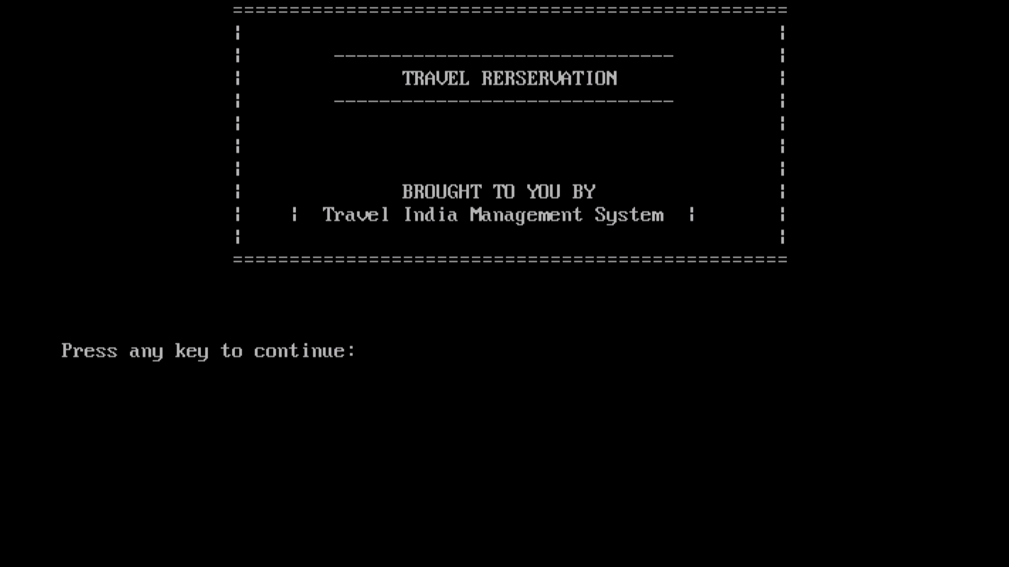

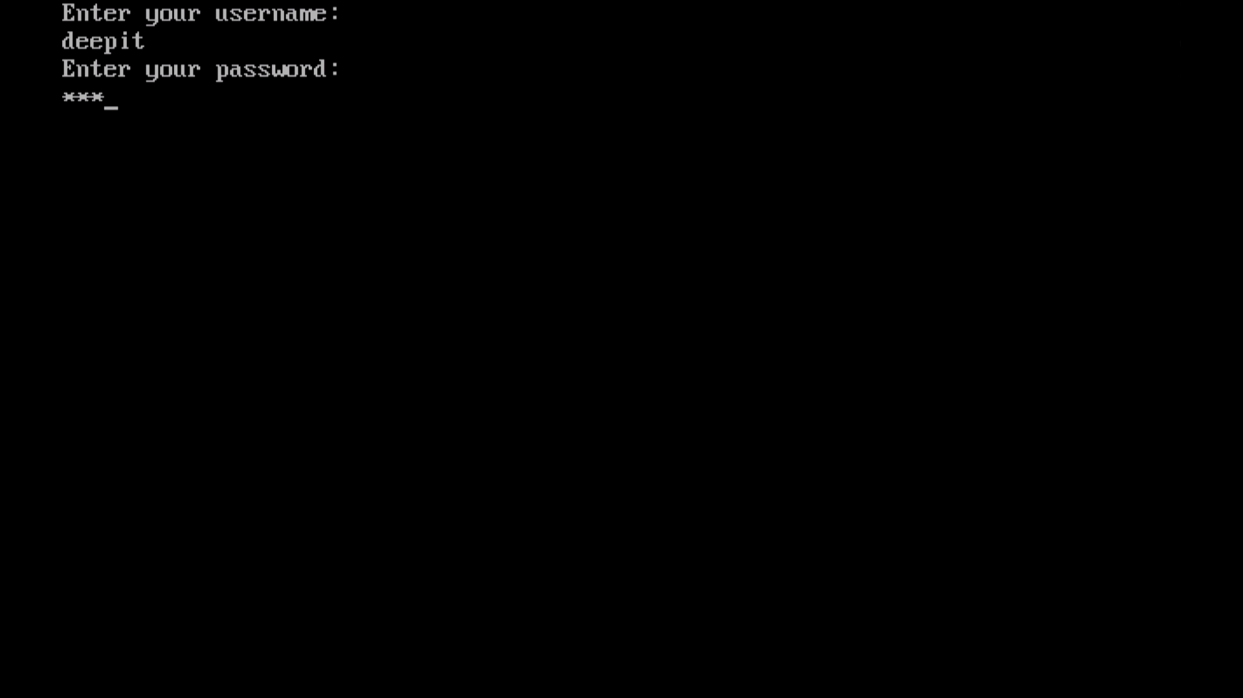

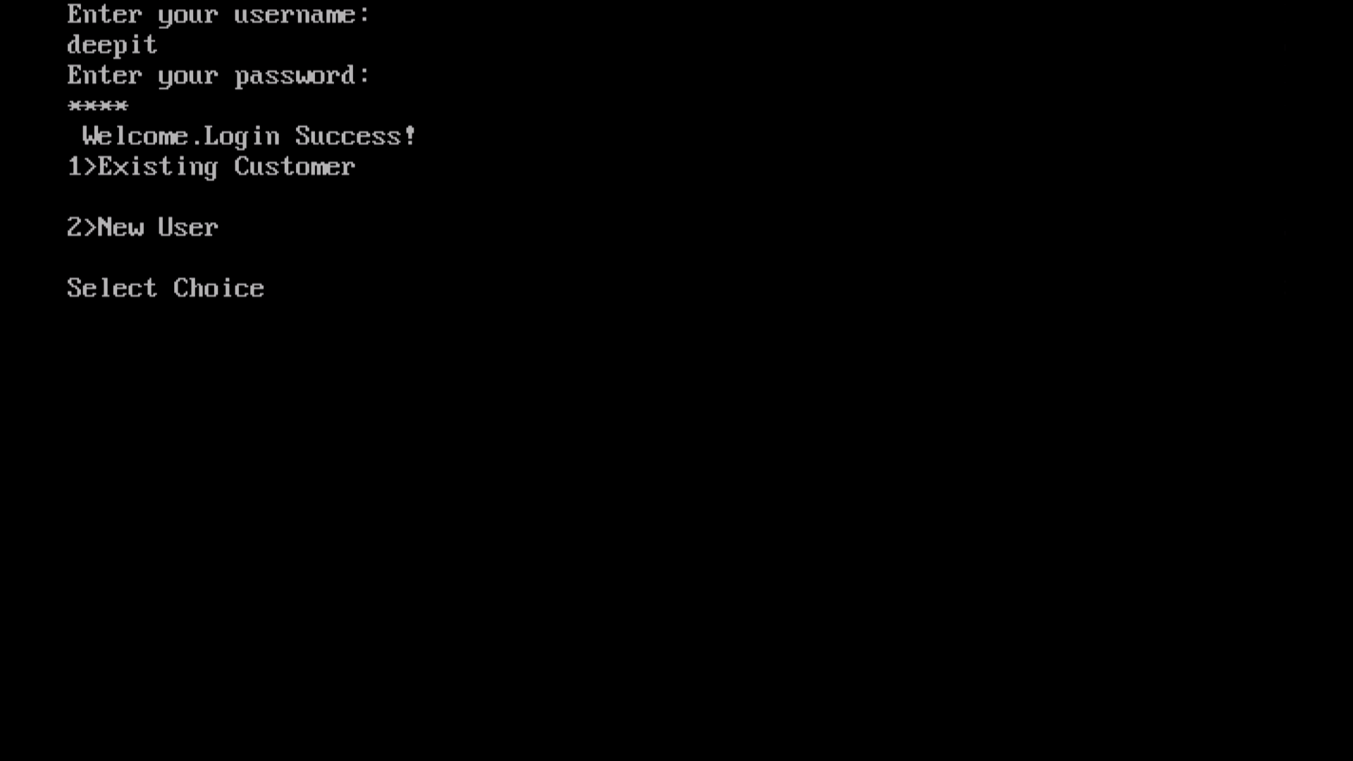

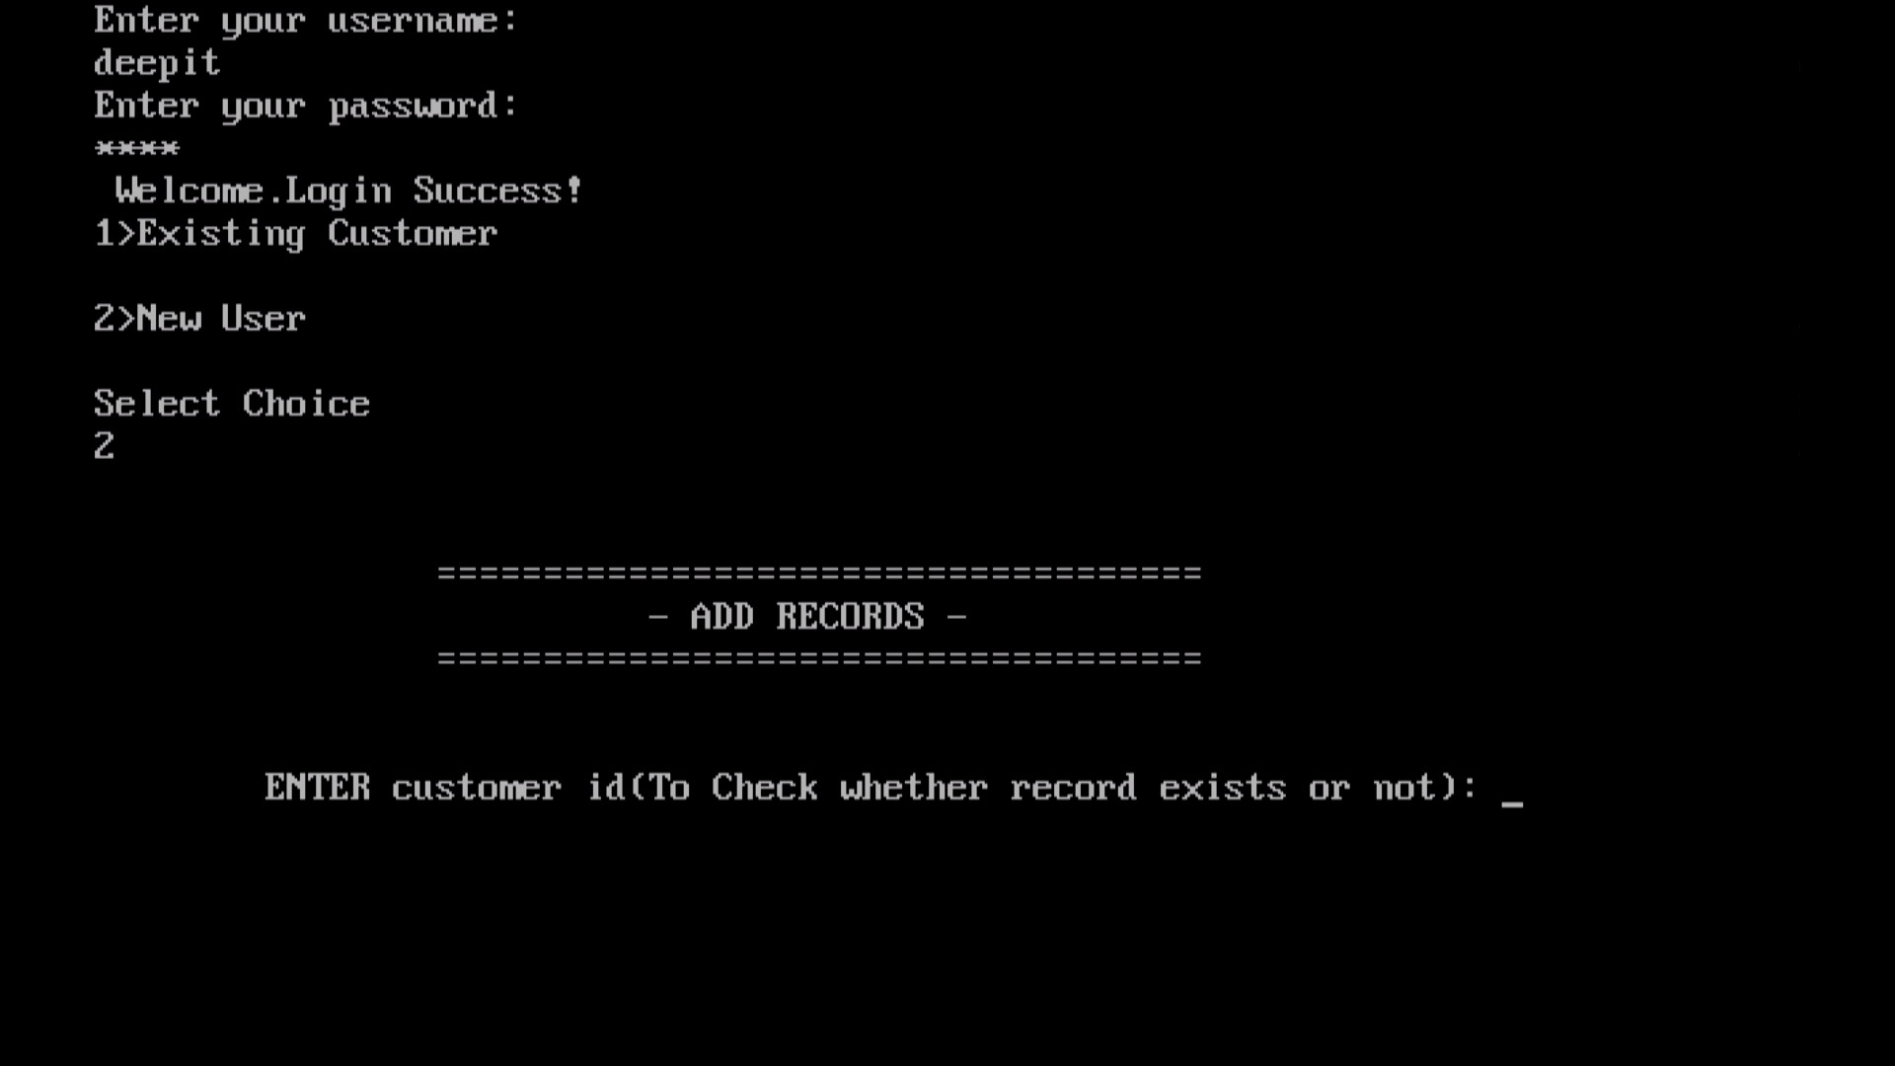

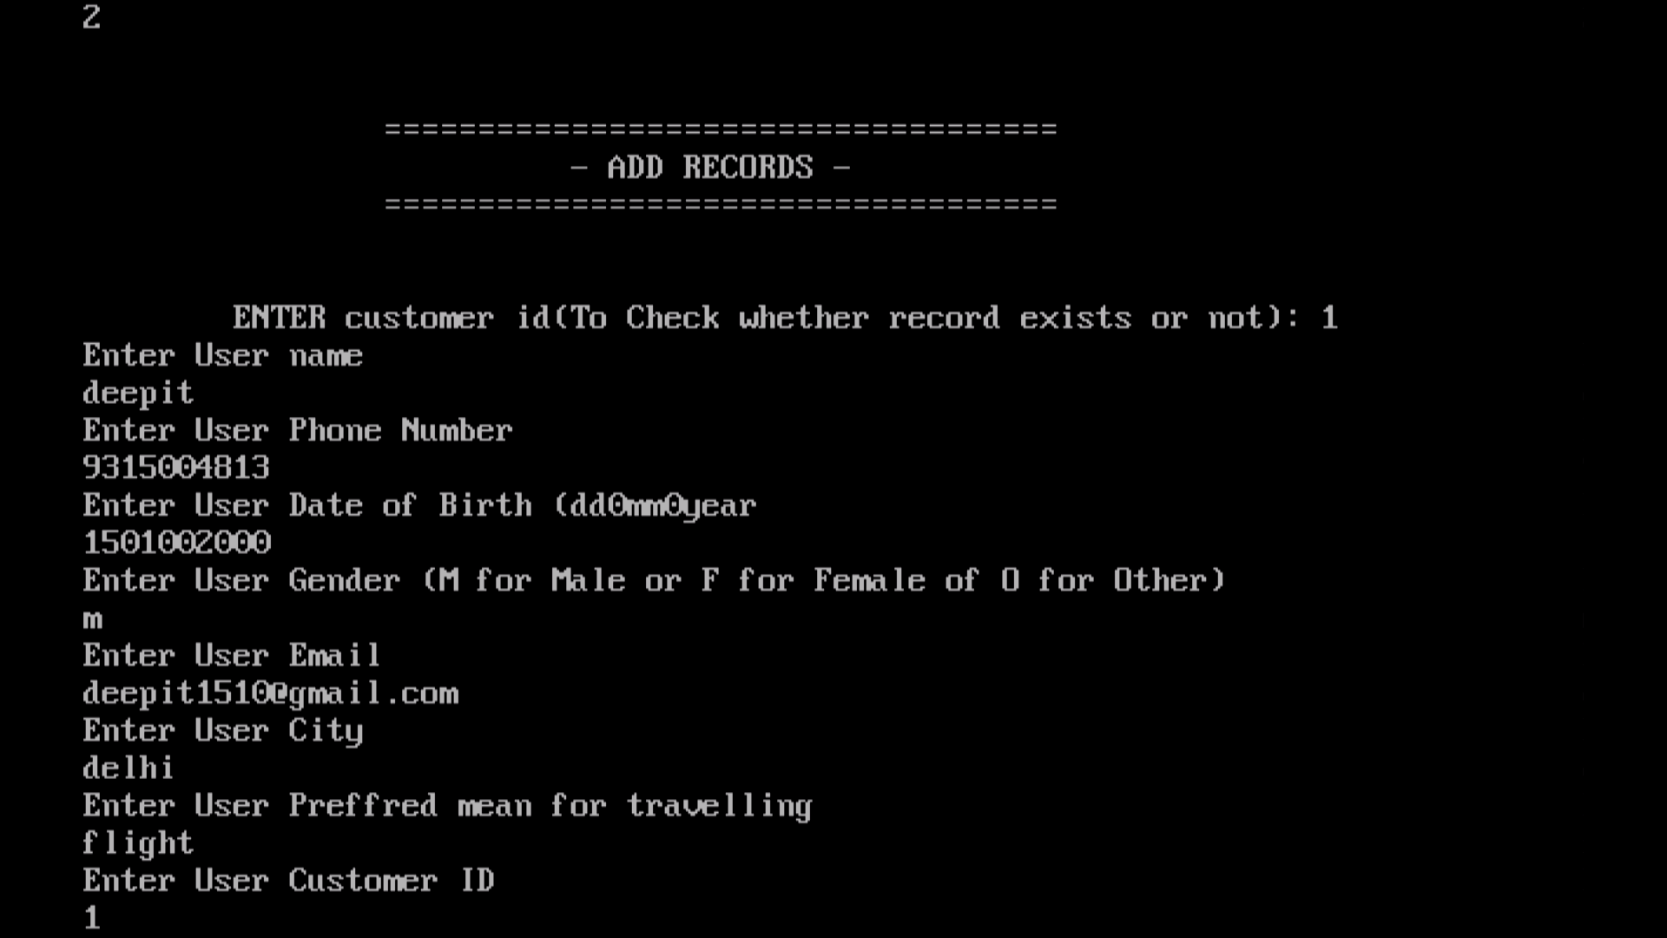

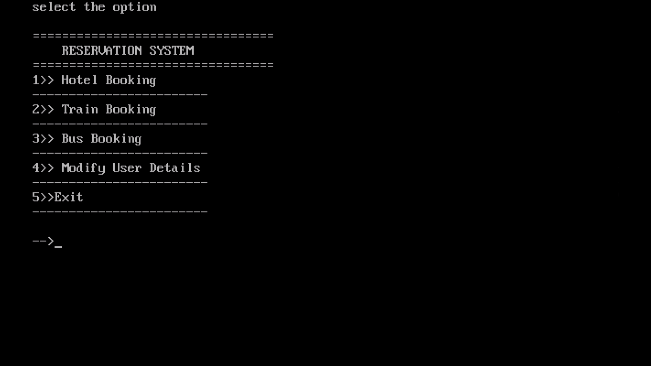

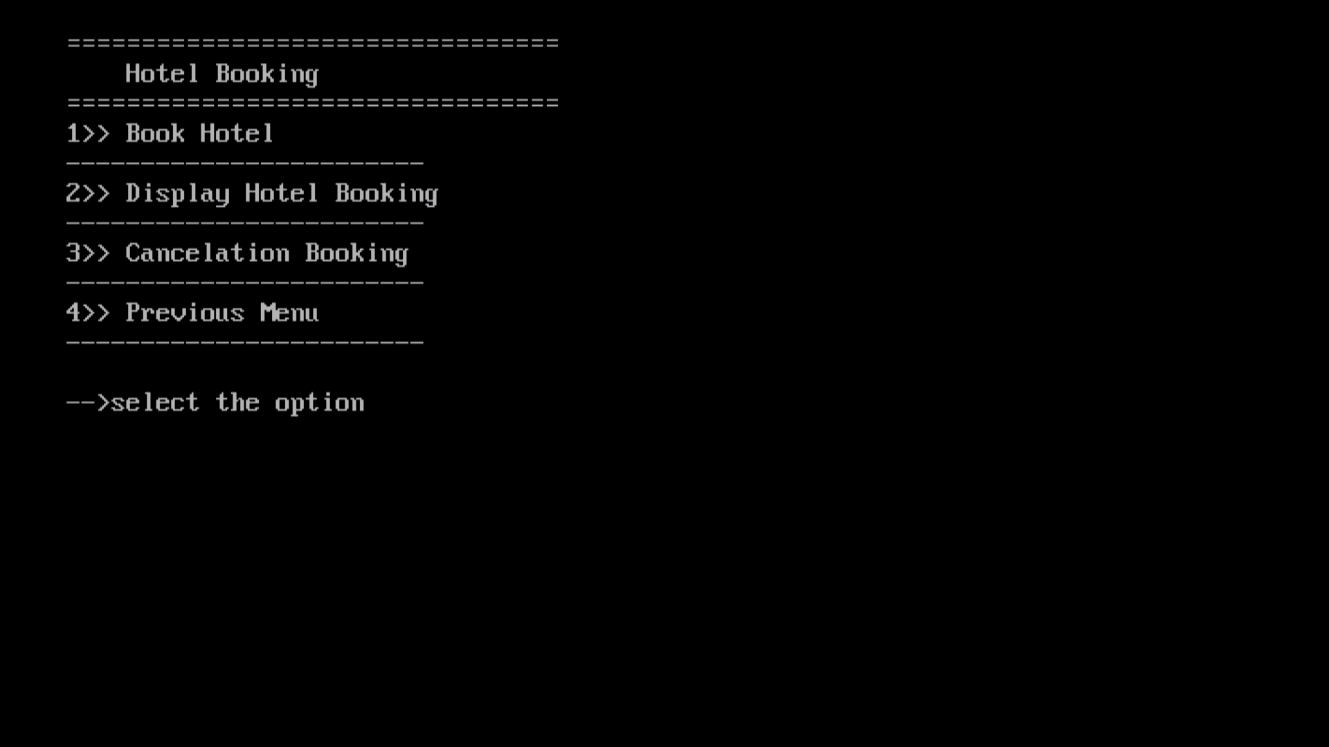

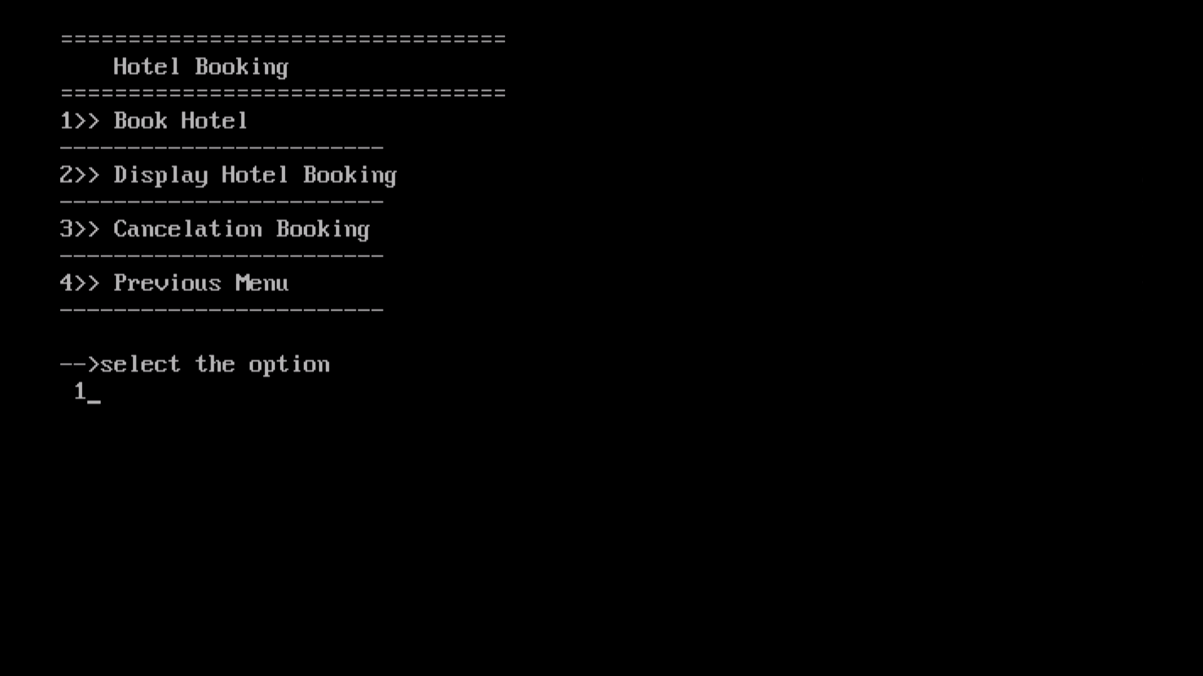

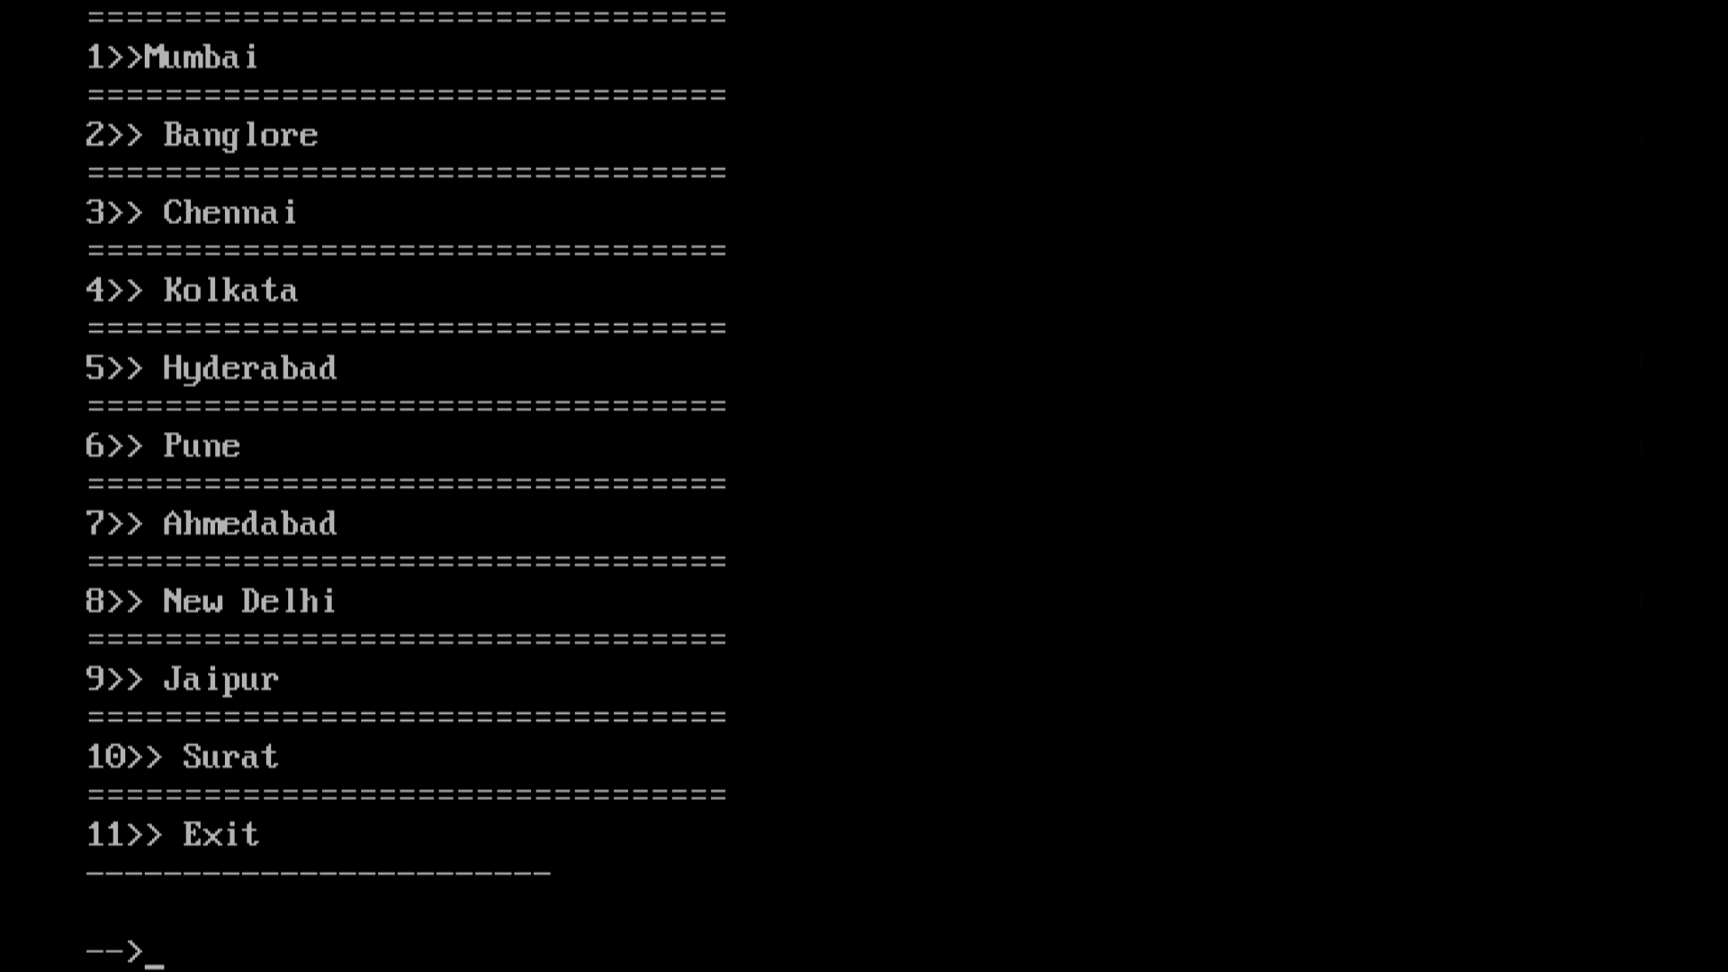

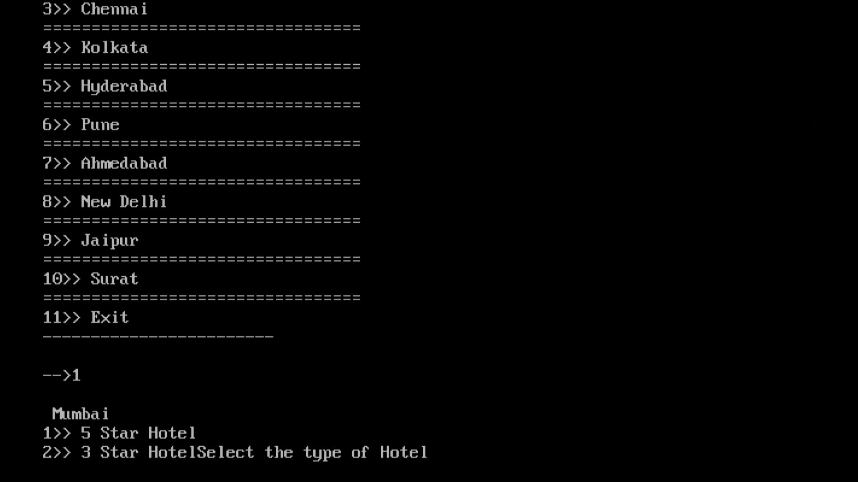

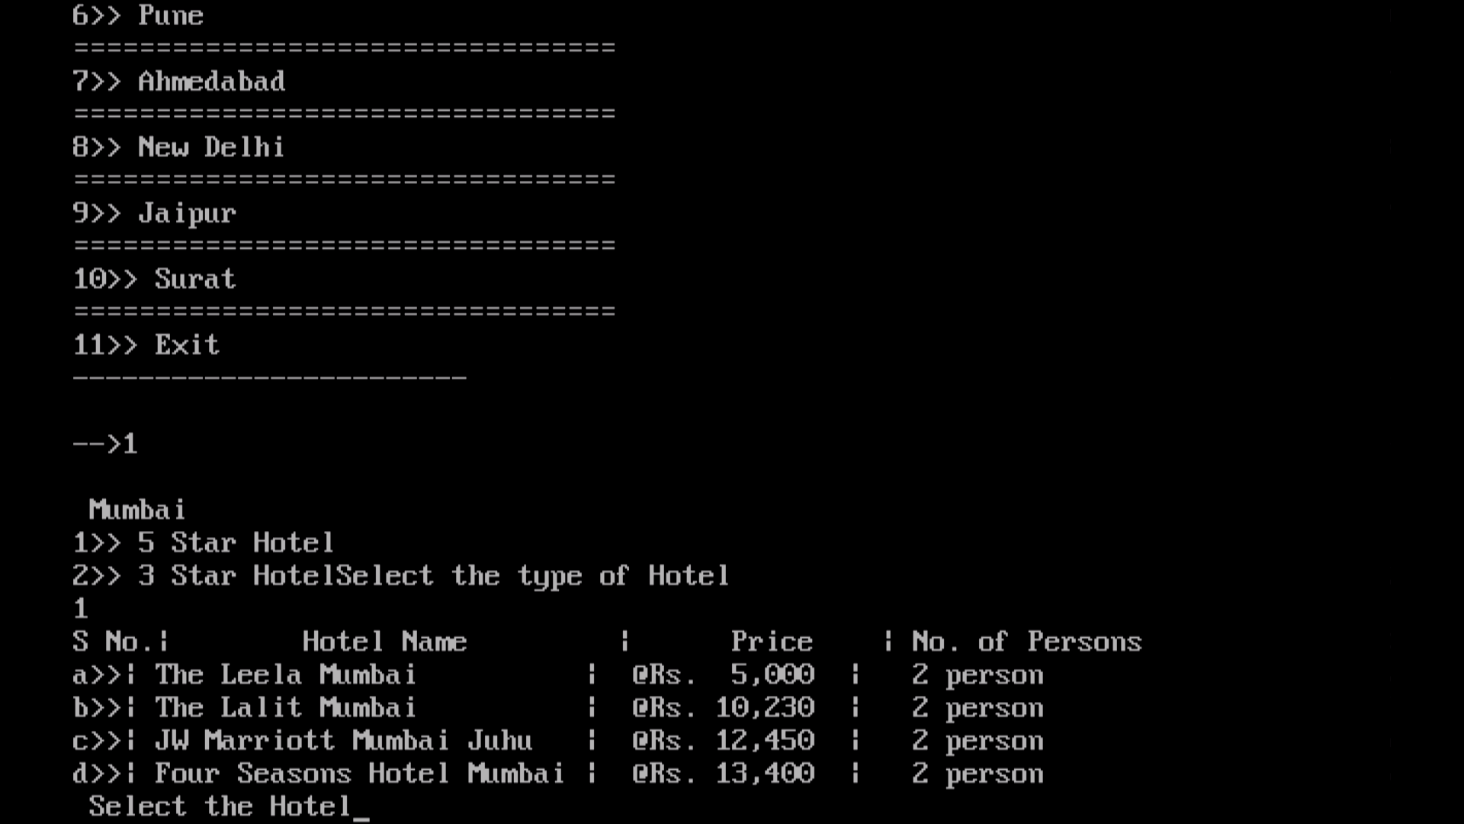

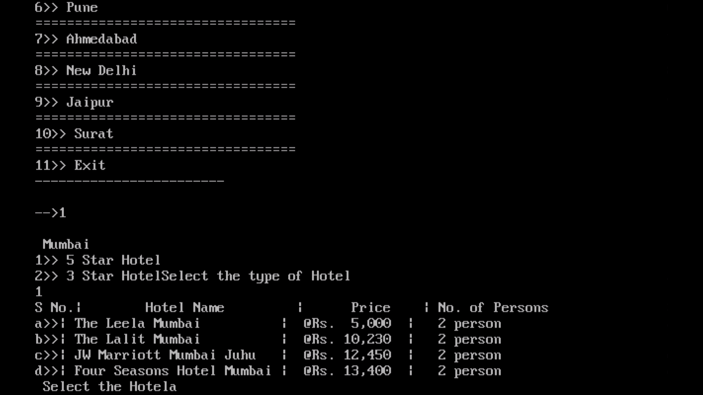

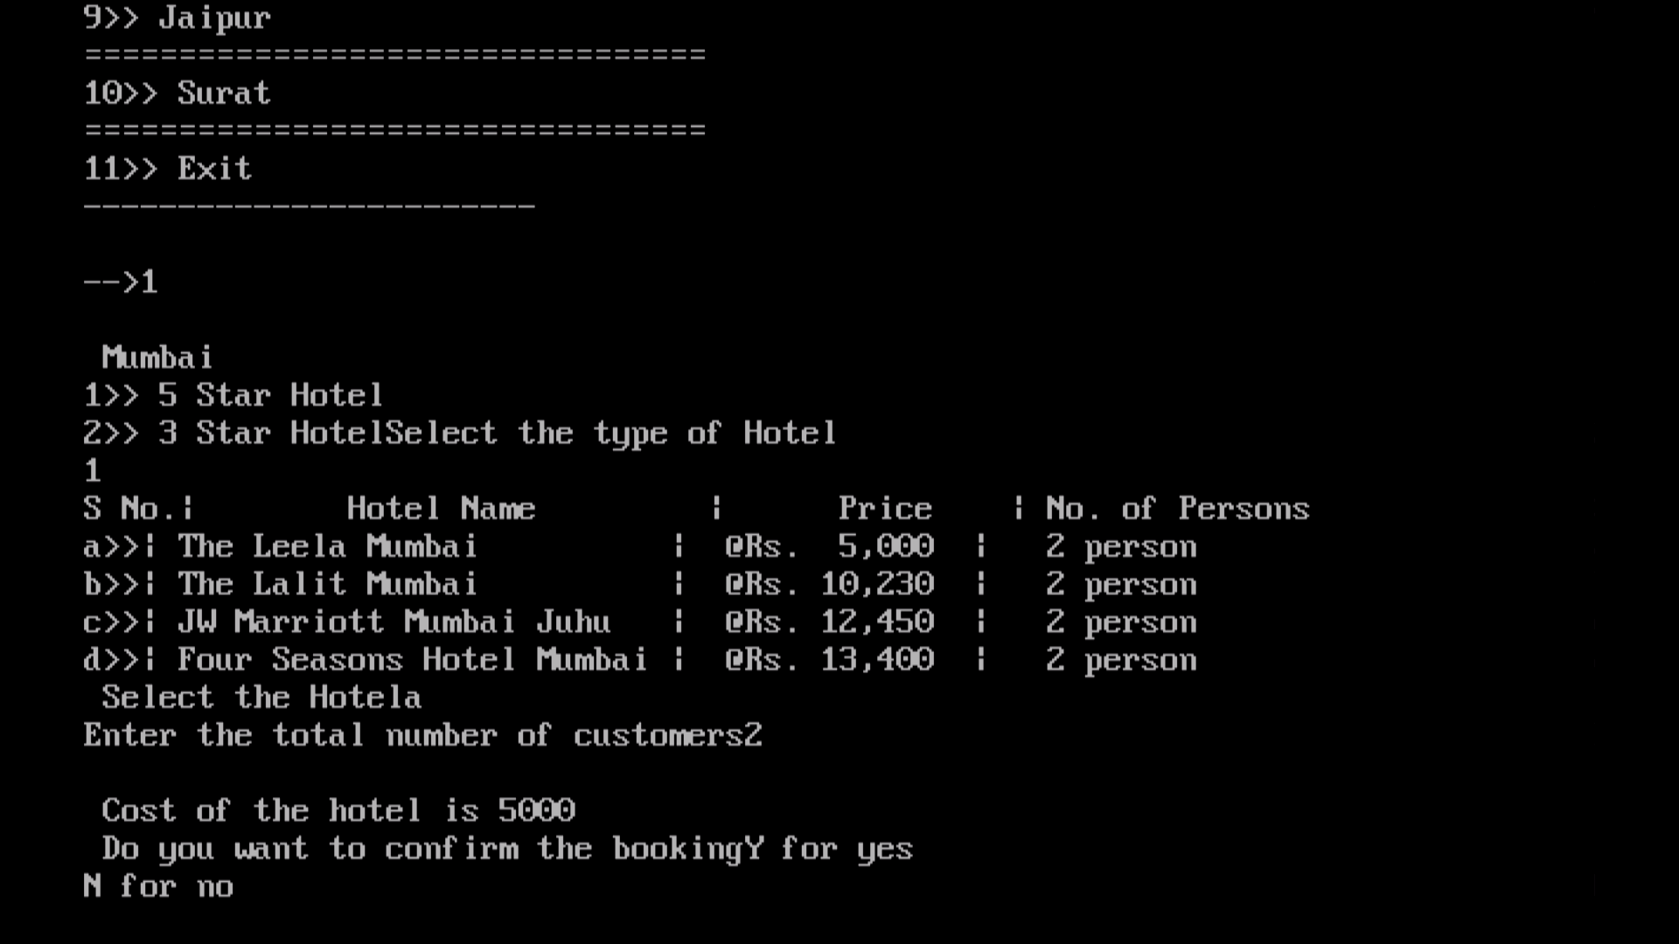

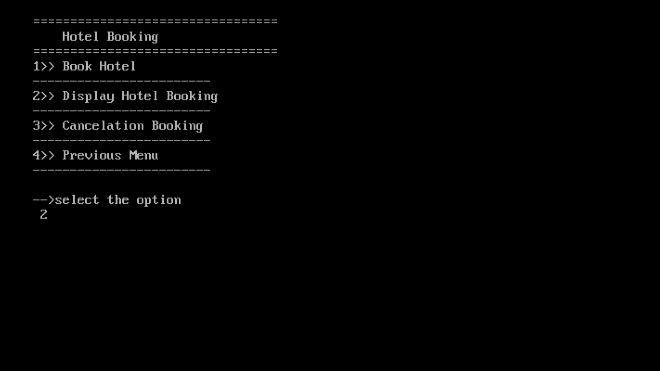

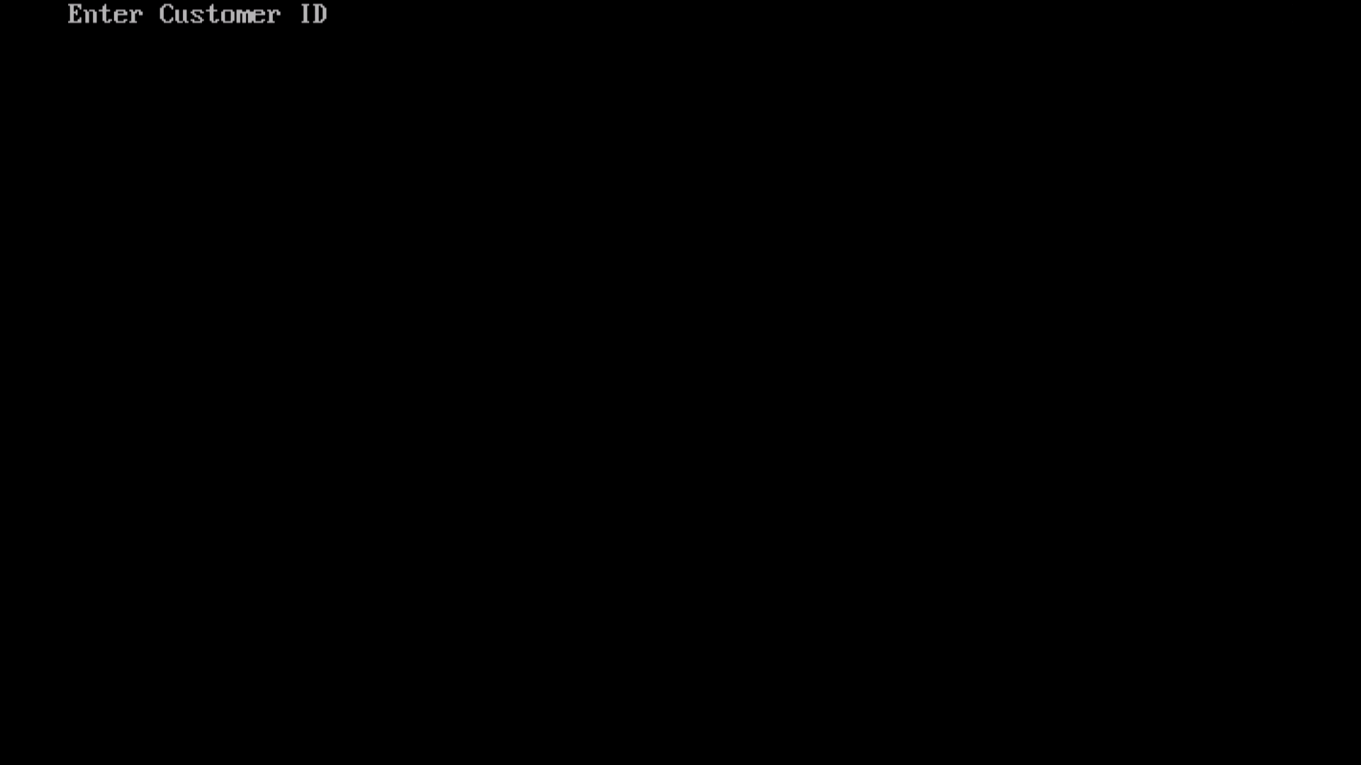

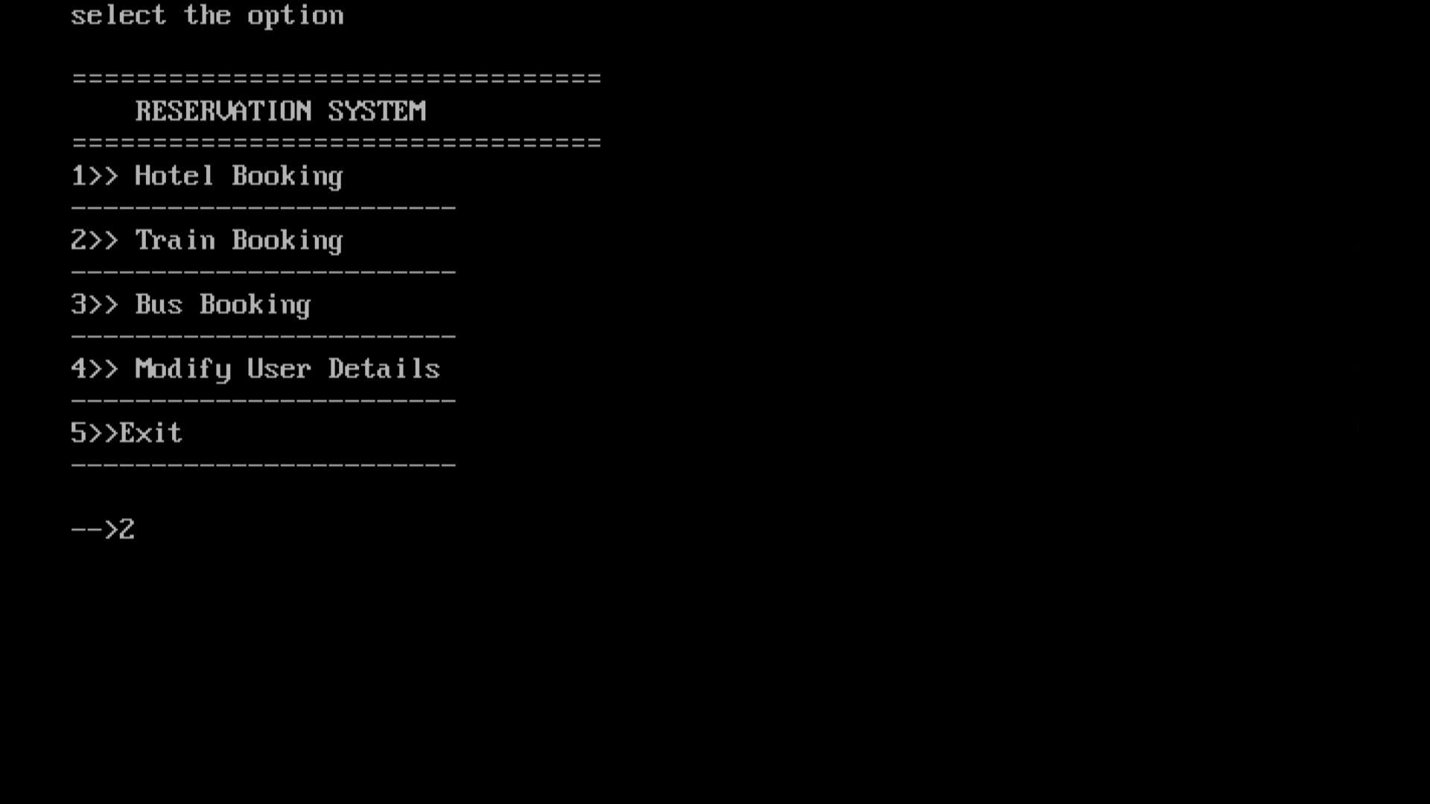

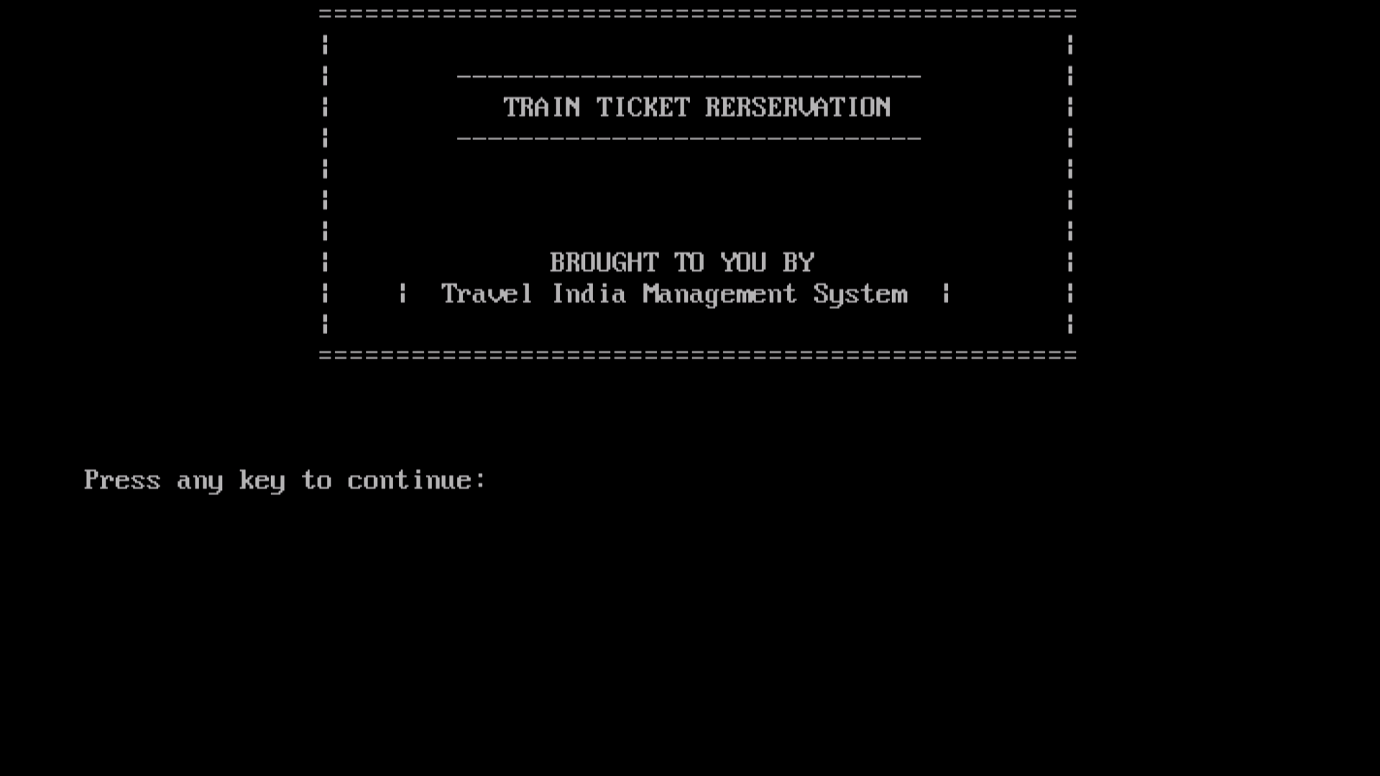

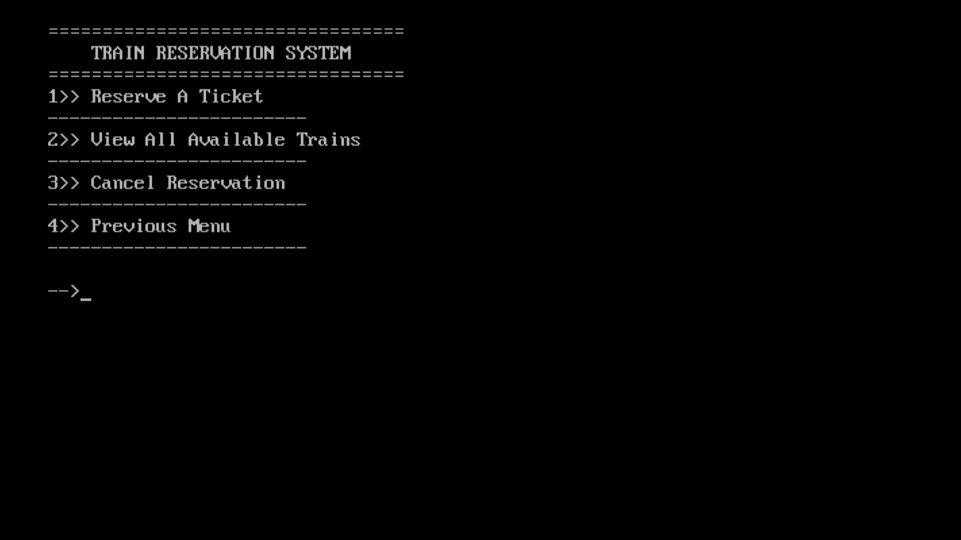

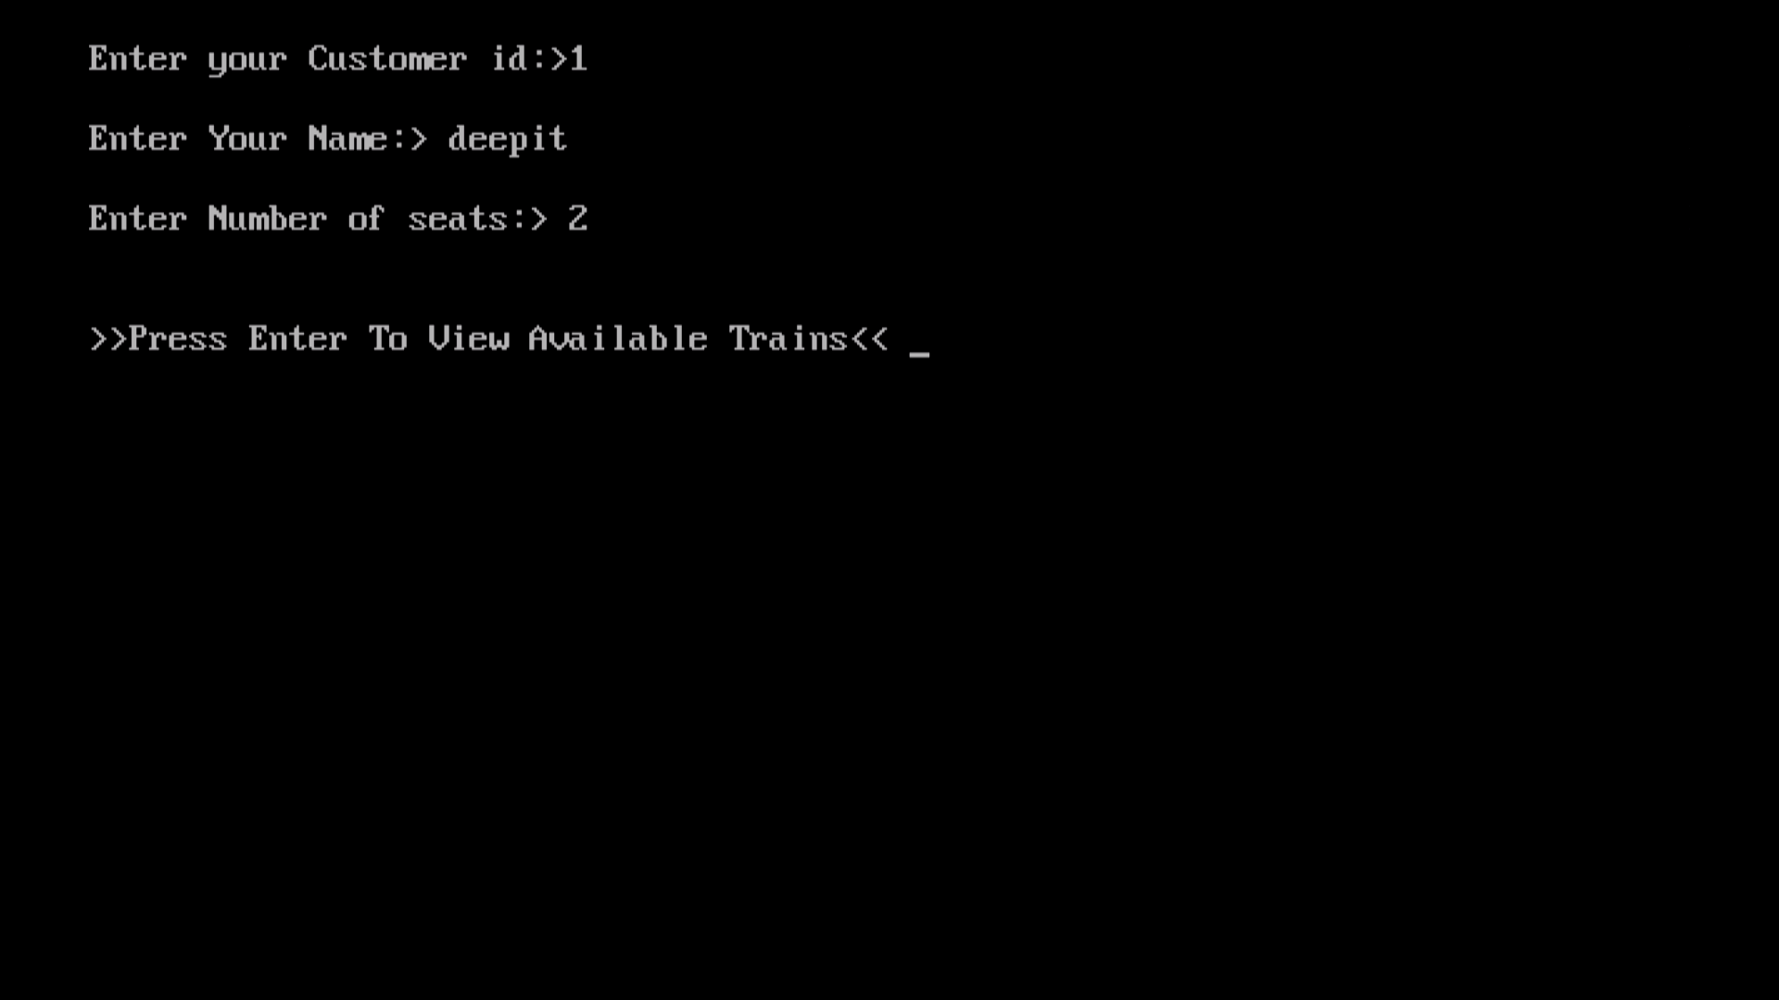

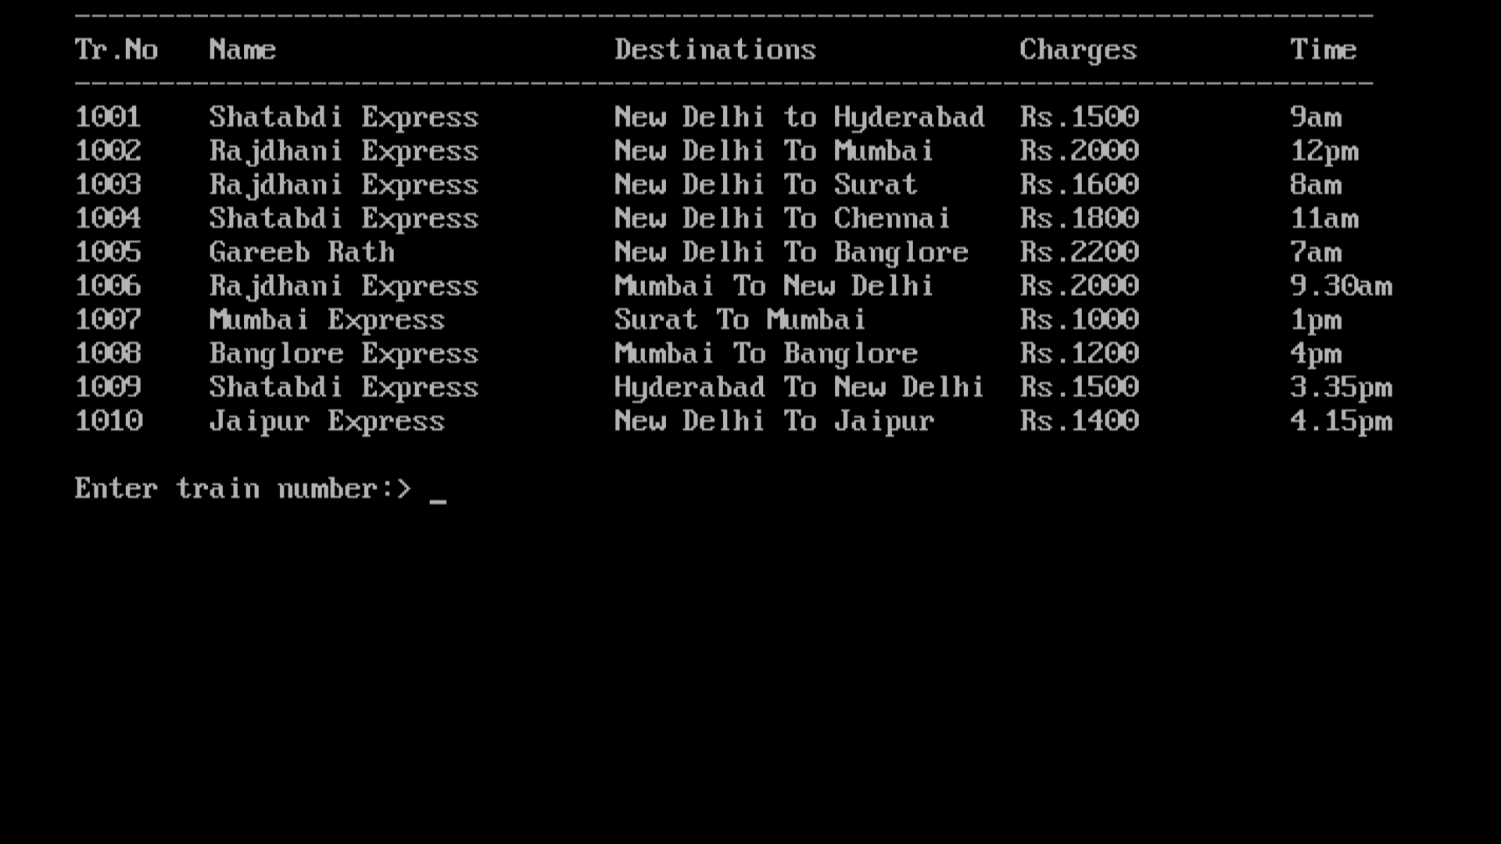

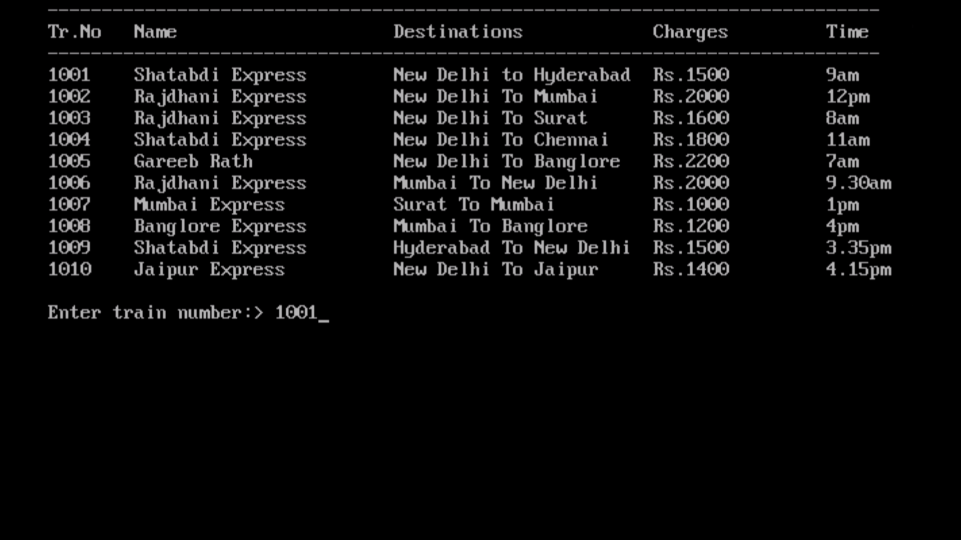

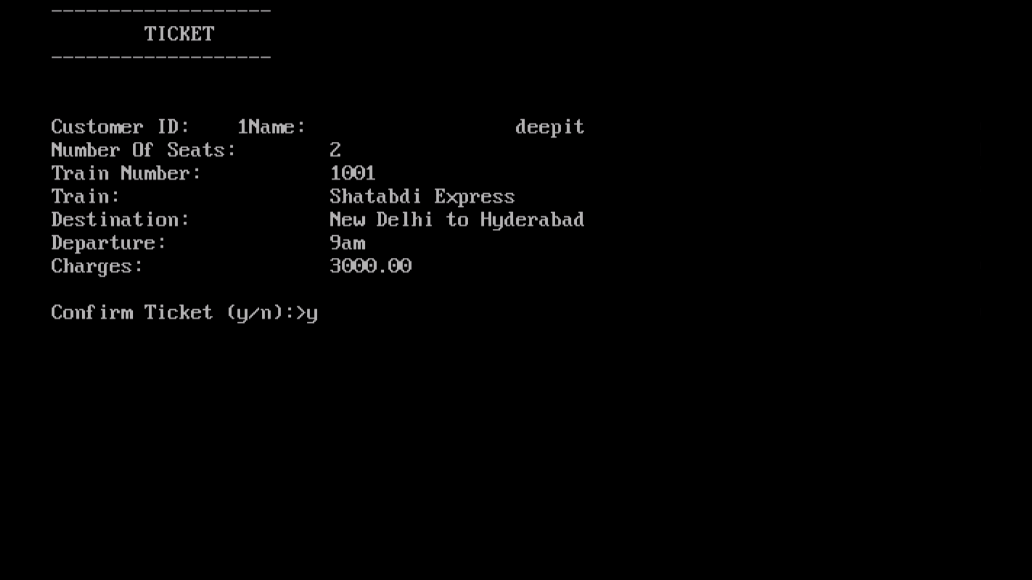

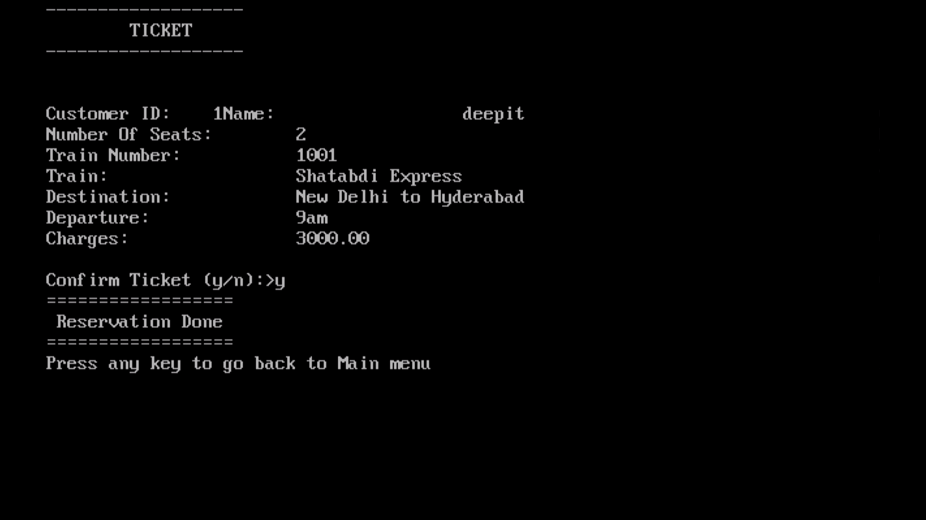

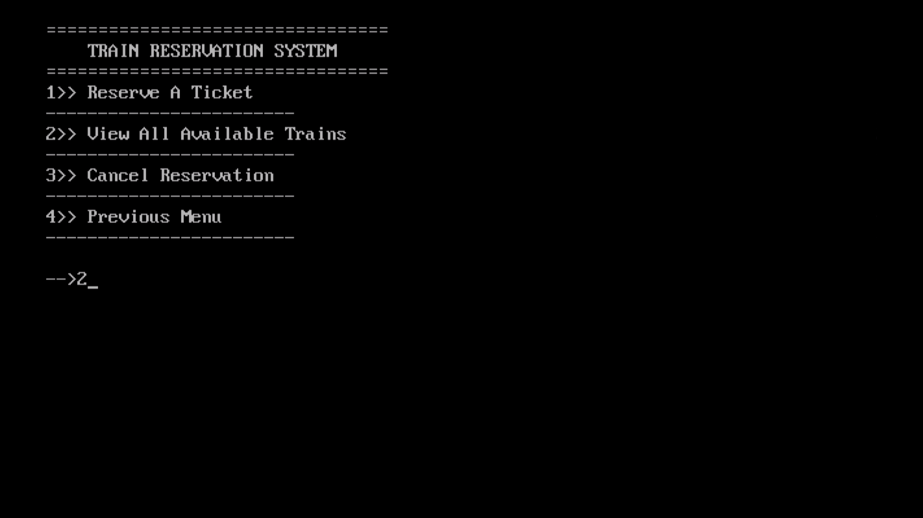

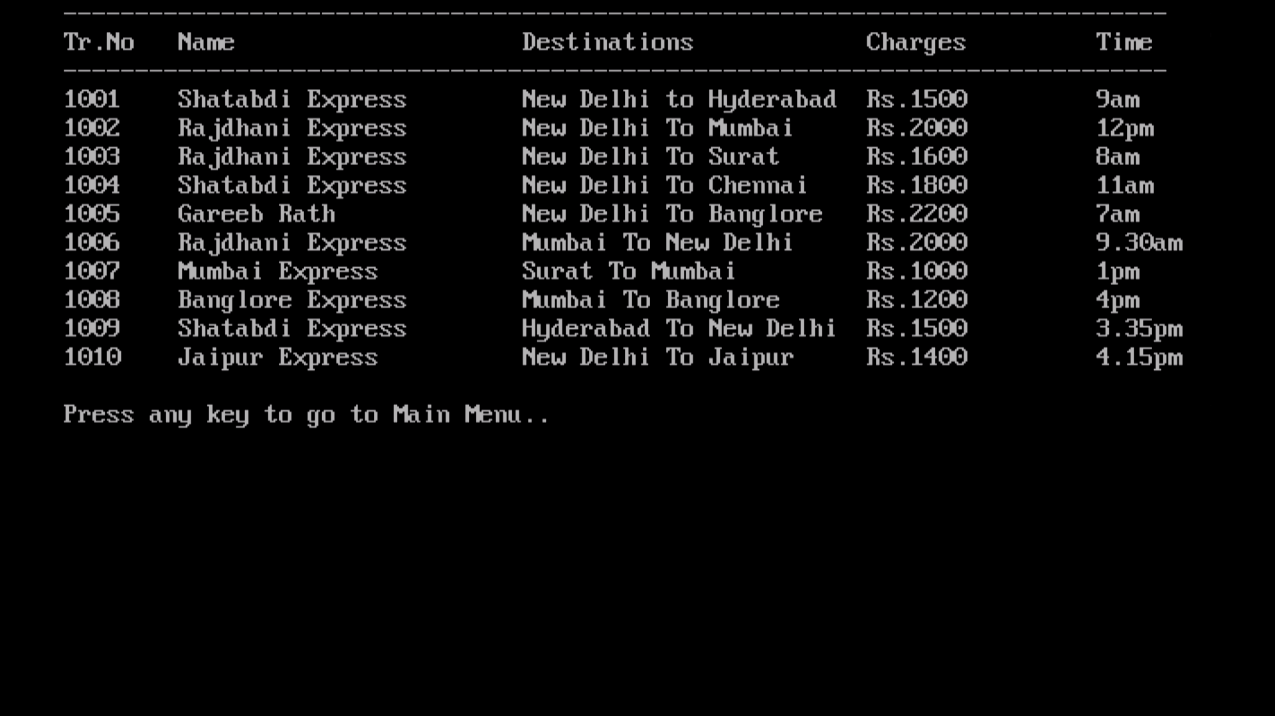

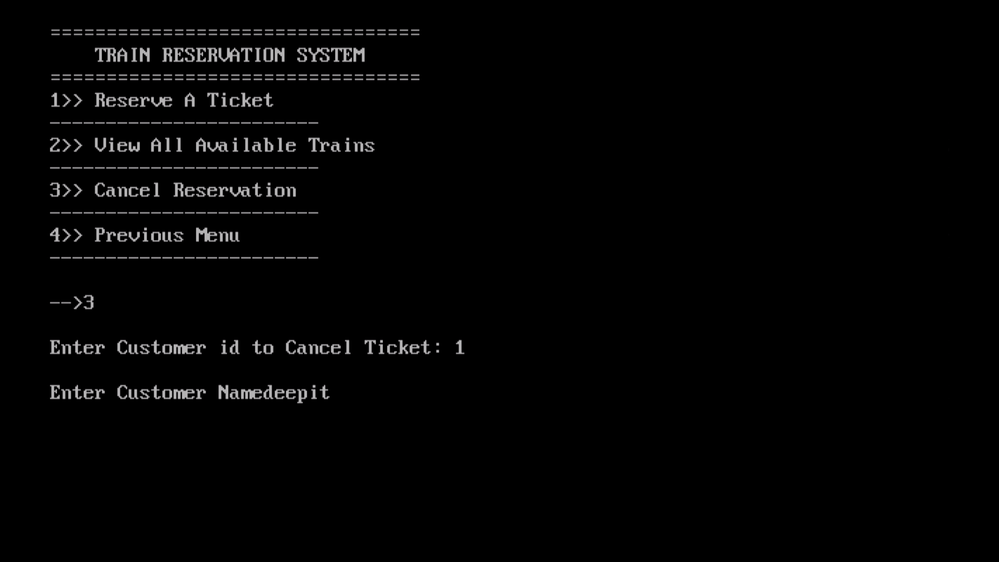

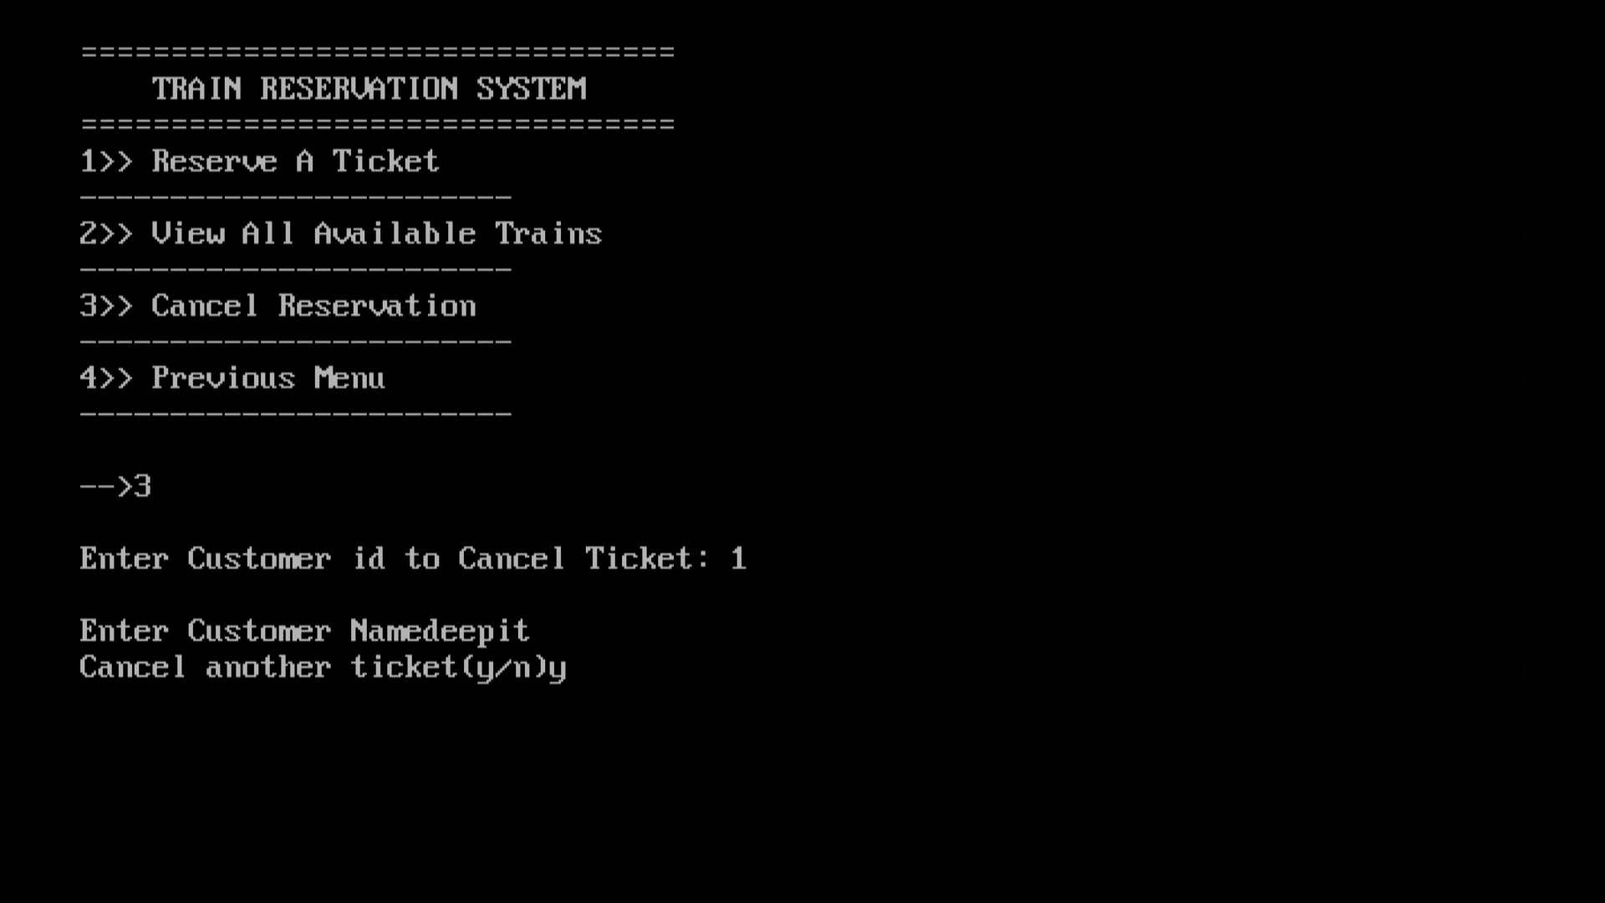

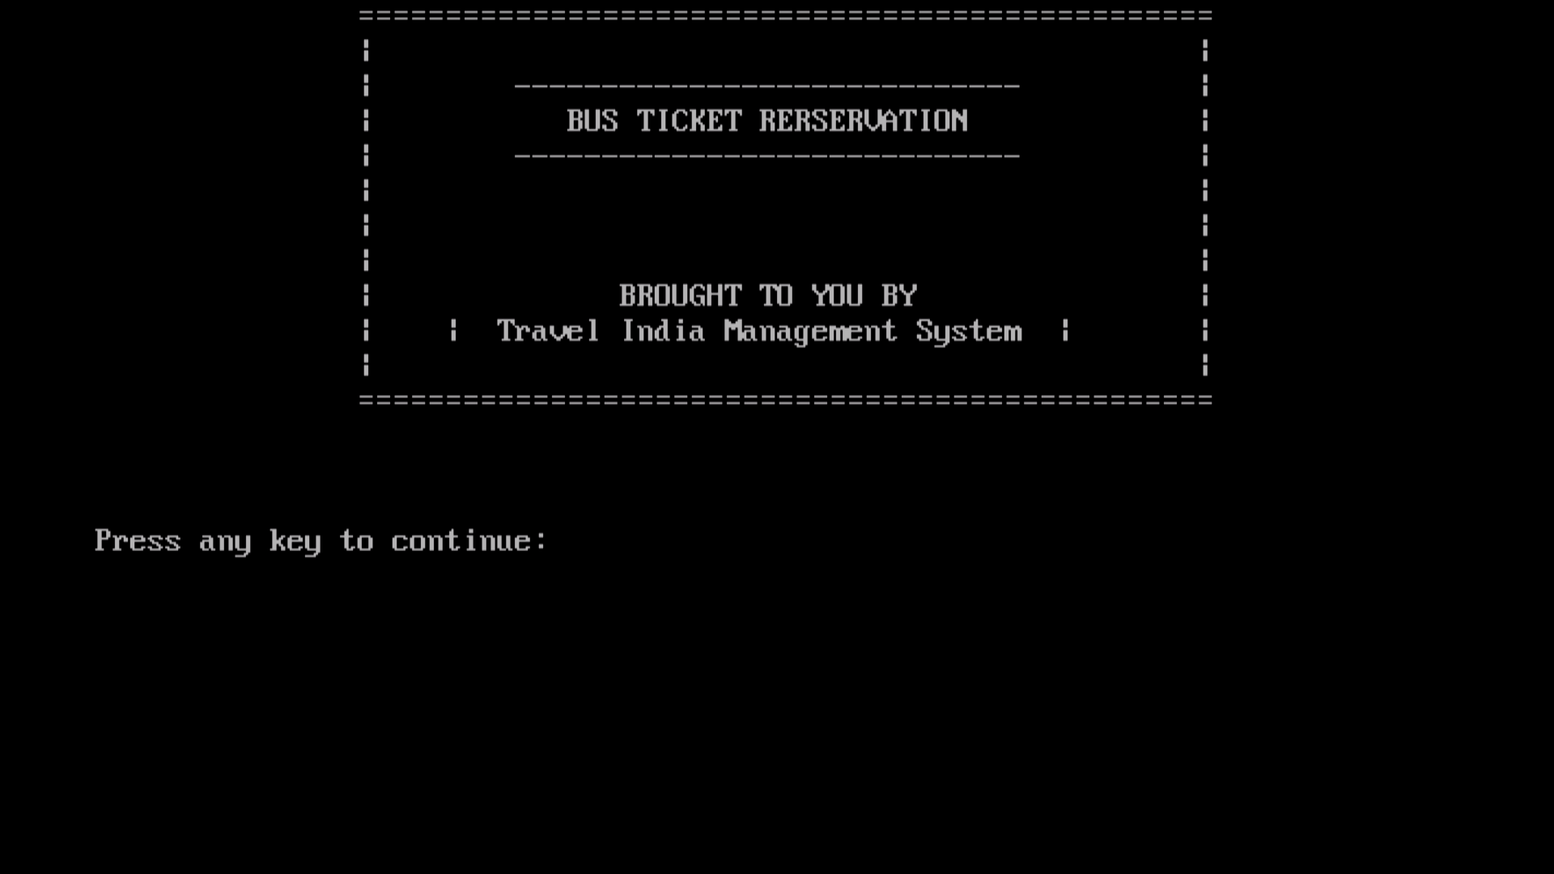

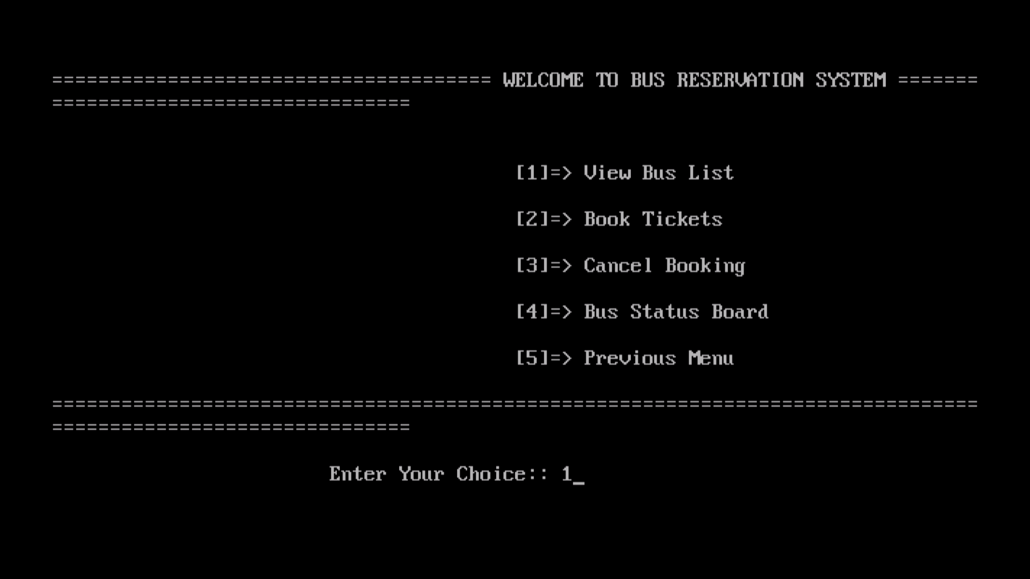

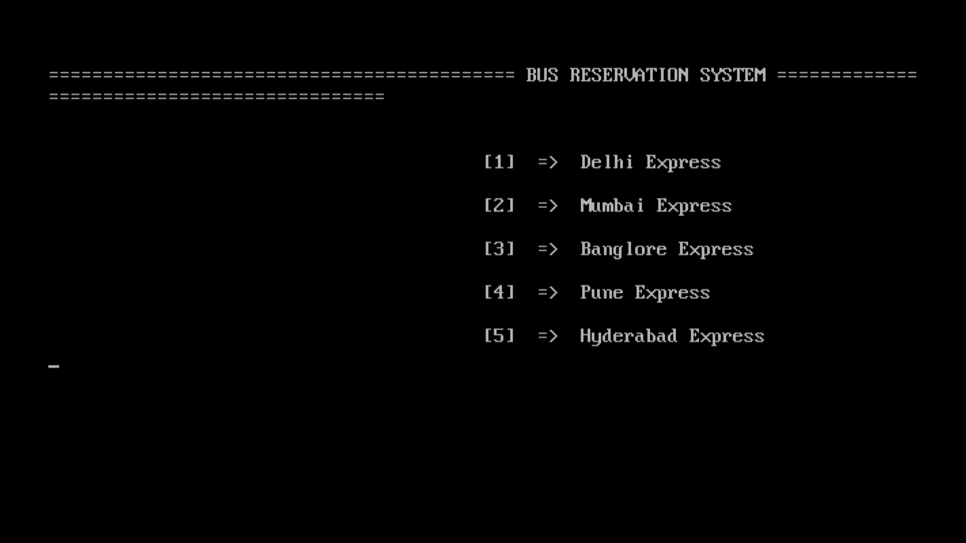

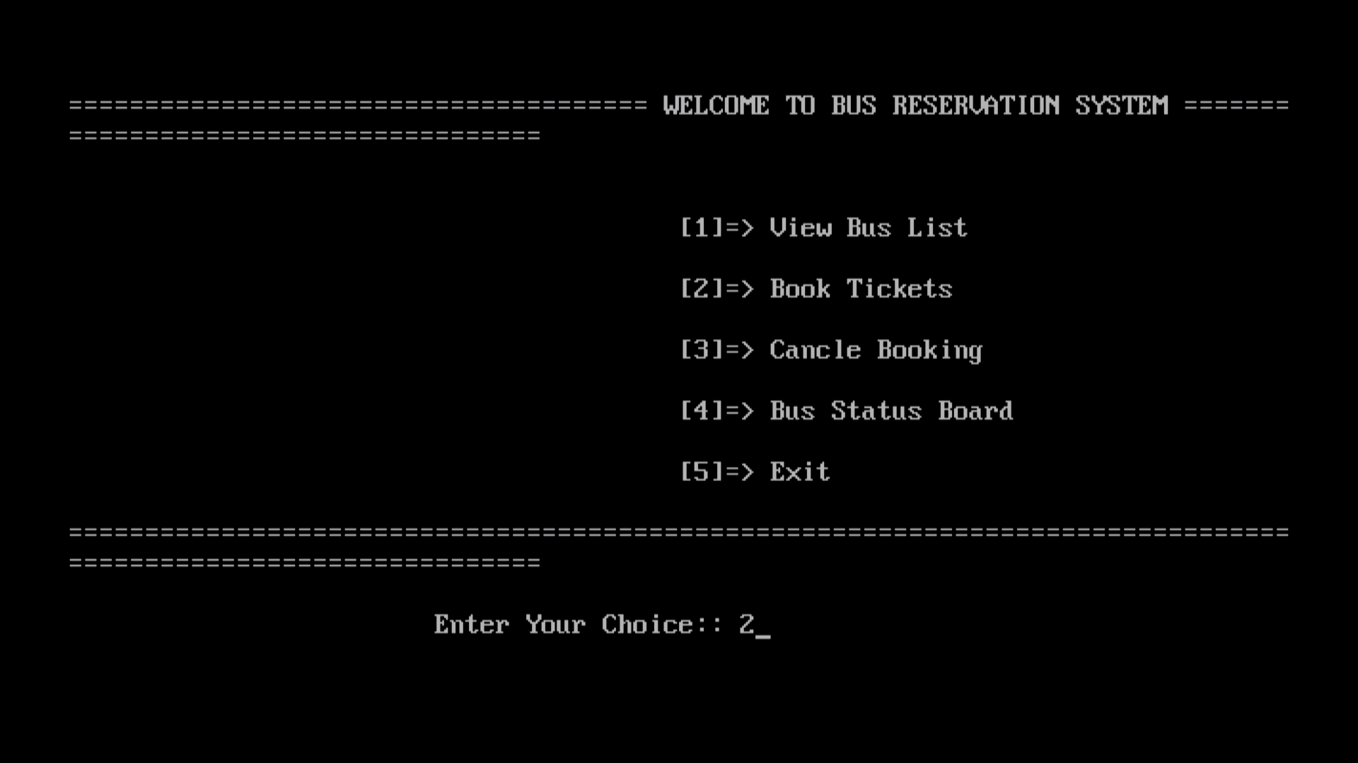

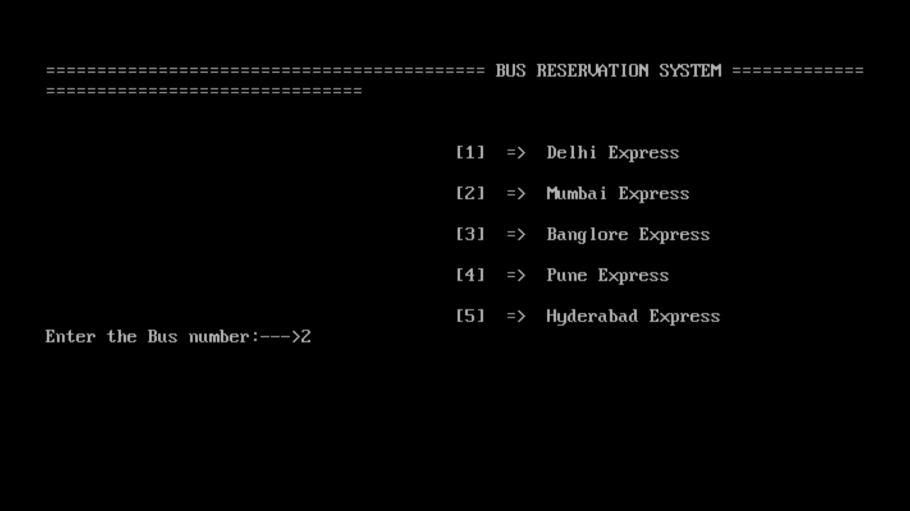

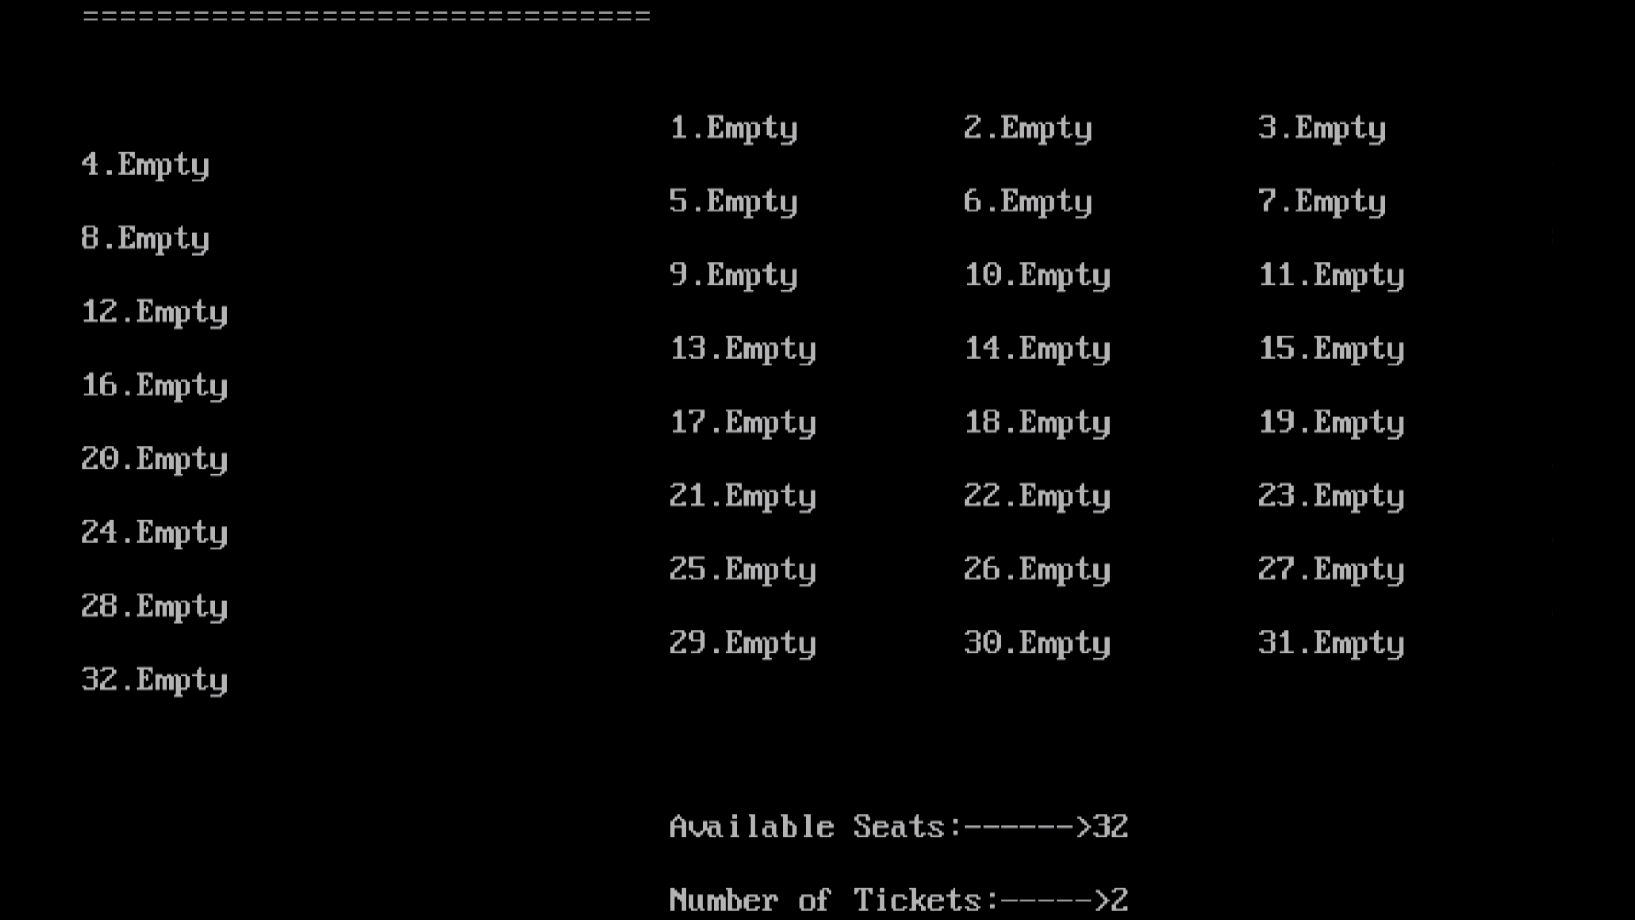

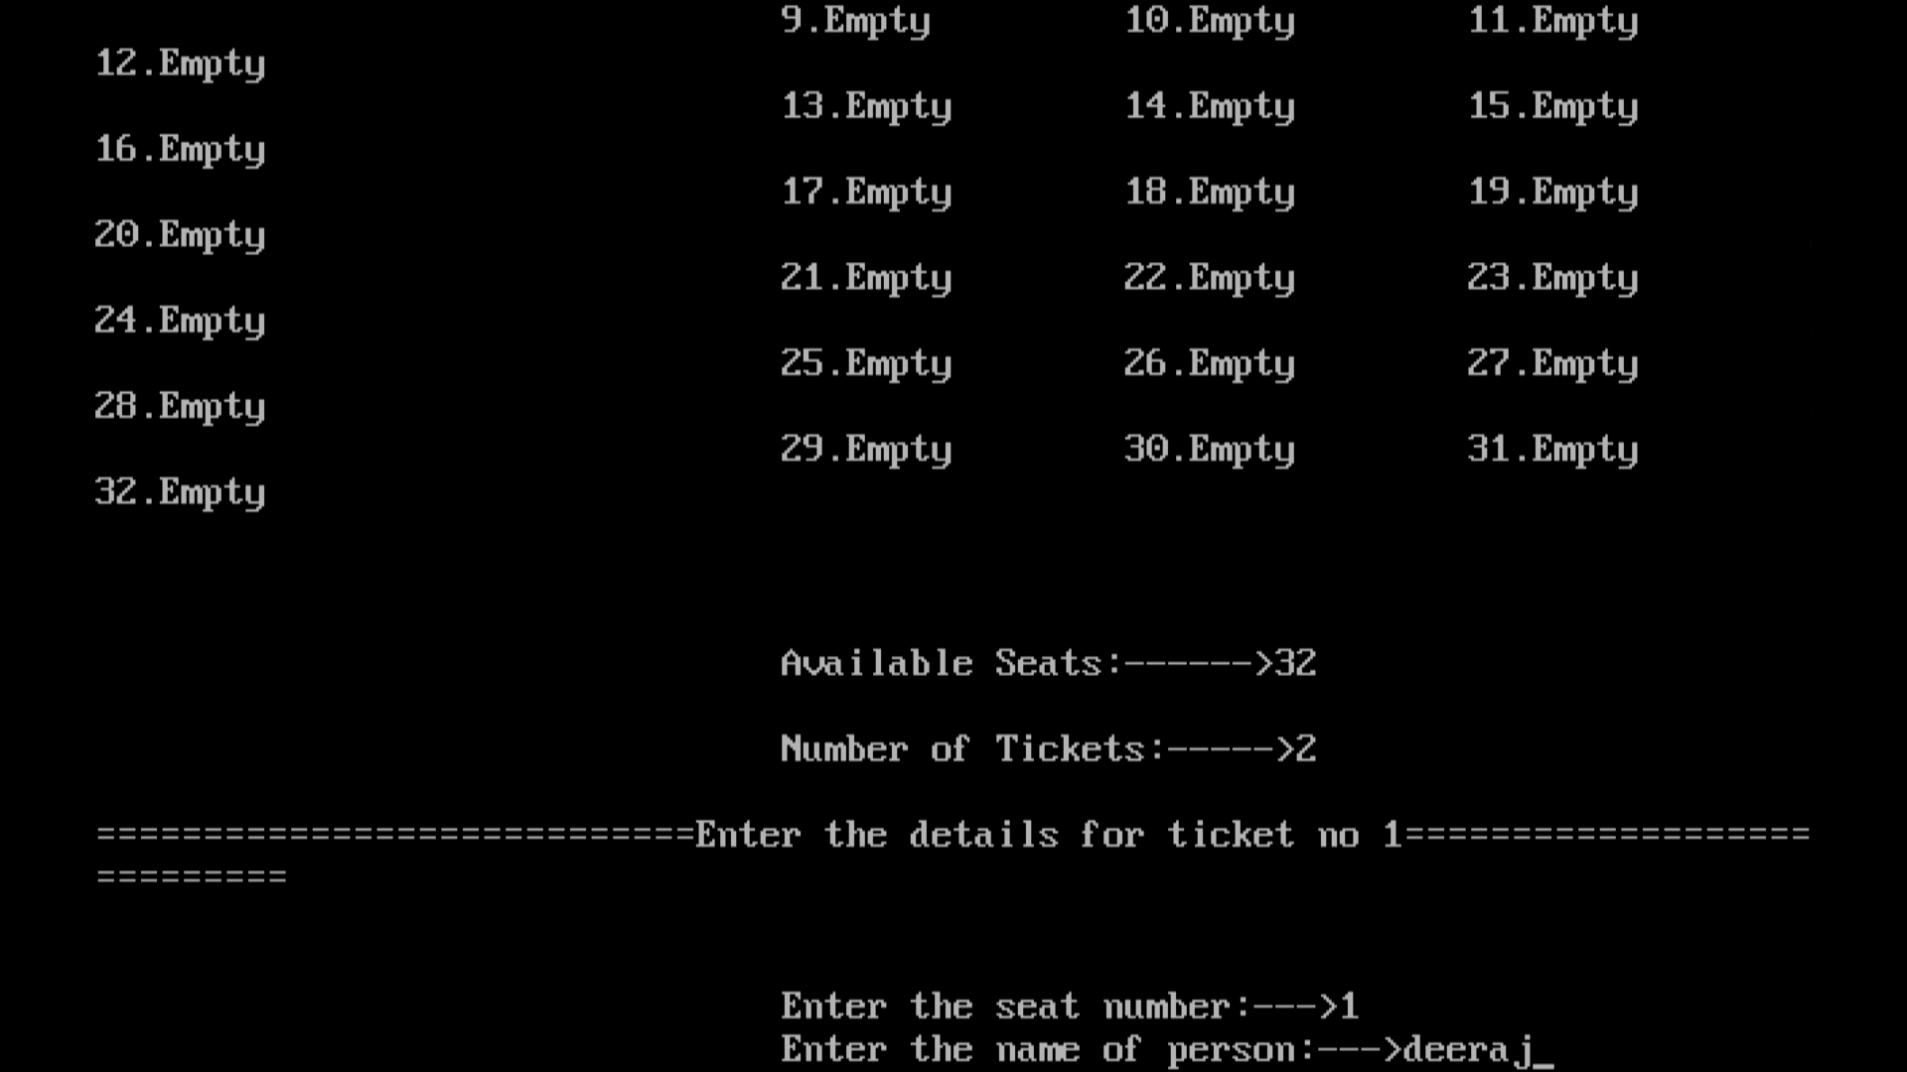

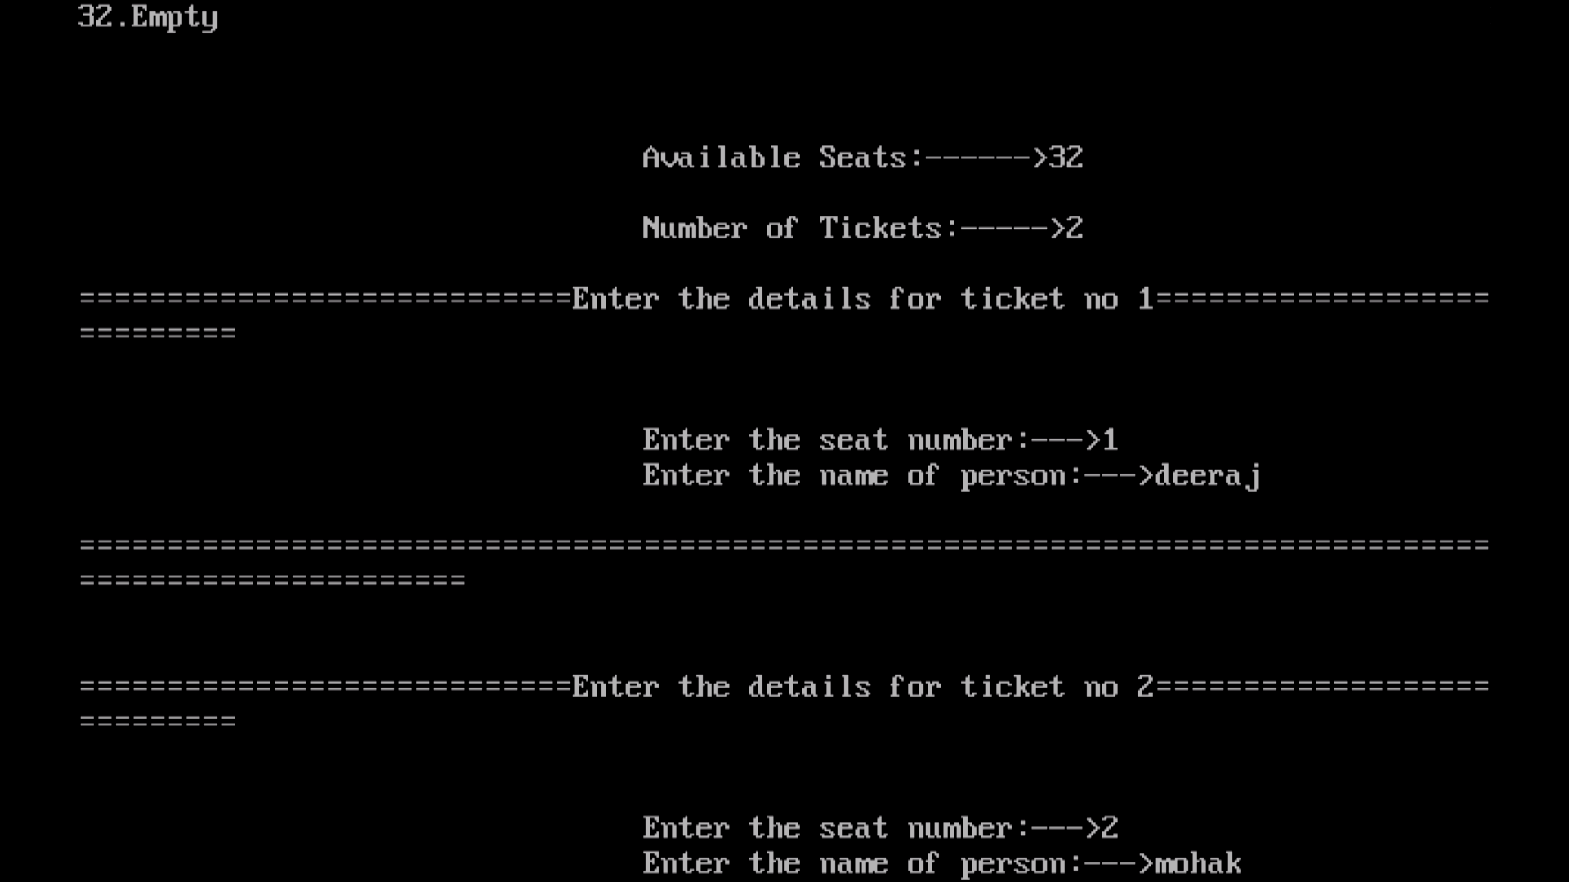

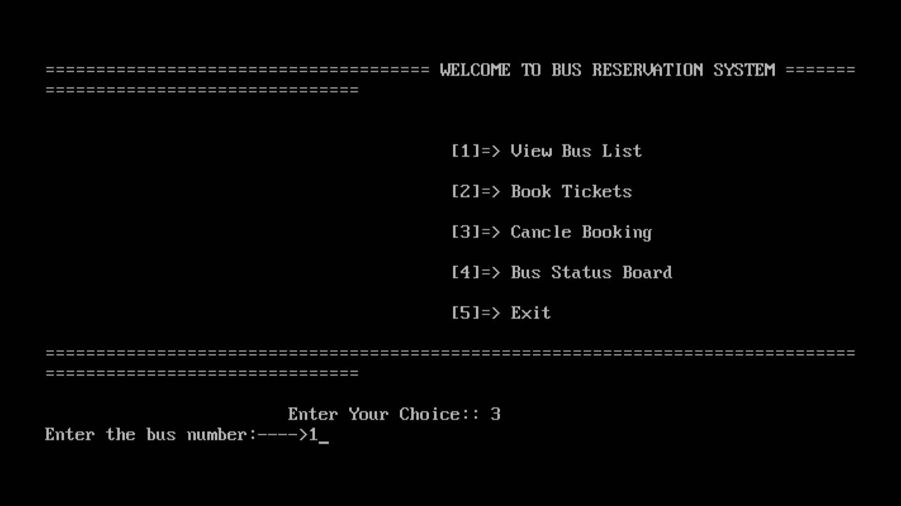

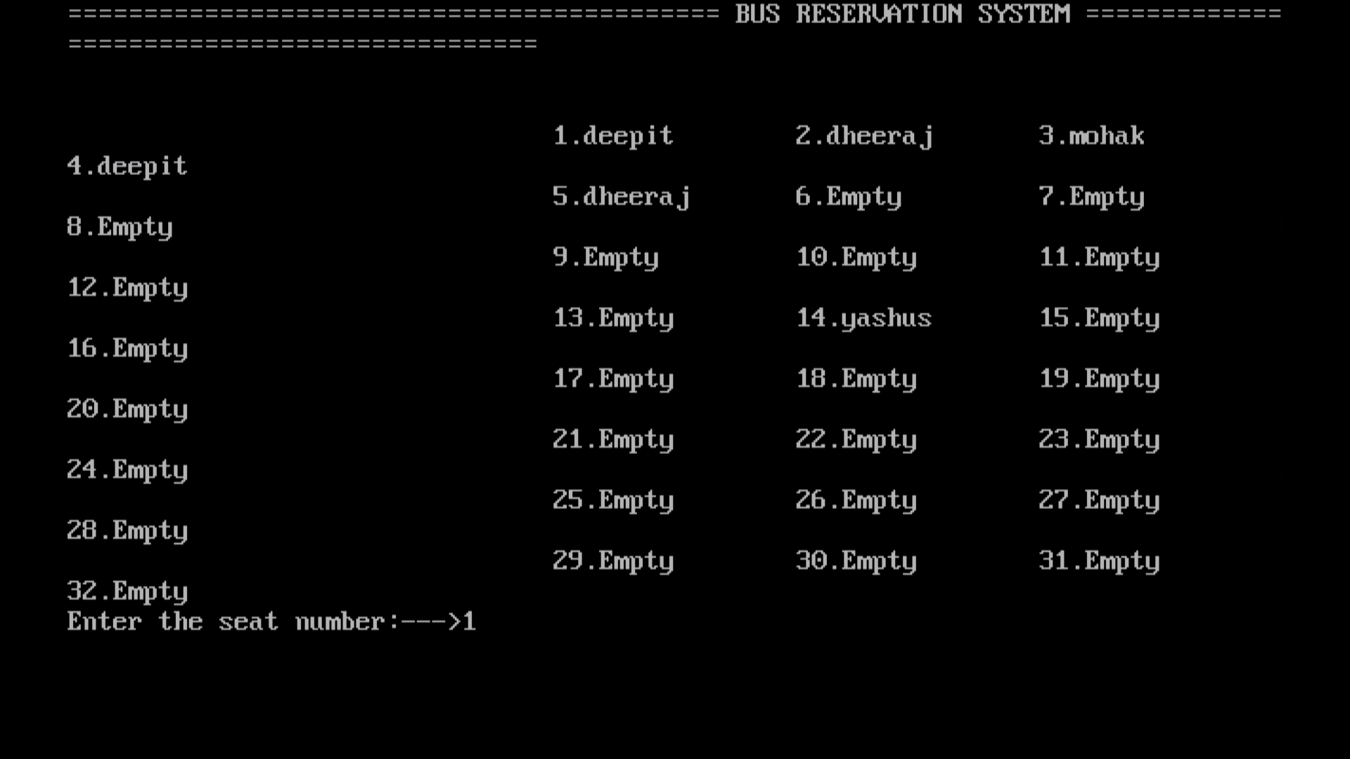

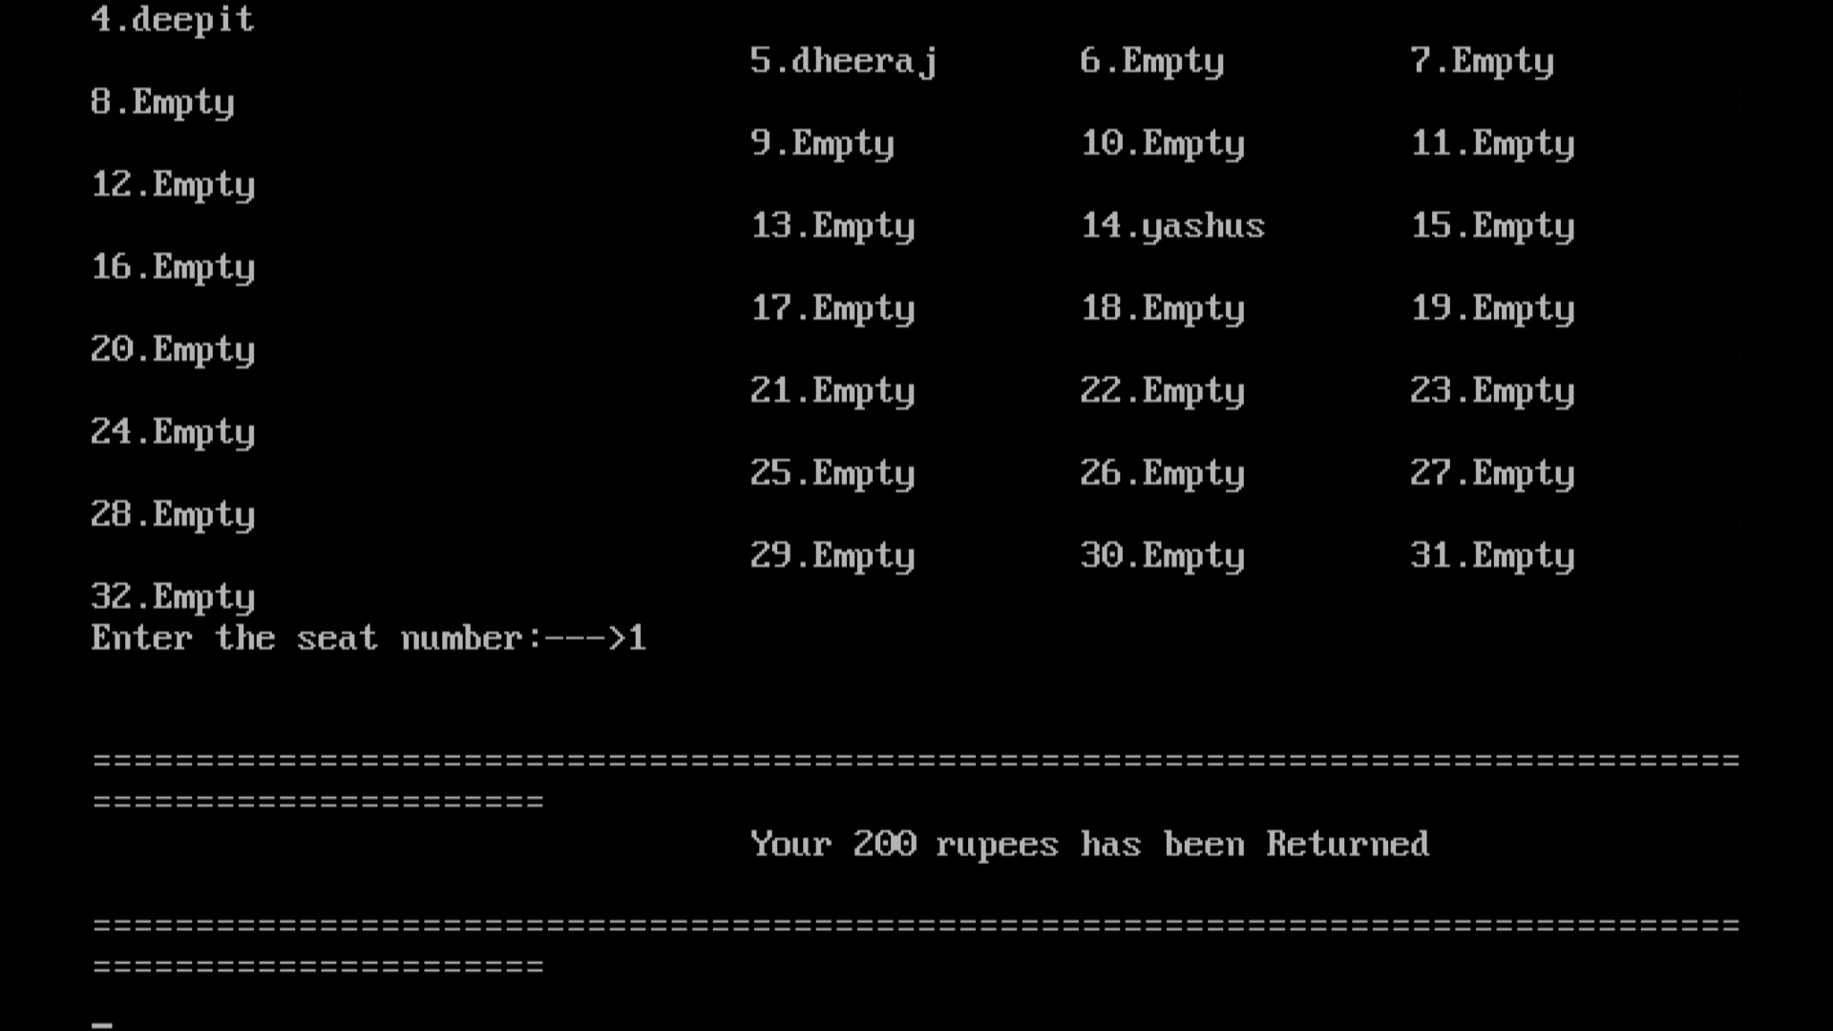

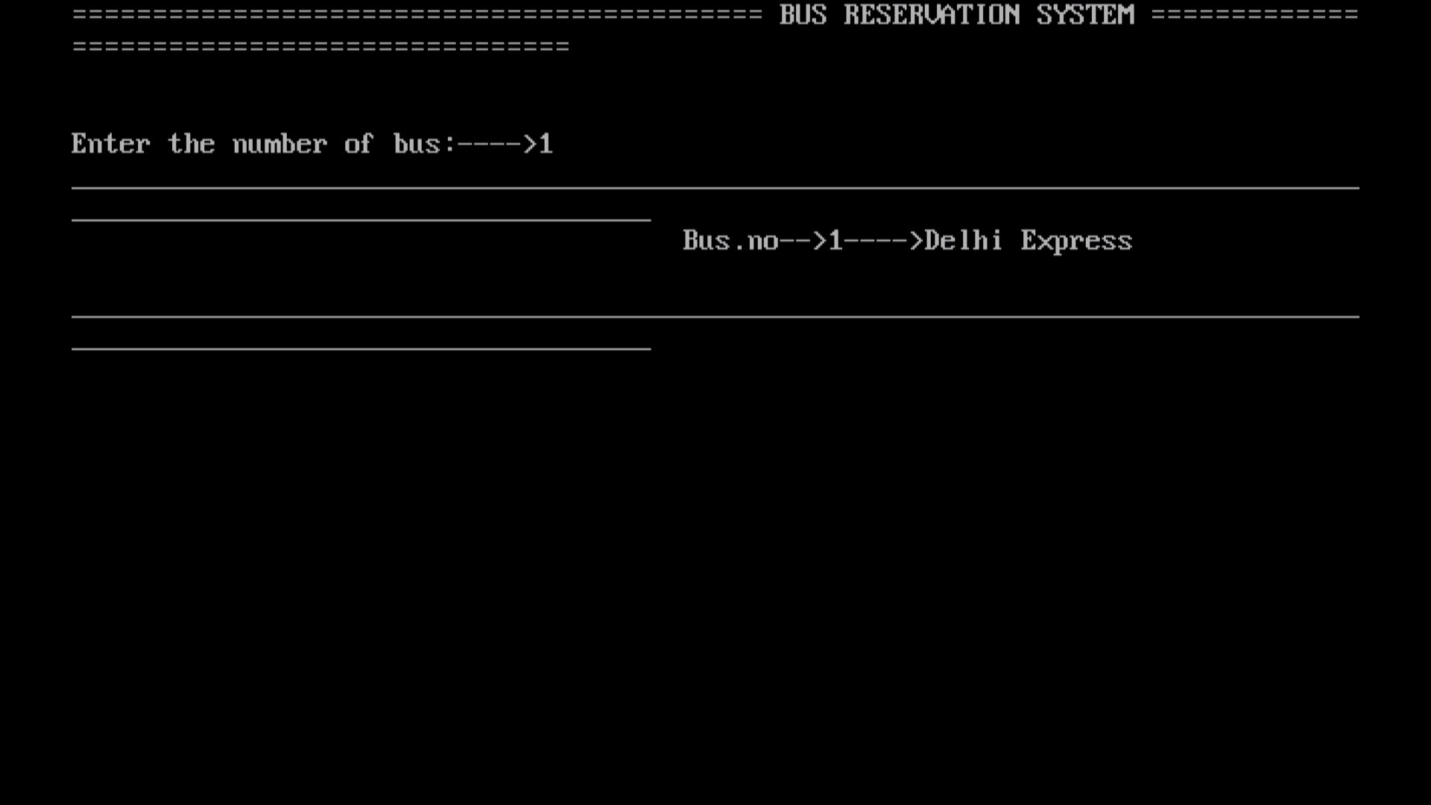

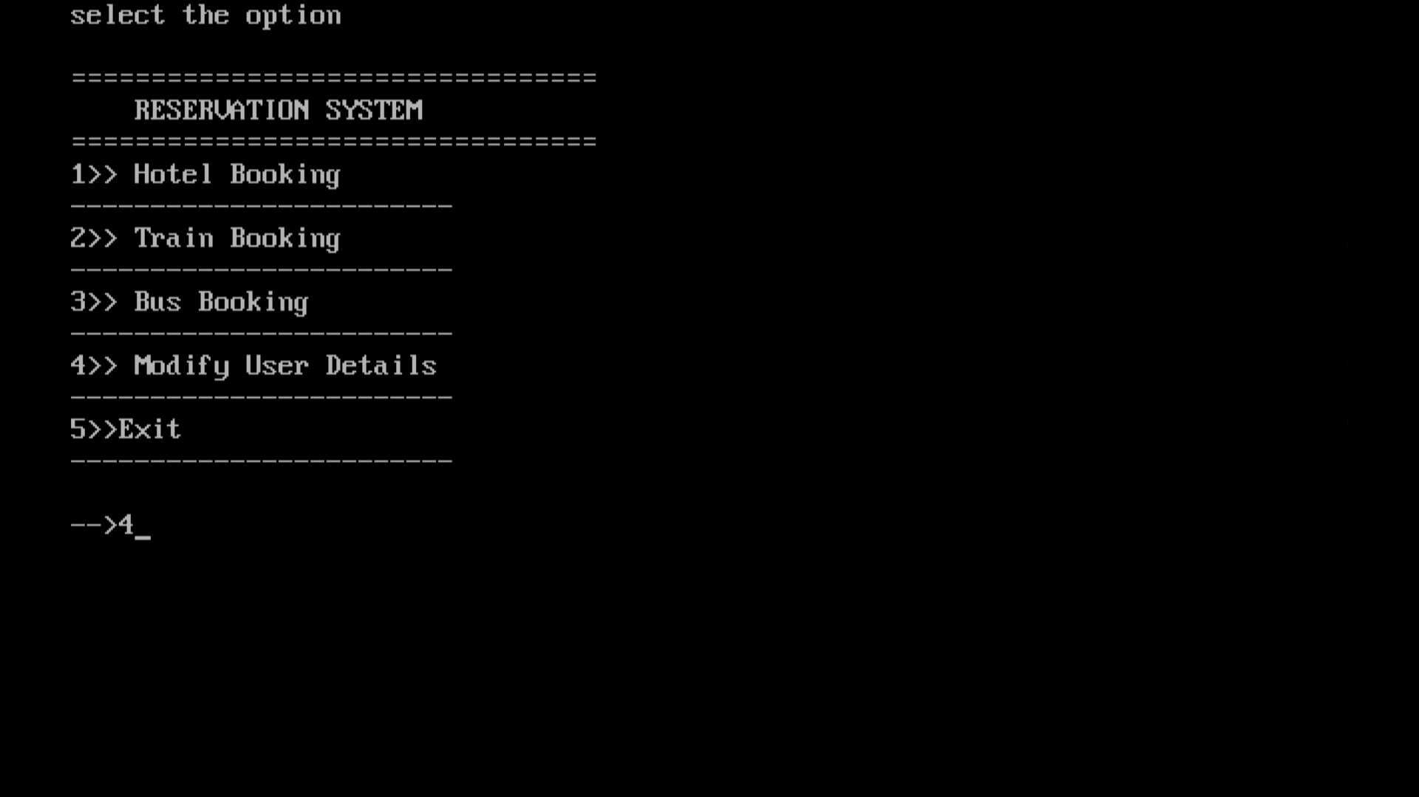

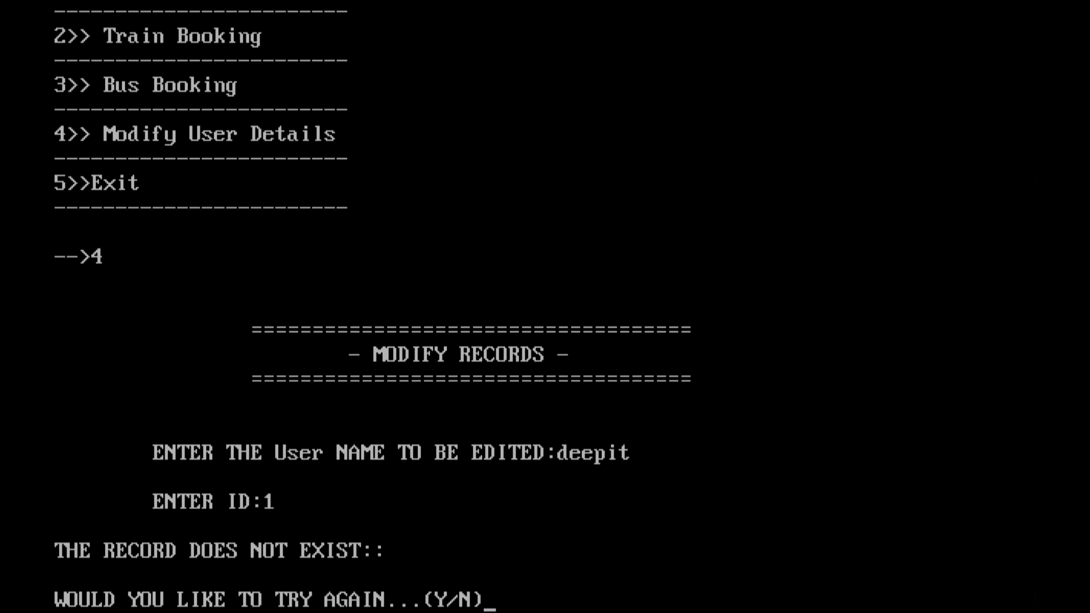

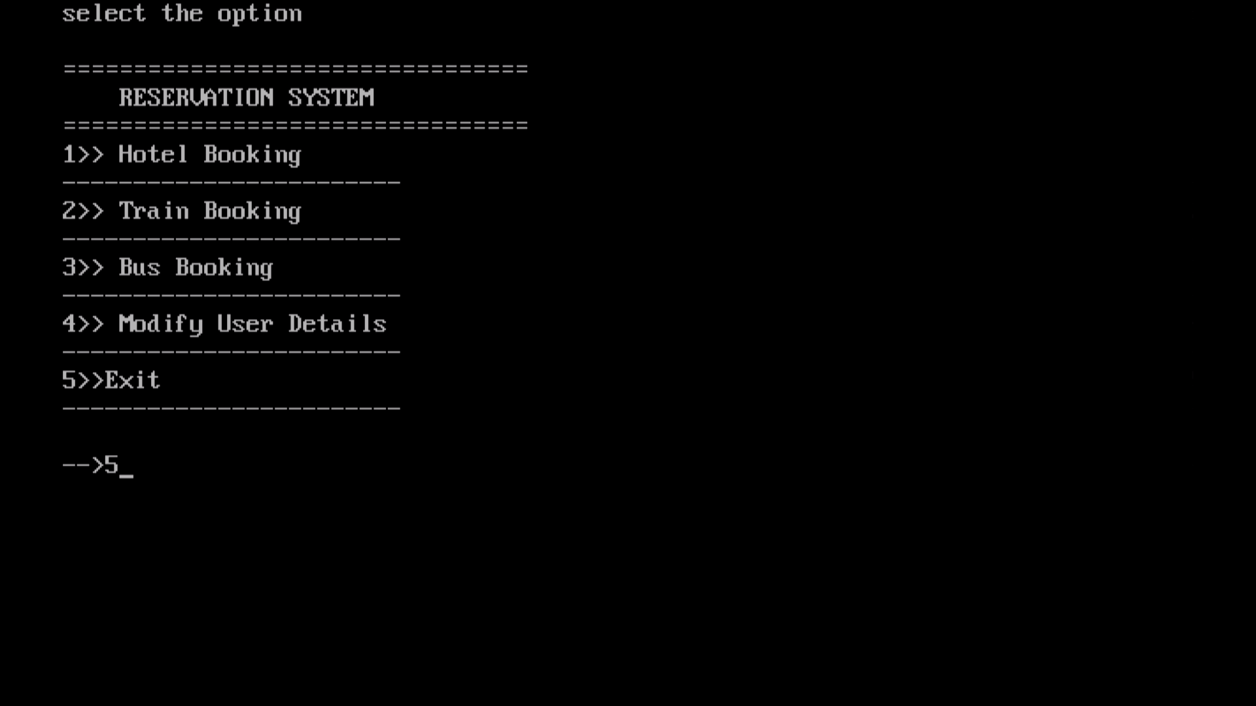
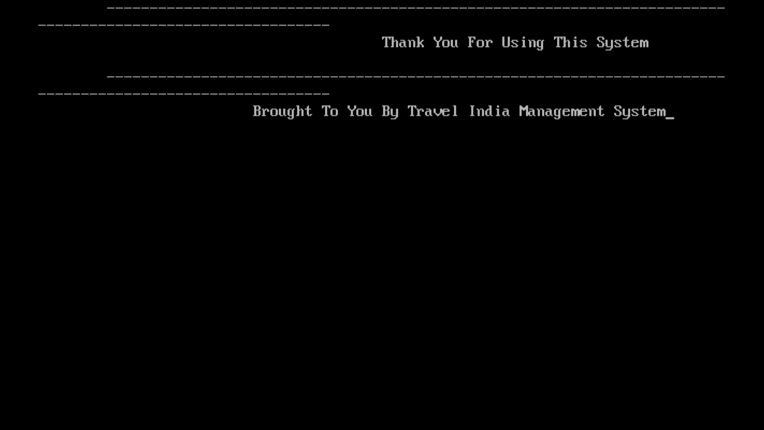

CONCLUSION

While developing the system a conscious effort has been made to create and develop a software package, making use of available tools, techniques and resources – that would generate a proper System.

While making the system, an eye has been kept on making it as user-friendly, as cost-effective and as flexible as possible. As such one may hope that the system will be acceptable to any user and will adequately meet his/her needs.

As in case of any system development processes where there are a number of shortcomings, there have been some shortcomings in the development of this system also. The project is still under modification.

Problems In Existing System
As we know manual system are quite tedious, time consuming and less efficient and accurate in comparison to the computerized system.

So following are some disadvantages of the old system:
- Time consuming
- Less accurate
- Less efficient
- Lot of paper work
- Slow data processing
- Not user friendly environment
- Difficult to keep old records
Scope of Proposed System
- The scope of this system is to provide user efficient working environment and more output can be generated through this. This system provides user friendly interface resulting in knowing each and every usability features of the system.
- This system helps in tracking records so that past records can be verified through them and one can make decisions based on the past records. This system completes the work in a very less time resulting in less time consumption and high level of efficiency.
- This system is developed in such a way that even a naïve user can also operate the system easily. The calculations are made very quickly and the records are directly saved into databases and the databases can be maintained for a longer period of time. Each record can be retrieved and can be verified for the future transactions.
- Also this system provides high level of security for data leaking as only admin people can access the database no changes can be made in it until it verifies the user login id and password.
- We also have operator login through which operator can take orders but can’t make changes in the database. Limited access is available to the operator.

BIBLIOGRAPHY

BOOKS REFERRED

- Let Us C
By - Yashavant Kanetkar

- Programming And Problem Solving Through ‘C’
By - Satish Jain

